AI HEALTH INSURANCE ASSISTANCE USING LLM + RAG
(PolicyLens)
A project report submitted in partial fulfilment of the requirements for the award of the degree of
BACHELOR OF TECHNOLOGY
in
COMPUTER SCIENCE AND ENGINEERING (DATA SCIENCE)
Submitted by
G.PRANATHI | 23K91A6764
CH.AISHWARYA | 23K91A6747
BHAVANSH MANE | 23K91A6728
B.DEEKSHITH | 24K95A6701
Batch A1 (CSE - Data Science, Section A)
Under the esteemed guidance of
[GUIDE NAME]
[DESIGNATION]
[COLLEGE LOGO]
DEPARTMENT OF COMPUTER SCIENCE AND ENGINEERING (DATA SCIENCE)
[COLLEGE NAME]
[COLLEGE ADDRESS / AFFILIATING UNIVERSITY]
[ACADEMIC YEAR]

[COLLEGE LOGO]
[COLLEGE NAME]
DEPARTMENT OF COMPUTER SCIENCE AND ENGINEERING (DATA SCIENCE)
CERTIFICATE
This is to certify that the project report entitled "AI Health Insurance Assistance Using LLM + RAG (PolicyLens)" is a bonafide record of the work carried out by G.PRANATHI (23K91A6764), CH.AISHWARYA (23K91A6747), BHAVANSH MANE (23K91A6728), B.DEEKSHITH (24K95A6701), in partial fulfilment of the requirements for the award of the degree of Bachelor of Technology in Computer Science and Engineering (Data Science), during the academic year [ACADEMIC YEAR], under my supervision.

Project Guide  [GUIDE NAME]  [DESIGNATION] | Head of the Department  [HOD NAME]  Department of Computer Science and Engineering (Data Science) | External Examiner  [NAME AND SIGNATURE]
DECLARATION
We hereby declare that the project report entitled "AI Health Insurance Assistance Using LLM + RAG (PolicyLens)", submitted to the Department of Computer Science and Engineering (Data Science), [COLLEGE NAME], in partial fulfilment of the requirements for the award of the degree of Bachelor of Technology in Computer Science and Engineering (Data Science), is a record of original work carried out by us under the guidance of [GUIDE NAME], [DESIGNATION]. The results embodied in this report have not been submitted to any other university or institution for the award of any degree or diploma.

G.PRANATHI | 23K91A6764
CH.AISHWARYA | 23K91A6747
BHAVANSH MANE | 23K91A6728
B.DEEKSHITH | 24K95A6701
Place: [PLACE]
Date: [DATE]
ACKNOWLEDGEMENT
We express our sincere gratitude to our project guide, [GUIDE NAME], [DESIGNATION], for valuable guidance, encouragement and constructive suggestions throughout this project.
We thank [HOD NAME], Head of the Department of Computer Science and Engineering (Data Science), for providing the facilities and support needed to complete this work, and [PRINCIPAL NAME], Principal, [COLLEGE NAME], for the encouragement given to us.
We thank the project coordinators and all faculty and staff members of the department for their help, and our families and friends for their constant support.
We also acknowledge the authors of the base paper, Maha Ahmed Abdullah Albayati and Oguz Findik, the insurers who publish their policy wordings for the public, and the authors and maintainers of the open-source software on which PolicyLens is built, in particular FastAPI, SQLAlchemy, PyMuPDF, ChromaDB, rank-bm25, Sentence-Transformers, React and Vite, and the providers of the Gemini API.

G.PRANATHI
CH.AISHWARYA
BHAVANSH MANE
B.DEEKSHITH
ABSTRACT
Health insurance policies are long, technical documents, so policyholders struggle to understand coverage, exclusions, waiting periods and claim procedures, and they usually learn what a policy does not cover when a claim is rejected. Agents and helplines give slow, generic answers, and general-purpose chatbots answer from broad training data rather than from the user's own policy, so they can state coverage details that the wording does not contain. The base paper by Albayati and Findik (IEEE Access, 2025) handles long legal documents by selecting important passages and then generating text from them, but it summarises Turkish court rulings and does not answer questions, cite passages or guide claims.
This project builds PolicyLens, an AI health-insurance assistant that combines retrieval-augmented generation with a large language model. An uploaded policy wording is parsed into numbered clauses with page positions and highlight boxes. A Policy Card lists the key terms, each linked to the clause and page that state it and verified against its quote. A hybrid retriever (BM25, MiniLM embeddings, Reciprocal Rank Fusion and a cross-encoder) selects the clauses relevant to a question, and Google Gemini writes a plain-language answer in English, Hindi or Telugu from those clauses only. Citations are filtered to the retrieved clauses, an independent natural-language-inference model scores how well each answer is supported, and a two-score rule makes the assistant answer "not covered in this policy" without calling the model when the wording is silent. Claim Copilot adds calculated eligibility pre-checks, a verdict, a document checklist, claim steps and a cost estimate, and the system compares two policies and flags risky terms.
No model is trained, so the system is evaluated on a hand-built set drawn from four real policy wordings: 57 questions, 14 claim scenarios and 52 Policy Card values. The relevant clause was in the top five for 51 of 51 answerable questions, all 51 answers were correct and correctly cited, 6 of 6 out-of-scope questions were declined with no false abstentions, 14 of 14 claim verdicts were correct and 51 of 52 card values were correct. The mean faithfulness score was 87.0 and the median answer time 4.3 seconds. Twenty-five automated tests pass. The evaluation set is small, was partly used for tuning and was run with the smallest model of the fallback chain, no user study was carried out, and no numeric comparison with the base paper is possible because the tasks and metrics differ.
Keywords: health insurance, retrieval-augmented generation, large language model, question answering, faithfulness, claim guidance.
TABLE OF CONTENTS
CHAPTER 1 INTRODUCTION 1
1.1 Introduction to the Project Domain 1
1.2 Background and Motivation 1
1.3 Problem Statement 2
1.4 Need for the Proposed System 3
1.5 Objectives 3
1.6 Scope of the Project 4
1.7 Key Contributions 5
1.8 Limitations and Assumptions 6
1.9 Organisation of the Report 7
CHAPTER 2 LITERATURE SURVEY 8
2.1 Overview of the Literature Survey 8
2.2 Base Paper Analysis 8
2.3 Related Work 9
2.4 Datasets and Algorithms Used in the Literature 11
2.5 Strengths and Limitations of Existing Approaches 11
2.6 Research Gap 12
CHAPTER 3 FEASIBILITY STUDY 13
3.1 Technical Feasibility 13
3.2 Economic Feasibility 13
3.3 Operational Feasibility 14
3.4 Schedule Feasibility 14
3.5 Advantages and Constraints 15
CHAPTER 4 SYSTEM REQUIREMENTS AND ANALYSIS 16
4.1 Existing System and its Limitations 16
4.2 Proposed System and its Advantages 16
4.3 Functional Requirements 17
4.4 Non-Functional Requirements 17
4.5 Hardware and Software Requirements 18
4.6 User Roles and Constraints 18
CHAPTER 5 SYSTEM DESIGN 20
5.1 System Architecture 20
5.2 High-Level Workflow 21
5.3 Data-Flow Diagrams 21
5.4 UML Diagrams 23
5.5 Database Design 26
5.6 Module Design 28
5.7 User Interface Design 28
CHAPTER 6 METHODOLOGY AND SOFTWARE IMPLEMENTATION 30
6.1 Overall Methodology 30
6.2 Dataset 30
6.3 Preprocessing: Parsing and Segmentation 32
6.4 Algorithm Choice and Justification 32
6.5 Mathematical Formulation 33
6.6 Models and Training Configuration 35
6.7 Application Architecture 36
6.8 Key Code Walkthroughs 37
6.9 Implementation Decisions and Reasoning 38
6.10 API Design 39
6.11 Security and Error Handling 40
6.12 Installation and Execution 40
CHAPTER 7 SYSTEM TESTING 42
7.1 Testing Strategy 42
7.2 Unit Testing 42
7.3 Integration Testing 42
7.4 Functional Testing 43
7.5 Security Testing 44
7.6 Validation and Edge Cases 44
7.7 Performance Testing 45
7.8 User Acceptance Testing 45
7.9 Limits of the Testing Done 45
CHAPTER 8 RESULTS AND OUTPUT SCREENS 47
8.1 Output Screens 47
8.2 Model Performance 55
8.3 Improvement Across the Three Runs 61
8.4 Comparison with the Base Paper 61
8.5 Sample Inputs and Outputs 62
8.6 Success and Failure Analysis 63
8.7 Limits of the Results 63
8.8 Objectives Against Outcomes 64
CHAPTER 9 CONCLUSION 65
9.1 Summary of the Work 65
9.2 Objectives Achieved 65
9.3 Key Findings 65
9.4 Practical Applications 66
9.5 Known Limitations 67
CHAPTER 10 FUTURE SCOPE 68
10.1 Improvements 68
10.2 Additional Features 68
10.3 Scalability and Deployment 68
10.4 Further Research 69
REFERENCES 70
APPENDIX A IMPORTANT CODE 72
A.1 Hybrid Retrieval 72
A.2 Faithfulness Scoring 73
A.3 Co-payment Rule 74
A.4 Password Hashing and Tokens 74
APPENDIX B INSTALLATION AND USER GUIDE 75
B.1 Installation Guide 75
B.2 User Guide 75
APPENDIX C ADDITIONAL SCREENS 77

LIST OF FIGURES
Fig. 5.1: System architecture of PolicyLens 20
Fig. 5.2: High-level workflow 21
Fig. 5.3: Data-flow diagram, level 0 (context) 22
Fig. 5.4: Data-flow diagram, level 1 22
Fig. 5.5: Data-flow diagram, level 2: Answer a question (process 4.0) 23
Fig. 5.6: Use-case diagram 24
Fig. 5.7: UML class diagram 25
Fig. 5.8: Sequence diagram: asking a question and opening a citation 26
Fig. 5.9: Entity-relationship diagram (12 tables) 27
Fig. 6.1: Retrieval ablation: BM25, dense, hybrid and hybrid with re-rank 33
Fig. 8.1: Landing page 47
Fig. 8.2: Dashboard 48
Fig. 8.3: My policies 48
Fig. 8.4: Policy Card 49
Fig. 8.5: Risk highlights 49
Fig. 8.6: Original document with the cited clause highlighted 50
Fig. 8.7: Clause search 50
Fig. 8.8: Cited answer 51
Fig. 8.9: Out-of-scope question declined 51
Fig. 8.10: Citation sheet 52
Fig. 8.11: Hindi answer 52
Fig. 8.12: Claim Copilot: treatment step 53
Fig. 8.13: Claim check: partly covered 53
Fig. 8.14: Claim check: not covered 54
Fig. 8.15: Plan comparison 54
Fig. 8.16: Model performance 55
Fig. 8.17: Headline results of the evaluation run 56
Fig. 8.18: Retrieval ablation (hit@1, hit@3, hit@5, MRR@10) for the four methods 56
Fig. 8.19: Answer accuracy by question category 57
Fig. 8.20: Distribution of faithfulness scores (56 answers) 58
Fig. 8.21: Median and 95th-percentile time by stage 59
Fig. 8.22: Claim Copilot confusion matrix 59
Fig. 8.23: Extraction accuracy by field 60
Fig. 8.24: Retrieval, answer and citation accuracy across the three runs 61
Fig. 9.1: Improvement across the three evaluation runs 66
Fig. C.1: Sign in 77
Fig. C.2: Ask your policy: choose a policy 77
Fig. C.3: Settings 77
Fig. C.4: Create account 77
Fig. C.5: Original document viewer 77
Fig. C.6: Co-payment answer (weak support score) 77
Fig. C.7: Claim Copilot: policy step 78
Fig. C.8: Compare plans: form 78
Fig. C.9: Dark theme 78
Fig. C.10: Policy Card, dark theme 78
Fig. C.11: Policy Card translated to Telugu 78
Fig. C.12: Dashboard (full page) 79
Fig. C.13: Policy Card (full page) 79
Fig. C.14: Risk highlights (full page) 80
Fig. C.15: Claim check, partly covered (full page) 80
Fig. C.16: Claim check, not covered (full page) 81
Fig. C.17: Model performance (full page) 81
Fig. C.18: Phone layout: cited answer (390 px) 82
Fig. C.19: Phone layout: Policy Card (390 px) 82

LIST OF TABLES
Table 1.1: Organisation of the report 7
Table 2.1: Related work reviewed 11
Table 2.2: Techniques in the literature and their role in PolicyLens 11
Table 2.3: Strengths and limitations of existing approaches 11
Table 3.1: Cost elements of the project 13
Table 3.2: Project schedule from the repository history 15
Table 3.3: Advantages and constraints of the project 15
Table 4.1: Limitations of the existing system 16
Table 4.2: Features of PolicyLens 16
Table 4.3: Functional requirements 17
Table 4.4: Non-functional requirements 17
Table 4.5: Hardware and software requirements 18
Table 5.1: Database tables 27
Table 5.2: Modules of PolicyLens 28
Table 6.1: Pipeline of PolicyLens 30
Table 6.2: The four sample policy wordings 30
Table 6.3: Evaluation set (data/eval/) 31
Table 6.4: Algorithm choices 32
Table 6.5: Retrieval ablation on 51 questions (run eval-20260922-0027) 33
Table 6.6: Models used 35
Table 6.7: Pipeline settings 35
Listing: reciprocal_rank_fusion() in ml/retrieval/fusion.py 37
Listing: Abstention check in services/answerer.py 37
Listing: Citation filtering in services/answerer.py 37
Listing: Claim support in ml/faithfulness.py 38
Listing: Cost estimate in services/eligibility.py 38
Table 6.8: Implementation decisions 38
Table 6.9: API endpoints 39
Listing: Request body 39
Listing: Request body 39
Table 6.10: Installation and execution 40
Table 7.1: Unit tests 42
Table 7.2: Integration tests 42
Table 7.3: Backend test inventory (pytest, 15 October 2026) 43
Table 7.4: Functional test cases 43
Table 7.5: Validation and edge cases 44
Table 7.6: Performance measurements 45
Table 8.1: Headline results (run eval-20260922-0027) 55
Table 8.2: Retrieval on 51 answerable questions 56
Table 8.3: Answer accuracy by question category 57
Table 8.4: Scores used by the abstention rule 58
Table 8.5: Answer time by stage (live Gemini calls) 58
Table 8.6: Claim verdicts: expected (rows) against predicted (columns), 14 scenarios 59
Table 8.7: Policy Card values by policy (52 hand-checked values) 60
Table 8.8: Evaluation runs 61
Table 8.9: PolicyLens and the base paper 62
Table 8.10: Sample inputs and outputs (live run, 15 October 2026) 62
Table 8.11: Failure and weakness analysis 63
Table 8.12: Objectives against outcomes 64
Listing: retrieve() in ml/retrieval/hybrid.py 72
Listing: score_claims() in ml/faithfulness.py 73
Listing: copay_applies() in services/eligibility.py 74
Listing: hash_password(), verify_password() and create_access_token() in core/security.py 74
Table B.1: User guide 75

LIST OF ABBREVIATIONS
Abbreviation | Expansion
AI | Artificial Intelligence
API | Application Programming Interface
BM25 | Best Matching 25 (Okapi keyword ranking)
CE | Cross-Encoder
CPU | Central Processing Unit
DFD | Data-Flow Diagram
ER | Entity-Relationship
FK | Foreign Key
FR | Functional Requirement
HTTP | Hypertext Transfer Protocol
IRDAI | Insurance Regulatory and Development Authority of India
JSON | JavaScript Object Notation
JWT | JSON Web Token
LLM | Large Language Model
MRR | Mean Reciprocal Rank
NFR | Non-Functional Requirement
NLI | Natural-Language Inference
OCR | Optical Character Recognition
ORM | Object-Relational Mapping
PDF | Portable Document Format
RAG | Retrieval-Augmented Generation
REST | Representational State Transfer
ROUGE | Recall-Oriented Understudy for Gisting Evaluation
RRF | Reciprocal Rank Fusion
SHA-256 | Secure Hash Algorithm, 256-bit
SQL | Structured Query Language
UI | User Interface
UIN | Unique Identification Number (of an insurance product)
UML | Unified Modeling Language
URL | Uniform Resource Locator

CHAPTER 1
INTRODUCTION

1.1 Introduction to the Project Domain
Health insurance is the main financial protection most families have against the cost of hospital treatment. In India it is sold through dozens of products from many insurers, and each product is defined by a policy wording: a document of twenty to sixty pages that sets out what is covered, what is excluded, how long a policyholder must wait before certain treatments are covered, what share of each bill the policyholder pays, and how a claim must be made. The policyholder is expected to read and understand this document, but it is written in dense legal and technical language and is rarely read in full.
The domain of this project is therefore document understanding for insurance, and more precisely question answering and claim guidance over a single long, clause-structured legal document. It sits between several established areas of computer science. Retrieval-augmented generation (RAG) [7] grounds a large language model (LLM) in text retrieved from a trusted source. Classical information retrieval supplies keyword ranking such as BM25 [8] and rank fusion [9]. Dense sentence embeddings [10], [11] and cross-encoder re-ranking [12] supply semantic matching. Natural-language inference [14] can check whether a statement is supported by a text.
PolicyLens, the system built in this project, combines these ideas into one application. A person uploads their policy wording (or opens one of four sample wordings); PolicyLens parses it into numbered clauses with page positions, builds a Policy Card that lists the key terms with the clause and page that support each value, answers questions in plain language with citations, flags the fine print that tends to cost money at claim time, checks a planned claim, and compares two policies. The title of the project, AI Health Insurance Assistance Using LLM + RAG, should be read in exactly that sense: a large language model does the writing, but retrieval decides what it is allowed to say, and independent checks measure how well each answer is supported.

1.2 Background and Motivation
Three observations motivated the project. First, policy wordings are long and technical, so the details that matter most are easy to miss. A cataract operation, a knee replacement or a delivery may be covered only after a waiting period of one to four years; a room that costs more than the stated limit can reduce the whole claim proportionately; a co-payment may apply from a given age. Policyholders usually discover these conditions when a claim is rejected or reduced, not when they buy the policy.
Second, the usual sources of help are slow and generic. Agents, helplines and FAQ pages answer in general terms and depend on human availability, and comparison websites compare premiums and headline benefits rather than exclusions and claim conditions. General-purpose chatbots answer fluently but from broad training data, not from the user's own wording, so they can state coverage details that the policy does not contain. The research literature calls such statements hallucinations [16]. For a legally binding document a confident wrong answer is worse than no answer: the study of Quebec automobile-insurance questions by Beauchemin et al. found that between 5% and 13% of the answers given by a retrieval-augmented GPT-4o contained a false statement that could mislead a customer [2].
Third, claim filing has no guided pre-check. A policyholder planning an operation has no simple way to learn whether the waiting period is complete, which documents the insurer will ask for, or how much of the bill is likely to be theirs. This makes a claim-guidance feature a natural companion to question answering. The base paper [1] addresses a different task, the summarisation of long Turkish court rulings, but it shows how long, domain-specific legal text can be handled by selecting the important passages first and generating from them. That extract-then-generate idea is the starting point of this project, applied to health-insurance wordings and extended from summaries to cited answers and claim guidance.

1.3 Problem Statement
Health insurance policies are long and technical, so users cannot easily find coverage, exclusions and conditions. Users depend on agents and helplines that give slow, generic and inconsistent answers. General chatbots may produce answers that are not supported by the user's actual policy. Claim filing lacks guidance on eligibility and required documents, which leads to delays and rejections.
Formal statement. Given the text of a health-insurance policy wording (a PDF with a selectable text layer), produce (i) a structured Policy Card in which every extracted value is tied to the clause and page that state it; (ii) for any question about the policy, an answer in English, Hindi or Telugu that uses only that wording, cites the clauses it relies on, and says plainly when the wording does not cover the question; (iii) for a planned treatment, a verdict (covered, partly covered, not covered, or needs more information) with eligibility pre-checks, a document checklist, claim steps and a cost estimate; and (iv) a side-by-side comparison of two policies. The system must measure, not assume, how accurate and how well supported its answers are.
Need. A conversational assistant that answers strictly from the user's own policy document, cites the supporting clauses and guides claims step by step.

1.4 Need for the Proposed System
- Understanding before buying and before claiming. The decisive conditions (waiting periods, sub-limits, co-payments, exclusions) are scattered across the wording; a tool must surface them with their sources.
- Trustworthy answers. A policyholder can only rely on an answer if it names the clause and page it comes from and if the system admits when the wording is silent.
- Measured reliability. Because LLMs can state unsupported facts [16], the system needs an independent, quantitative check of how well each answer is supported, and an offline evaluation that can be repeated.
- Guidance, not just explanation. Claim pre-checks, a document checklist and an out-of-pocket estimate address the delays and rejections that follow from missing information.
- Accessibility. Many policyholders read more comfortably in Hindi or Telugu than in English, so questions and answers must work in those languages while the evidence stays in the original English wording.
- Low cost and privacy. The system should run on an ordinary laptop, keep documents on the user's machine, and use an external model only for the language generation step.

1.5 Objectives
1. Extract key policy attributes automatically from uploaded health insurance documents.
2. Build a RAG pipeline that retrieves the policy clauses relevant to each user question.
3. Generate plain-language answers with an LLM, grounded in and citing the retrieved clauses.
4. Provide guided claim support with eligibility pre-checks, evidence checklists and procedural steps.
5. Summarise risks, exclusions and cost-coverage trade-offs to support plan comparison.
6. Evaluate the assistant for answer accuracy, faithfulness and response time.
These are the six objectives of the project as defined at its start. Chapter 8 measures each of them against the results.

1.6 Scope of the Project

1.6.1 In scope
- Health-insurance policy wordings in PDF form with a selectable text layer, including two-column layouts, tables and IRDAI exclusion codes.
- Parsing into numbered clauses with page numbers and highlight positions, and a viewer that shows the original page with the cited clause highlighted.
- A Policy Card of key terms (sum insured, waiting periods, co-payment, room-rent rule, sub-limits, exclusions, claim deadlines) with source and verification status for every value.
- Hybrid retrieval (BM25, dense embeddings, rank fusion, cross-encoder re-ranking) and cited answers with an NLI-based faithfulness score.
- Claim Copilot: calculated eligibility pre-checks, a verdict, a document checklist, claim steps and a cost estimate.
- Side-by-side comparison of two policies; risk highlights by severity; English, Hindi and Telugu questions, answers and card translation.
- A web application with accounts, a dashboard, a Model performance page, light and dark themes and a phone-friendly layout.
- An offline evaluation harness and a hand-built evaluation set drawn from four real policy wordings.

1.6.2 Out of scope
- Making or predicting the insurer's claim decision: PolicyLens explains the wording; the insurer decides.
- Scanned PDFs without a text layer (they are rejected with a clear message); optical character recognition is not included.
- Training or fine-tuning any model. Every model is pre-trained, and the evaluation set is used only to measure.
- Premium quotes, purchase, payment, claim submission to insurers or any integration with insurer systems.
- Medical advice, and policies other than health insurance.
- Uploads in languages other than English (questions and answers work in Hindi and Telugu, the wording must be English).
- Multi-user administration, roles beyond a single policyholder account, and production hardening such as HTTPS termination and rate limiting by IP.

1.6.3 Assumptions
- The uploaded wording is the policy the user holds and has a readable text layer in English.
- The Google Gemini API is reachable and the free-tier quota is not exhausted; when it is, the application falls back through a chain of models.
- One user works on one machine; the data folder stays on that machine.

1.7 Key Contributions
1. Clause-aware parsing and segmentation of insurance wordings. A parser that handles two-column layouts, running headers, letter-spaced headings and tables, and a segmenter that turns the text into numbered clauses (including IRDAI exclusion codes) with page numbers and highlight boxes, so that every citation can be shown on the original page.
2. Verified Policy Card. One schema-constrained Gemini call extracts the key terms; every value's quote is then located in the clauses to confirm its clause and page, and values whose quote cannot be found are shown as unverified. 51 of 52 hand-checked values were correct.
3. Measured hybrid retrieval for policy text. BM25, dense retrieval, rank fusion and cross-encoder re-ranking were compared on 51 questions; the combination found the right clause in the top five for all 51 and ranked it first for 80.4%.
4. Grounded, cited answers that can decline. Answers are limited to retrieved clauses, citations to clauses that were not retrieved are removed, and a two-score rule (re-rank below 0.004 and best BM25 below 9.0) makes the assistant answer "not covered in this policy" without calling the model: 6 of 6 out-of-scope questions were declined and none of 51 answerable questions was.
5. Independent faithfulness score. A local natural-language-inference model scores how well each answer's statements are supported by the clauses cited for them, with a number check; the mean score was 87.0 and the score is shown with every answer.
6. Claim Copilot with rules that cannot be overruled. Waiting-period checks, age and network co-payment, sub-limits and the cost estimate are calculated from the Policy Card, and the model's verdict cannot contradict a failed waiting-period check: 14 of 14 scenario verdicts were correct.
7. Multilingual use and plan comparison. English, Hindi and Telugu questions and answers, translated cards and risk lists, and a field-by-field comparison with trade-offs that cite both policies.
8. A repeatable evaluation. An offline harness, a 57-question evaluation set, 14 claim scenarios and 52 card checks, three kept runs that show how each fix improved the results, and a public Model performance page.
Contributions 1 and 6 to 8 are engineering contributions; contributions 2 to 5 are the elements whose quality was measured. Compared with the base paper [1], which summarises Turkish court rulings and reports ROUGE scores, this project changes the task from summarisation to grounded question answering and claim guidance, changes the domain from court rulings to health-insurance wordings, and replaces ROUGE with retrieval, citation, faithfulness and verdict measures.

1.8 Limitations and Assumptions
- Small evaluation. 51 answerable questions over four policies and 14 claim scenarios. A result of 100% means no error was found on this set, not that errors cannot occur.
- Partly tuned on the evaluation set. The abstention thresholds and parser fixes were made after studying failures on the same set, so the final figures are optimistic; a fresh unseen set is future work.
- Smallest model in the chain. During the evaluation the free-tier quota of the two larger Gemini models was exhausted, so every result comes from gemini-3.5-flash-lite.
- Faithfulness is a heuristic. A small NLI model and a number check; three of 56 correct answers scored below 50, and one identical question scored 99.0 in one run and 37.9 in another.
- Translation quality. A Telugu Policy Card line contains Bengali and Gurmukhi script mixed into the Telugu text, and bracketed English terms are left untranslated.
- Plan variants. A wording that covers several plan variants (HDFC ERGO covers seven) can make a card value ambiguous; selecting the variant is not yet implemented.
- Text-layer PDFs only, English wordings only; no OCR.
- Single machine and single user. No load, concurrency or security testing was carried out, and no user study with real policyholders.
- No comparison on the base paper's metric. The base paper reports ROUGE for summarisation; PolicyLens does not summarise, so no numeric comparison is possible.

1.9 Organisation of the Report
Table 1.1: Organisation of the report
Chapter | Title | Content
1 | Introduction | Domain, motivation, problem statement, objectives, scope, contributions, limitations
2 | Literature Survey | Base paper, related work by theme, algorithms, strengths and limitations, research gap
3 | Feasibility Study | Technical, economic, operational and schedule feasibility
4 | System Requirements and Analysis | Existing and proposed system, requirements, platform, user role
5 | System Design | Architecture, workflow, DFDs, UML, database, modules, user interface
6 | Methodology and Software Implementation | Pipeline, dataset, preprocessing, algorithms, mathematics, application, API, security, installation
7 | System Testing | Strategy, unit, integration, functional, security, validation, performance, acceptance, limits
8 | Results and Output Screens | Output screens, measured results, comparison, failure analysis, objectives against outcomes
9 | Conclusion | Summary, objectives achieved, findings, applications, limitations
10 | Future Scope | Improvements, features, deployment, research

The report ends with the references, Appendix A (important code), Appendix B (installation and user guide) and Appendix C (additional screens).

CHAPTER 2
LITERATURE SURVEY

2.1 Overview of the Literature Survey
The survey covers four groups of work. The first is the base paper [1], on summarising long legal documents. The second is recent work on question answering over insurance and policy documents with retrieval-augmented generation [2]-[6]. The third is the retrieval and language-model techniques that PolicyLens is built from: retrieval-augmented generation [7], BM25 [8], dense retrieval and sentence embeddings [10], [11], [18], rank fusion [9], cross-encoder re-ranking [12], [15] and natural-language inference [13], [14]. The fourth is work on the reliability of language-model output [16].
Of the sources, the base paper [1], the Quebec insurance study [2] and the policy-document RAG evaluation [6] were read in detail (abstract, method and results). The sources [3] and [4] are listed in the batch literature survey, but their text could not be retrieved independently, so they are described here by title and venue only and no result is attributed to them. For [5] the bibliographic details were confirmed but the results were not read, so only its topic is stated.

2.2 Base Paper Analysis
Base paper. M. A. A. Albayati and O. Findik, "A hybrid transformer-based framework for multi-document summarization of Turkish legal documents," IEEE Access, vol. 13, pp. 37165-37181, 2025, doi: 10.1109/ACCESS.2025.3545750.
Problem and data. Albayati and Findik address the lack of automated summarisation tools for Turkish legal documents, where the agglutinative morphology and specialised vocabulary make the task harder. They collected 2,000 Turkish court rulings (consumer-rights cases) from a public website with a scraping tool and cleaned them to keep the decisions and legal arguments.
Method. A hybrid pipeline. Extractive methods, TF-IDF and TextRank, first select the important sentences of each ruling. Transformer models for long inputs, LED and Long-T5, together with BART-large and GPT-3.5 Turbo, then generate an abstractive summary from the extractive output. The paper evaluates the extractive methods with cosine similarity and content precision, recall and F1, and the abstractive models with ROUGE [19].
Reported results. TF-IDF with keyword guidance reached a content F1 of 0.47. GPT-3.5 Turbo gave the best ROUGE scores: ROUGE-1 55%, ROUGE-2 35%, ROUGE-L 42% and ROUGE-Sum 44%. BART-large was the weakest model.
Claimed contributions. The first Turkish legal summarisation framework, a validated dataset of Turkish civil cases, evidence that a hybrid extractive-plus-abstractive approach works for legal text, and preprocessing adapted to Turkish.
What PolicyLens adopts. The base paper's central idea is that a long, domain-specific legal document is best handled by first selecting the important passages and then generating text from them. PolicyLens applies the same idea to health-insurance wordings: retrieval selects the relevant clauses, and the language model generates from those clauses only.
What PolicyLens changes. The task (cited question answering, claim guidance and comparison instead of summarisation), the domain (health-insurance wordings instead of court rulings), the language (English wordings with Hindi and Telugu interaction instead of Turkish), the selection step (a measured hybrid retriever with a cross-encoder instead of TF-IDF and TextRank), the generation model (Gemini with a JSON schema instead of fine-tuned summarisers) and the evaluation (retrieval, citation, faithfulness and verdict measures instead of ROUGE).
Limitations of the base paper, as we read them. It evaluates summaries by overlap with reference summaries, which does not show whether a statement is supported by the source; it has no citations back to passages; and it does not address question answering or guidance. These are not criticisms of its purpose, only the reasons it cannot be used unchanged here.

2.3 Related Work

2.3.1 Question answering over insurance and policy documents
Beauchemin, Khoury and Gagnon [2] test retrieval-augmented generation for Quebec automobile-insurance questions. They build a reference corpus of insurance expertise and a set of 82 expert answers to lay questions, and evaluate GPT-4o with and without the corpus, with automatic and manual assessment. Retrieval improved the answers on average, but between 5% and 13% of answers still contained a false statement that could mislead a customer, and the authors conclude that LLM answering is not reliable enough for mass use in critical areas. This is the strongest argument for the two safeguards in PolicyLens: citations that the user can check, and an independent faithfulness score.
Maharjan and Yadav [6] compare a plain LLM, a basic RAG pipeline and an advanced RAG pipeline with cross-encoder re-ranking on public-health policy documents, using Mistral-7B-Instruct-v0.2 and the same all-MiniLM-L6-v2 embedding model that PolicyLens uses. Faithfulness rose from 0.347 (plain LLM) to 0.621 (basic RAG) and 0.797 (advanced RAG), and they report that document segmentation remains a bottleneck for multi-step reasoning. Their two findings, that two-stage retrieval matters and that segmentation limits quality, correspond to PolicyLens's re-ranker and to its clause-aware segmenter.
A multi-strategy RAG system for medical-insurance question answering is described in [3], and an AI chatbot for the Iran Health Insurance Organization in [4]. Both are listed in the batch survey; only their titles and venues are used here. Knollmeyer et al. [5] study knowledge-graph-enhanced RAG for document question answering in manufacturing, which indicates that structure beyond flat text chunks is an active direction; PolicyLens keeps the document's own clause structure instead of building a graph.

2.3.2 Retrieval and ranking
Retrieval-augmented generation [7] conditions a generator on passages retrieved from an external store, which reduces reliance on the model's memory. BM25 [8] is the standard probabilistic keyword ranking and remains strong when queries and documents share exact terms. Dense retrieval [18] embeds queries and passages into a vector space; Sentence-BERT [10] and the distilled MiniLM [11] provide compact general-purpose embeddings. Reciprocal Rank Fusion [9] combines ranked lists without calibrating their scores. Cross-encoders [12] read the query and passage together and rank more accurately than either retriever alone, at higher cost; MS MARCO [15] is the usual training data for such rankers.

2.3.3 Checking model output
Hallucination in natural language generation is surveyed in [16]. Natural-language inference, trained on corpora such as MultiNLI [14] and used with strong encoders such as DeBERTaV3 [13], predicts whether a premise entails a hypothesis, and so can score whether an answer's statements are supported by the text it cites. PolicyLens uses a small NLI cross-encoder for this purpose, independent of the model that wrote the answer. The large language model itself is accessed through the Gemini API [17].
Table 2.1: Related work reviewed
Ref. | Work | Task / approach | Data | Reported result | Limitation for this project
[1] | Albayati and Findik, 2025 (base paper) | Hybrid extractive + abstractive summarisation of rulings | 2,000 Turkish court rulings | GPT-3.5 Turbo ROUGE-1 55%, ROUGE-2 35%, ROUGE-L 42% | Summarisation, not QA; no citations; Turkish court rulings
[2] | Beauchemin et al., 2024 | RAG over an insurance corpus with GPT-4o | Quebec auto-insurance corpus; 82 expert answers | Better on average; 5-13% of answers had a false statement | Auto insurance; one model; small answer set
[6] | Maharjan and Yadav, 2026 | Plain LLM vs basic vs advanced RAG (cross-encoder) | Public-health policy documents | Faithfulness 0.347 / 0.621 / 0.797 | Public-health guidance, not insurance wordings
[3] | Multi-strategy RAG for medical-insurance QA, 2026 | Multi-strategy RAG | Not retrieved | Not retrieved | Listed in batch survey only
[4] | AI chatbot, Iran Health Insurance Organization, 2023 | Service chatbot | Not retrieved | Not retrieved | Listed in batch survey only
[5] | Knollmeyer et al., 2025 | Knowledge-graph-enhanced RAG for documents | Manufacturing documents | Not read | Different domain; results not read

2.4 Datasets and Algorithms Used in the Literature
Table 2.2: Techniques in the literature and their role in PolicyLens
Technique | Used in | Role in PolicyLens
TF-IDF, TextRank (extractive selection) | [1] | Counterpart of retrieval: selects passages before generation. PolicyLens uses BM25 [8] instead
LED, Long-T5, BART-large, GPT-3.5 Turbo | [1] | Abstractive generators; PolicyLens uses Gemini [17] with a JSON schema
ROUGE-1/2/L | [1], [19] | Summary overlap; not applicable to cited QA
RAG with GPT-4o | [2] | Same principle; PolicyLens adds a faithfulness score and abstention
all-MiniLM-L6-v2 embeddings | [6], [10], [11] | Dense retrieval in PolicyLens
Cross-encoder re-ranking | [6], [12], [15] | Final ranking of fused candidates
Reciprocal Rank Fusion | [9] | Combines BM25 and dense rankings
NLI (DeBERTa family) | [13], [14] | Faithfulness scoring of each answer

2.5 Strengths and Limitations of Existing Approaches
Table 2.3: Strengths and limitations of existing approaches
Approach | Strengths | Limitations
Reading the wording / agents and helplines | Authoritative; human judgement | Slow, inconsistent, generic; the wording is long and technical
Comparison websites | Easy premium and benefit comparison | Do not explain exclusions, waiting periods or claim conditions
General-purpose chatbots | Fluent, available at any time | Answer from training data, not the user's policy; may hallucinate [16]; no citations
RAG over insurance text [2] | Grounded in a corpus; better on average than the plain model | 5-13% false statements remain; one model; no per-answer support score
Advanced RAG with re-ranking [6] | Faithfulness 0.797 vs 0.347 for the plain model | Different domain; segmentation named as a bottleneck
Summarisation framework [1] | Handles very long legal texts; strong ROUGE with GPT-3.5 Turbo | Summaries only; no question answering, citations or guidance

2.6 Research Gap
Existing work summarises or answers questions over legal and general documents, but few systems combine policy attribute extraction, clause-grounded question answering and claim guidance for health insurance. The survey leaves five specific gaps that this project addresses:
1. Structure. Retrieval over flat chunks loses the clause numbers and pages on which a policyholder relies; segmentation is named as a bottleneck in [6]. A clause-aware parser that preserves numbering, pages and positions is needed.
2. Per-answer evidence of support. [2] shows that retrieval alone leaves false statements; no reviewed system gives the user a score of how well each answer is supported by the cited text.
3. Knowing when not to answer. A policy question may simply not be covered by the wording; the assistant must decline without calling the model rather than invent an answer.
4. Guidance as well as explanation. None of the reviewed work combines question answering with calculated claim pre-checks, document checklists and a cost estimate.
5. Measured, repeatable evidence on real wordings. The reviewed studies work on one insurance line or on other domains; a repeatable evaluation on several real health-insurance wordings, with retrieval, citation, faithfulness, abstention and verdict measures, was not found in the work reviewed.

CHAPTER 3
FEASIBILITY STUDY

3.1 Technical Feasibility
The project needs five technical capabilities: reading PDFs with complex layouts, retrieving clauses, generating grounded text, checking the generated text, and serving everything through a web application. Each was available without a GPU or a paid service.
PDF reading. PyMuPDF returns every text line with its page, position and font, which is enough to rebuild reading order in two-column layouts, remove running headers and footers and locate highlight boxes. The four sample wordings (two-column A4, small-page two-column, single column with Def. N numbering, single column with multi-level numbering) parsed in 3.2 to 4.2 seconds each.
Retrieval. BM25 needs no model; the MiniLM embedding model (91.6 MB), the MS MARCO cross-encoder (91.8 MB) and the NLI model (294.5 MB) are small enough to run on a CPU. On the development machine (12-thread Intel Core i5-12500, 15.7 GB of memory) BM25 answers in about 1 ms, dense search in about 11 ms and the cross-encoder re-rank in about 0.9 s.
Generation. Google's Gemini models accept a whole 40 to 60 page wording in one request and return output that follows a JSON schema, which makes extraction and answers machine-checkable. A free tier is available for development. A fallback chain covers quota limits and overload.
Web application. FastAPI, SQLAlchemy with SQLite, React and Vite are mature and run on a laptop. All of this was demonstrated in the built system: 25 backend tests pass and the web application builds without type errors.
The one technical risk is dependence on an external model service. It is reduced by the fallback chain, by a disk cache that avoids repeating identical requests, and by doing everything that can be done locally (retrieval, re-ranking, faithfulness, eligibility rules, risk rules) without the service.

3.2 Economic Feasibility
Table 3.1: Cost elements of the project
Item | Choice | Cost
Language model | Gemini API, free tier (fallback chain of three models) | No fee during development; quota-limited
Local models | all-MiniLM-L6-v2, ms-marco-MiniLM-L6-v2, nli-deberta-v3-xsmall (Apache-2.0) | No licence fee; one-off download (about 478 MB)
Software | Python, FastAPI, SQLAlchemy, SQLite, ChromaDB, PyMuPDF, React, Vite, Tailwind CSS (open source) | No licence fee
Hardware | An ordinary desktop or laptop; no GPU | Existing machine
Data | Four public policy wordings downloaded from insurers' websites; hand-written evaluation set | No fee; staff time only
Hosting | Runs locally; a server deployment was not costed | Not measured

The running cost of the system is therefore dominated by the language-model service. A complete evaluation run needs about 80 Gemini requests, and each answer needs one. The application records the model, token counts and latency of every request in the llm_calls table and shows the totals on the dashboard, so the cost of a paid plan could be estimated from real usage. A monetary estimate was not made because the project ran on the free tier.

3.3 Operational Feasibility
- Users. A policyholder needs only a browser. Registration is by e-mail and password; a demo account with four processed sample policies lets a new user see every feature at once.
- Setup. setup.bat installs the dependencies, downloads the local models and prepares the sample data; run.bat starts the API and the web app and opens the browser; stop.bat stops them.
- Everyday use. Uploading a 40-page policy takes seconds to parse and index plus one model request for the Policy Card; a question is answered in a median of 4.3 seconds.
- Maintenance. All settings are in a documented .env file; the Gemini model names are configuration, not code; the evaluation can be re-run with one command to detect regressions.
- Trust. Every answer shows its sources on the original page and a faithfulness score, and the interface states that the insurer makes the final decision.

3.4 Schedule Feasibility
The build history in the project repository shows the phases below. The dates are taken from the commit log and the evaluation run names; the documentation phase is the present work.
Table 3.2: Project schedule from the repository history
Phase | Date (2026) | Outcome
Planning and prompts | 21 September | Build plan (docs/PLAN.md), architecture and data model
Project foundations | 21 September | Backend skeleton, database models, authentication, PDF parsing and segmentation
Retrieval and evaluation | 21 September | BM25, dense index, fusion, re-ranking; evaluation harness and first run (eval-20260921-2353)
Chat, claims, comparison | 21 September | Answerer, faithfulness scorer, Claim Copilot, comparator, language service
Web application | 21 September | Landing page, dashboard, policy view, chat, claims, compare, model performance
Fixes and tuning | 21-22 September | Abstention rule, parent-context, exclusion-code clauses; runs eval-20260922-0008 and -0027
Documentation and screens | 22 September, 15 October | Product documents, real screenshots, diagrams, this report

The evaluation harness made the later phases fast: a full run takes about ten minutes, so each fix could be checked immediately. The schedule was feasible because every heavy component was an existing library or pre-trained model.

3.5 Advantages and Constraints
Table 3.3: Advantages and constraints of the project
Advantages | Constraints
Runs on one laptop with no GPU and no licence fee | Depends on an external model service and its free-tier quota
Documents stay on the user's machine; only clauses are sent to the model | Evaluated with the smallest model of the fallback chain
Every answer is cited and scored; the system can decline | Faithfulness score is a heuristic from a small NLI model
Rules (waiting periods, co-payment, estimate) are calculated, not generated | Text-layer, English wordings only; no OCR
Repeatable evaluation and public Model performance page | Small evaluation set; partly tuned on itself
English, Hindi and Telugu questions and answers | Translation quality limited (mixed-script line observed)

CHAPTER 4
SYSTEM REQUIREMENTS AND ANALYSIS

4.1 Existing System and its Limitations
Today a policyholder who wants to understand a health policy has four options. They can read the policy wording, which is long and technical. They can ask an agent or call a helpline, which is slow and depends on the person who answers. They can use a comparison website, which compares premiums and headline benefits. Or they can ask a general-purpose chatbot, which answers from broad training data instead of their own wording. Claim filing offers no guided pre-check.
Table 4.1: Limitations of the existing system
Limitation of the existing system | Consequence
Policy wording is technical and lengthy | Key exclusions, waiting periods and conditions are easily missed
Agent and helpline answers are slow and inconsistent | Depends on human availability; generic answers
General chatbots are not grounded in the policy | Can hallucinate coverage details [16]
No tool extracts key attributes automatically | Deductibles, limits and waiting periods must be found by hand
No guided claim pre-check | Delays and rejections from missing eligibility information and documents
Answers carry no clause references | The user cannot verify what they are told

4.2 Proposed System and its Advantages
PolicyLens answers strictly from the user's own policy wording. A person uploads a PDF; the system parses it into numbered clauses, builds a Policy Card, flags risks, answers questions with citations and a faithfulness score, checks planned claims and compares two policies, in English, Hindi or Telugu.
Table 4.2: Features of PolicyLens
Feature | What it does | Advantage over the existing system
F1 Policy upload and parsing | PDF to numbered clauses with pages and highlight positions | The wording becomes searchable and citable
F2 Policy Card | Sum insured, deductible, co-pay, room rent, waiting periods, sub-limits, exclusions, deadlines, each linked to its clause | Key terms in one place, with proof
F3 Clause-grounded chat | Plain-language answers citing clause and page; says "not covered in this policy" instead of guessing | No unsupported answers
F4 Hybrid retrieval | BM25 + MiniLM embeddings, fused and re-ranked | Finds the right clause for exact terms and for paraphrases
F5 Claim Copilot | Verdict, calculated checks, cost estimate, documents, steps | Guidance before filing
F6 Plan comparison | Two policies side by side with trade-offs | Compares exclusions and conditions, not only premiums
F7 Risk highlights | Waiting-period, sub-limit, co-pay and room-rent traps by severity | Surfaces the fine print
F8 Multilingual answers | English, Hindi, Telugu | Accessible to more users
F9 Faithfulness score | NLI score of each answer against its cited text | Shows how far to trust each answer

4.3 Functional Requirements
Table 4.3: Functional requirements
ID | Requirement | Satisfied by
FR1 | The user shall register, sign in and change language, theme and password | Auth and users API; Settings page
FR2 | The user shall upload a PDF policy wording or add sample policies; scanned, encrypted, oversize and duplicate files shall be refused with a clear message | POST /policies, /policies/samples
FR3 | The system shall parse the wording into numbered clauses with page numbers and highlight positions | pdf_parser, segmenter
FR4 | The system shall build a Policy Card whose values link to their clause and page and are marked verified or not | extractor
FR5 | The system shall flag risks by severity from rules and from the model, without duplicates | risk_engine
FR6 | The user shall search the clauses by keyword, semantics or hybrid | POST /policies/{id}/search
FR7 | The user shall ask questions and receive cited answers, a faithfulness score and follow-up questions; unanswerable questions shall be declined | answerer, faithfulness
FR8 | The user shall open any cited clause on the original page with the clause highlighted | page_renderer, viewer
FR9 | The user shall run a claim check and receive a verdict, pre-checks, documents, steps and an estimate; checklist ticks shall be saved | claim_copilot, eligibility
FR10 | The user shall compare two policies | comparator
FR11 | Questions and answers shall work in English, Hindi and Telugu; the card and risks shall be translatable | language service
FR12 | The user shall see a dashboard of their activity and a public page of measured model performance | dashboard, evaluation API

4.4 Non-Functional Requirements
Table 4.4: Non-functional requirements
ID | Requirement | How it is met / measured
NFR1 Accuracy | Answers shall be correct and cited | Answer accuracy 51/51, citation accuracy 100% on the evaluation set
NFR2 Faithfulness | Each answer shall carry a support score | Mean 87.0; shown on every answer
NFR3 Response time | A typical answer shall arrive within seconds | Median 4.3 s, 95th percentile 18.2 s (live Gemini)
NFR4 Security | Passwords hashed, tokens signed, data owner-only | bcrypt, JWT (24 h), owner checks tested in test_policy_flow.py
NFR5 Privacy | Documents stay local | Only retrieved clauses and the question go to the model API
NFR6 Reliability | The service shall survive model overload and restarts | Fallback chain, cool-down, cache, resumable ingestion
NFR7 Usability | Plain language, no horizontal scroll on phones, light/dark themes | Checked at 360 px and 1440 px (see testing)
NFR8 Portability | Runs on Windows 10/11 with Python 3.11 and Node LTS | setup.bat, run.bat, stop.bat
NFR9 Maintainability | Configuration outside the code; tests | .env; 25 backend tests; strict TypeScript
NFR10 Reproducibility | The evaluation shall be repeatable | ml/run_all.py; three runs kept in experiments/

4.5 Hardware and Software Requirements
Table 4.5: Hardware and software requirements
Item | Requirement
Machine used for development and measurement | 12th Gen Intel Core i5-12500 (6 cores, 12 threads), 15.7 GB RAM, no discrete GPU, Windows 11 Pro
Disk | About 2.5 GB for the virtual environment, node_modules and model weights (project plan); the data folder is about 4.7 MB
Minimum machine | Not measured; the system was run only on the machine above
Operating system | Windows 10 or 11 (batch scripts); the Python and Node code is portable
Python and Node | Python 3.11 (3.11.9 used); Node.js LTS
Backend libraries | FastAPI >= 0.115, Uvicorn, Pydantic >= 2.7, SQLAlchemy >= 2.0, PyJWT, passlib + bcrypt 4.0.1, google-genai >= 1.0, chromadb >= 1.0, rank-bm25, PyMuPDF >= 1.24, sentence-transformers >= 3.0, torch >= 2.3, numpy, pandas, matplotlib, scikit-learn, pytest, httpx
Web libraries | React 18.3, Vite, TypeScript, Tailwind CSS, shadcn/ui (Radix), React Router 7, TanStack Query 5, Axios, Recharts 3, Framer Motion, GSAP, Lenis
External service | Google Gemini API key (free tier): a key is the only credential needed
Browser | A current Chrome or Edge (used for all captures); other browsers were not tested

4.6 User Roles and Constraints
PolicyLens has one authenticated role, the policyholder. Every policy, conversation, claim check and comparison belongs to the user who created it and is visible only to that user; this is enforced in the API and covered by a test. Two things need no sign-in: the landing page and the Model performance page, which shows the public evaluation figures. A demo account (demo@policylens.app) is seeded with the four sample policies.
Constraints. The wording must be a PDF with a text layer, in English, up to the configured upload size. A claim check needs a Policy Card, so it is available only after a policy is processed. The faithfulness score and the claim verdict are aids; the insurer makes the final decision on any claim, and the interface says so.

CHAPTER 5
SYSTEM DESIGN

5.1 System Architecture
PolicyLens is a single-machine application: a React web app, a FastAPI backend, local storage and three CPU models, with the Gemini API as the only external service. The figure below shows the layers.
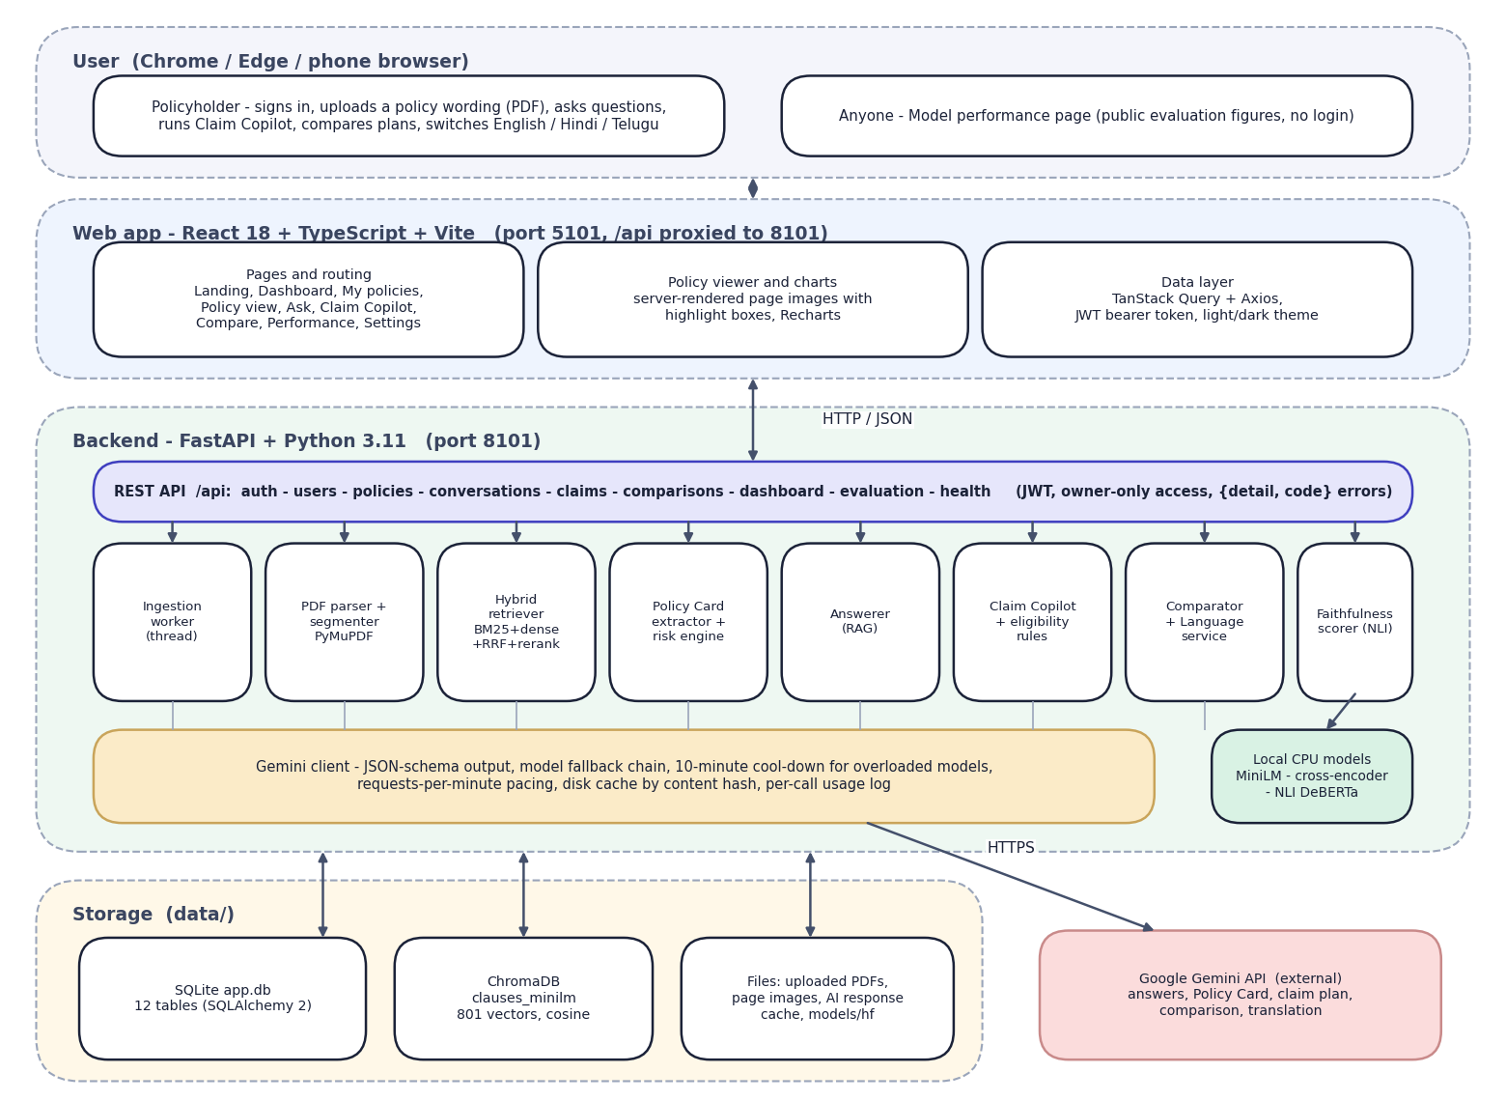
Fig. 5.1: System architecture of PolicyLens
The diagram shows five layers. At the top is the user's browser: a policyholder, and any visitor to the public Model performance page. Below it is the React web application, served by Vite on port 5101, which proxies every /api call to the backend. The backend is a FastAPI application on port 8101. Its REST layer exposes authentication, users, policies, conversations, claims, comparisons, the dashboard, evaluation and health endpoints, and passes work to eight services: the ingestion worker, the PDF parser and segmenter, the hybrid retriever, the Policy Card extractor with the risk engine, the answerer, Claim Copilot with the eligibility rules, the comparator with the language service, and the faithfulness scorer.
Every request to a language model goes through one Gemini client, which handles the JSON schema, the fallback chain, the pacing and the cache. Three small models run locally on the CPU. Storage is local: SQLite for records, ChromaDB for the clause vectors, and plain files for PDFs, page images and the response cache. The only external service is the Gemini API.
The design follows four principles. Ground everything in the document: the only text the language model may use is the clauses that retrieval hands it, tagged so that each statement can be traced. Check independently: faithfulness, quote verification and eligibility rules are computed outside the model that wrote the text. Keep the heavy work local: retrieval, re-ranking and scoring run on the CPU, which keeps documents on the user's machine and saves quota. Degrade gracefully: with the Gemini key removed, upload, search and the document viewer still work.

5.2 High-Level Workflow
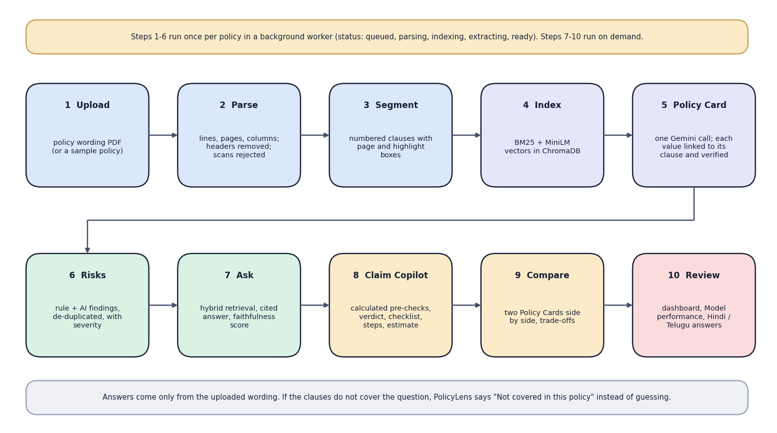
Fig. 5.2: High-level workflow
The ten steps fall into two groups. Steps 1 to 6 (upload, parse, segment, index, Policy Card, risks) run once per policy in a background worker whose status moves from queued to parsing, indexing, extracting and ready. Steps 7 to 10 (ask, Claim Copilot, compare, review) run on demand against a ready policy. The note at the bottom states the central rule of the system: if the wording does not cover a question, the assistant says so instead of guessing.

5.3 Data-Flow Diagrams
The data-flow diagrams show how data moves through PolicyLens at three levels of detail.
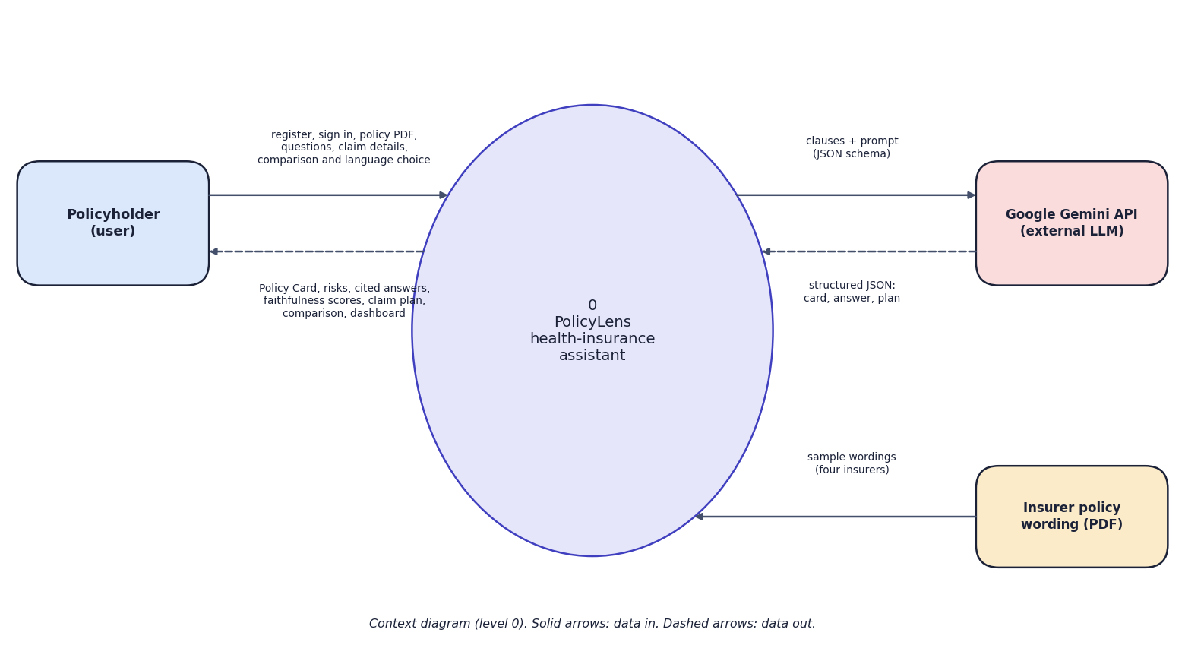
Fig. 5.3: Data-flow diagram, level 0 (context)
At the highest level PolicyLens is one process with three external entities. The policyholder sends credentials, policy PDFs, questions, claim details and comparison and language choices, and receives Policy Cards, risks, cited answers with faithfulness scores, claim plans and comparisons. The Gemini API receives clauses with a JSON schema and returns structured JSON. The insurer's policy wording is the input document, supplied either by the user or as one of four sample wordings.
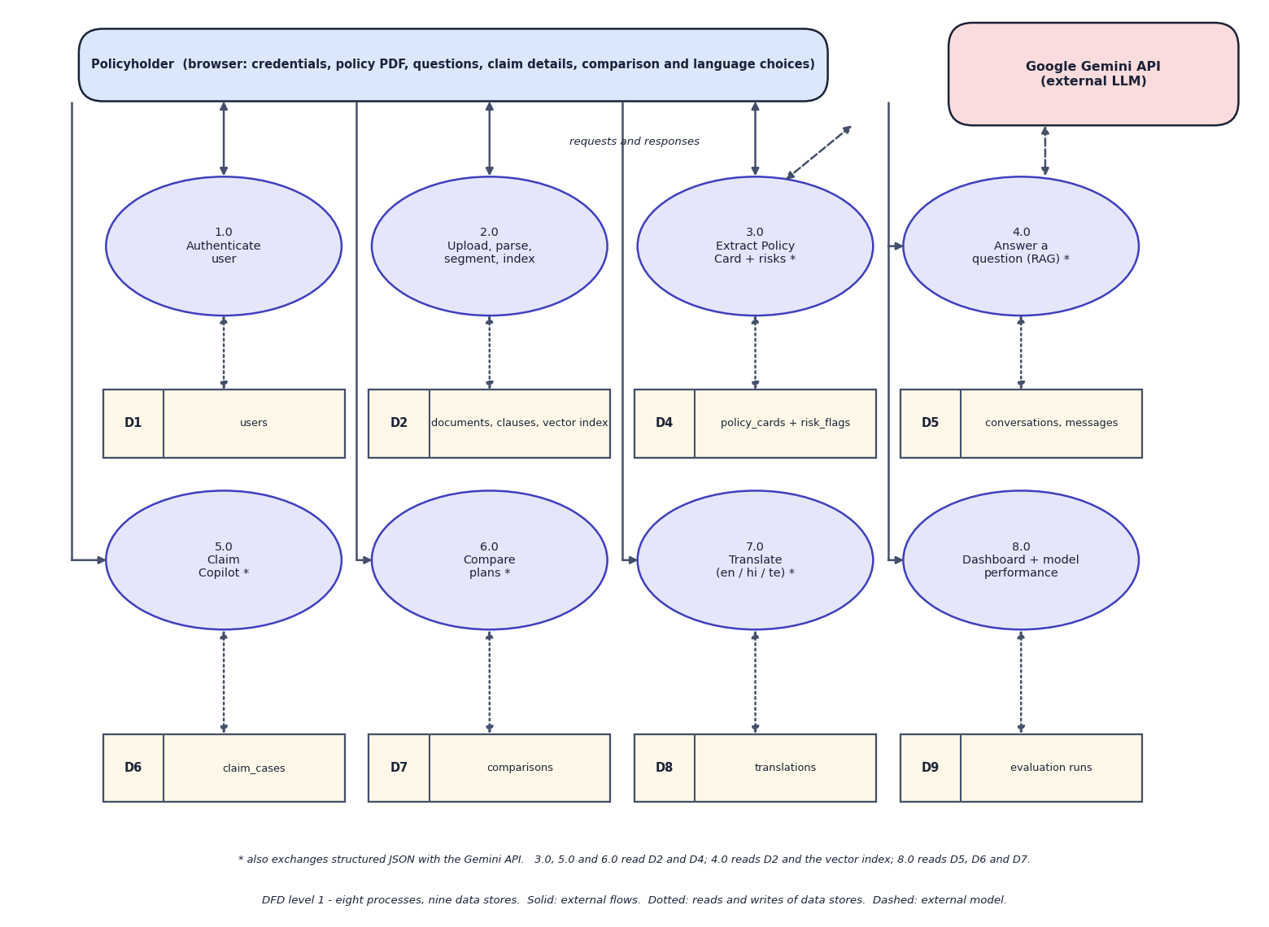
Fig. 5.4: Data-flow diagram, level 1
Level 1 splits PolicyLens into eight processes: authentication (1.0), upload, parse, segment and index (2.0), Policy Card and risk extraction (3.0), question answering (4.0), Claim Copilot (5.0), plan comparison (6.0), translation (7.0), and the dashboard with model performance (8.0). Nine data stores hold the users, the documents with their clauses and vector index, the cards and risk flags, the conversations and messages, the claim cases, the comparisons, the cached translations and the evaluation runs. Processes marked with an asterisk also exchange JSON with the Gemini API.
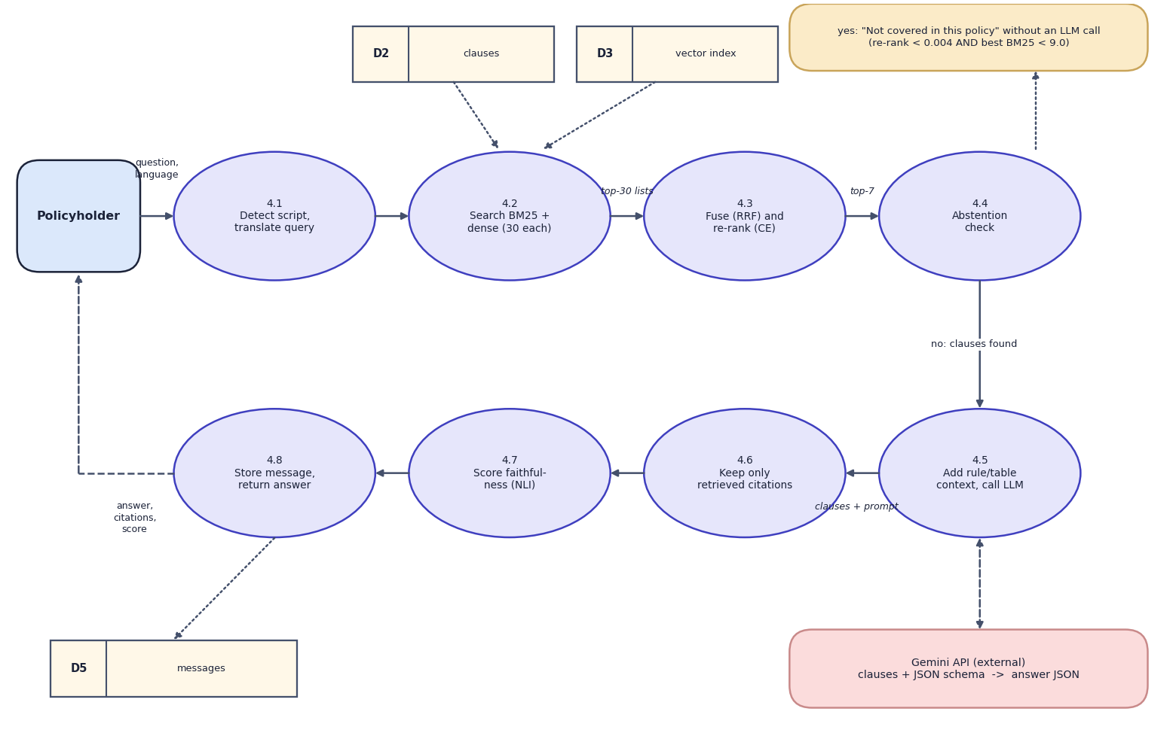
Fig. 5.5: Data-flow diagram, level 2: Answer a question (process 4.0)
Process 4.0 is expanded into eight steps that follow the code of answer_question(): detect the script and translate a Hindi or Telugu question into an English search query (4.1), search BM25 and the vector index for 30 candidates each (4.2), fuse the rankings and re-rank them with the cross-encoder (4.3), and check whether anything relevant was found (4.4). If nothing was, the answer "not covered in this policy" is returned without a model call. Otherwise the rule or table context is added and the model is called (4.5), citations to clauses that were not retrieved are dropped (4.6), the faithfulness score is computed (4.7), and the message is stored and returned (4.8).

5.4 UML Diagrams
Three UML views describe the design: the use-case diagram (who does what), the class diagram (what the code contains) and the sequence diagram (how the main flow runs). The algorithm itself is shown as a flowchart in Chapter 6.
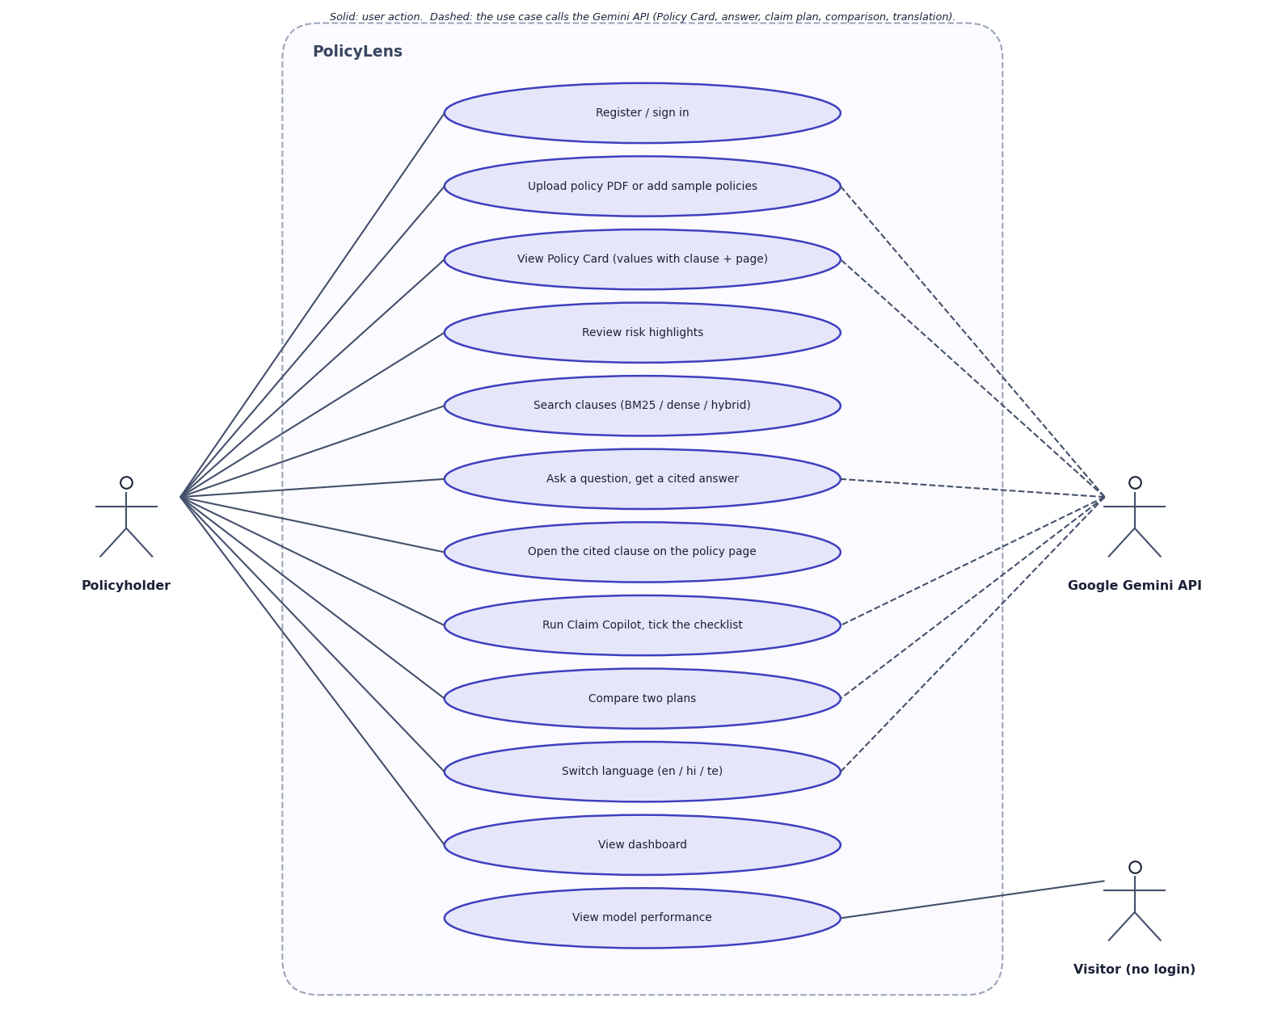
Fig. 5.6: Use-case diagram
The policyholder can register or sign in, upload a policy or add the samples, view the Policy Card, review risks, search clauses, ask questions, open a cited clause on its page, run Claim Copilot and tick its checklist, compare two plans, switch language and view the dashboard. A visitor who has not signed in can view the Model performance page. The Gemini API is an external actor used by the use cases that generate text: building the card, answering, claim planning, comparison and translation.
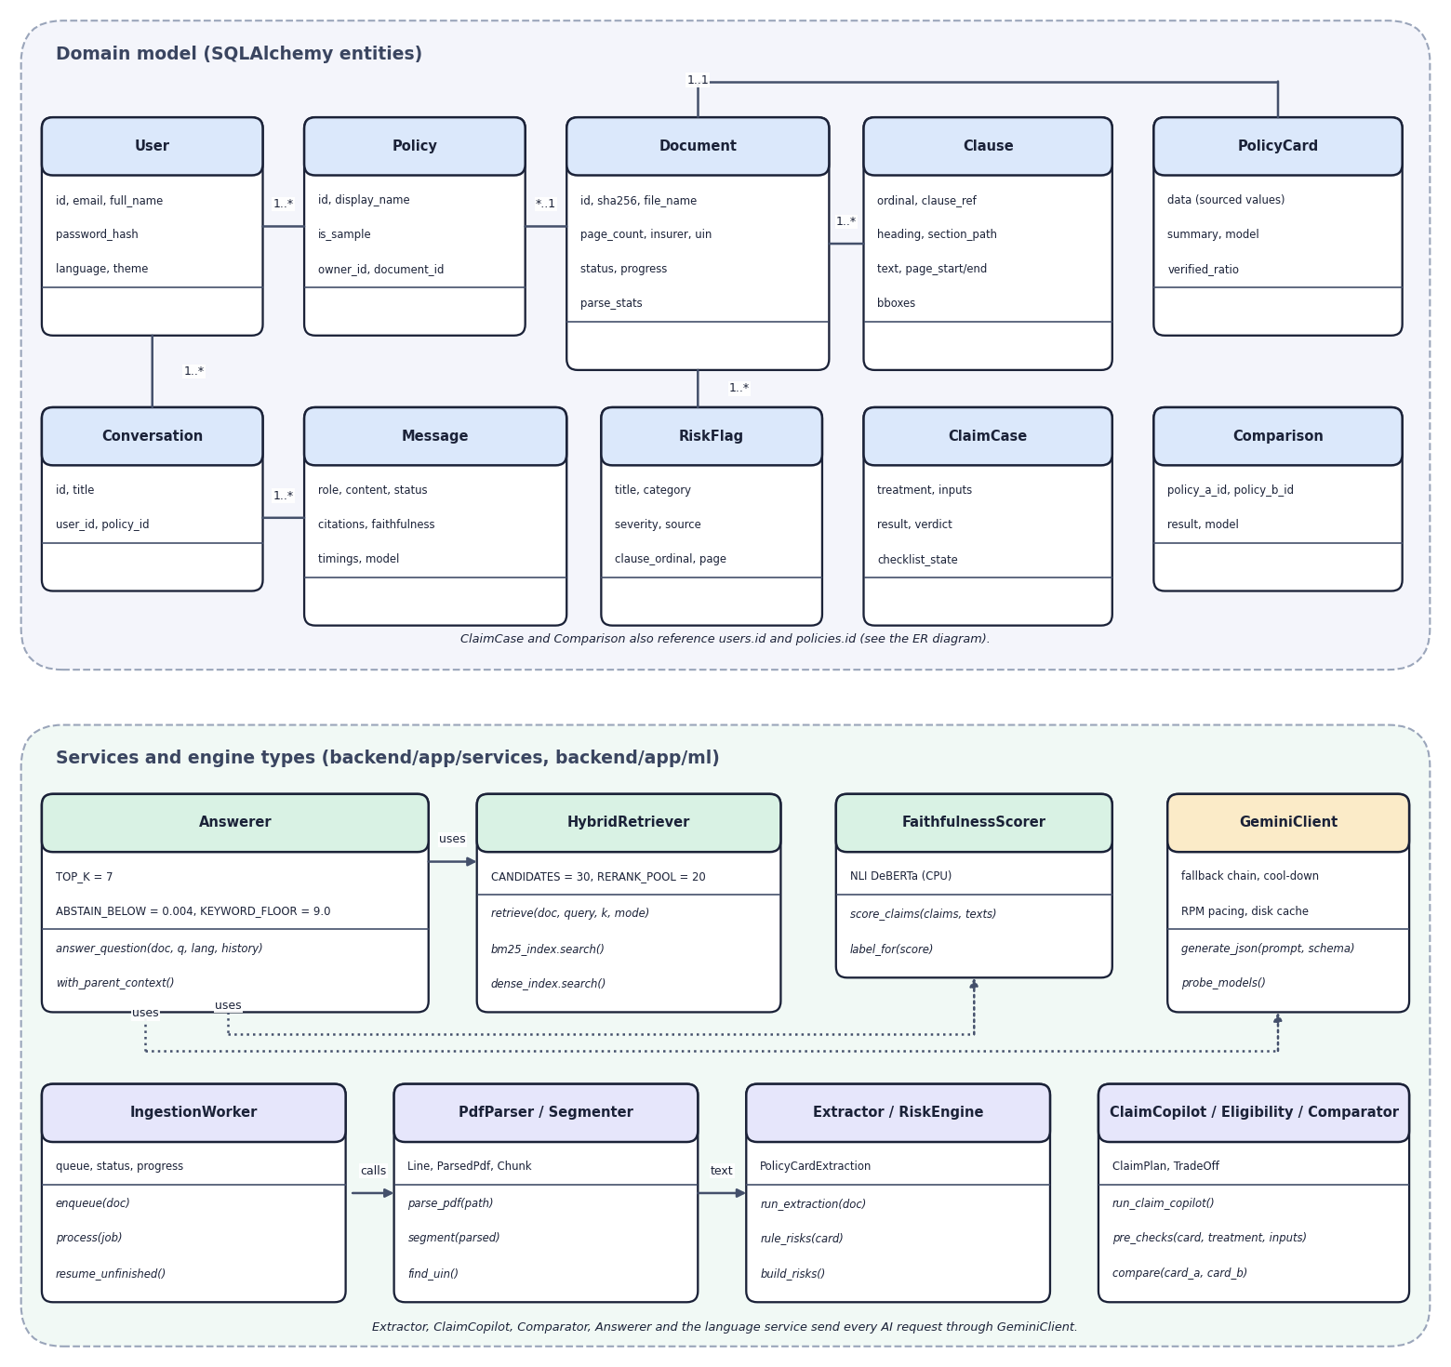
Fig. 5.7: UML class diagram
The upper part shows the domain entities with their main attributes and associations. The lower part shows the services and engine types with their key methods and constants: the answerer and its thresholds, the hybrid retriever, the faithfulness scorer, the Gemini client, the ingestion worker, the parser and segmenter, the extractor and risk engine, and the claim, eligibility and comparison services. Dotted arrows are dependencies; every AI request goes through the Gemini client.
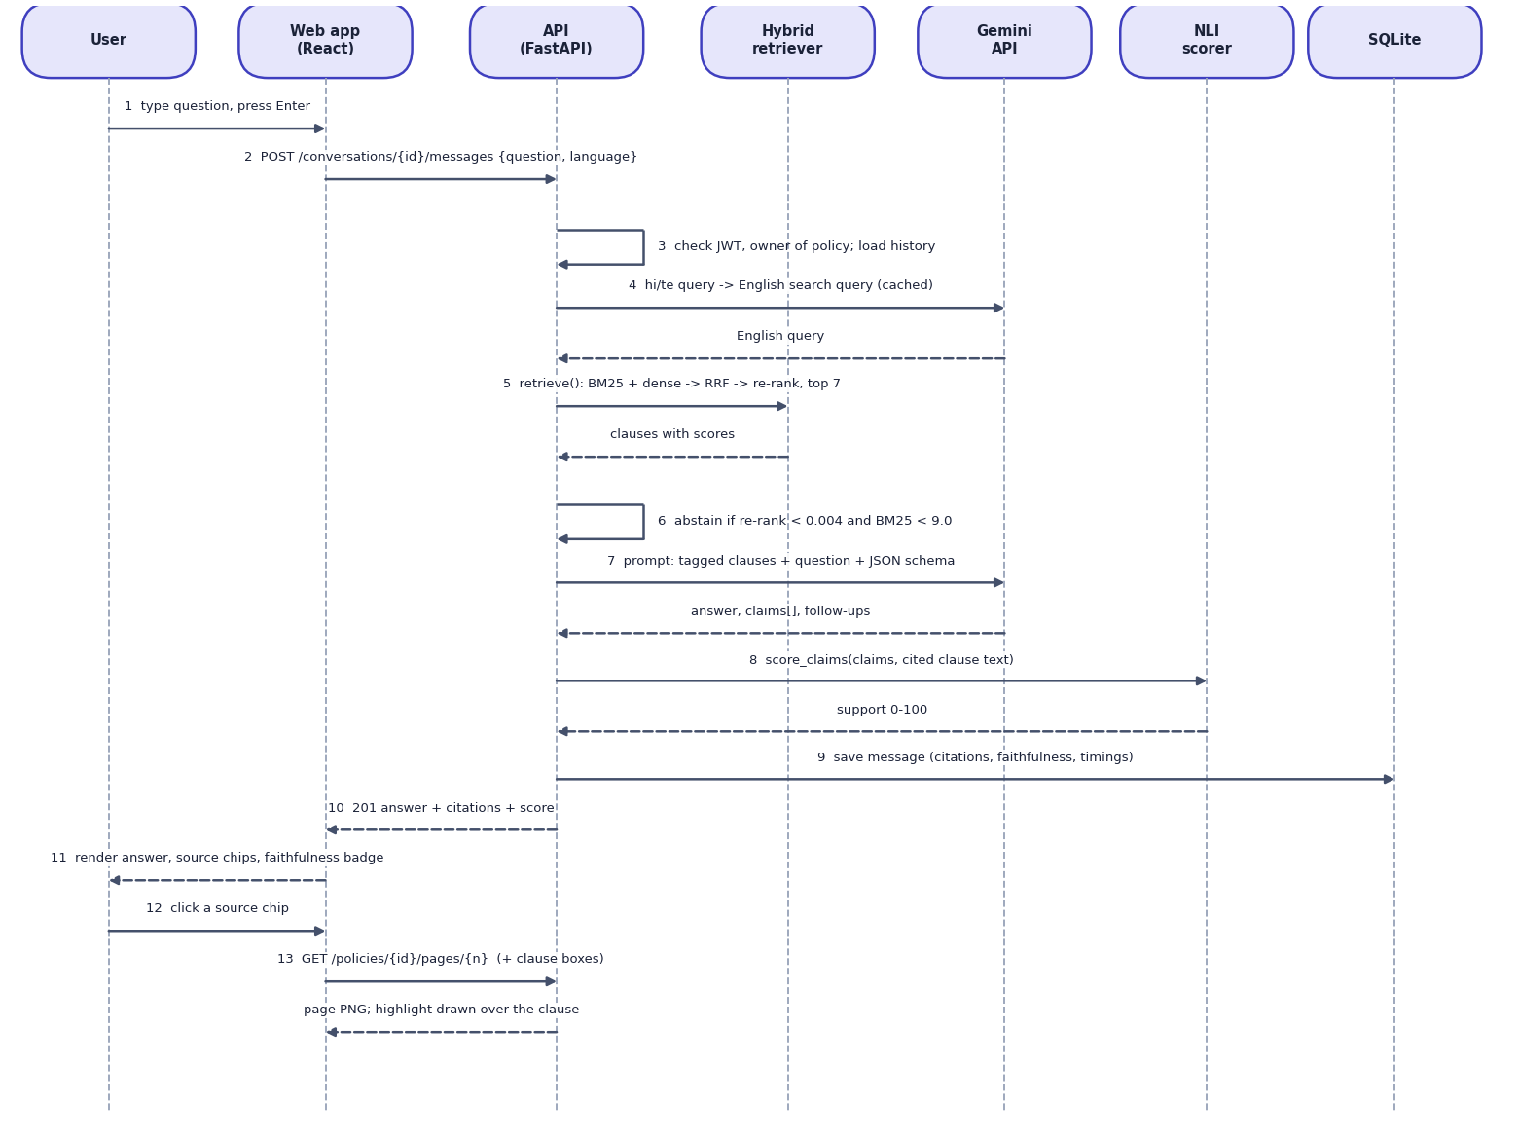
Fig. 5.8: Sequence diagram: asking a question and opening a citation
The sequence shows the main flow. The user submits a question; the web app posts it to the API, which checks the token and the ownership of the policy, translates the query if needed, retrieves the top clauses, and applies the abstention rule. If the model is called, the API sends the tagged clauses and the JSON schema, receives the answer and its claims, asks the NLI scorer for the support score, stores the message and returns the answer with its citations. When the user clicks a source chip the web app requests the page image, and the clause is highlighted on it.

5.5 Database Design
The database is SQLite, created by SQLAlchemy 2. Large structured results (citations, the Policy Card, claim results) are stored as JSON columns, because they are read and written whole and are never queried field by field.
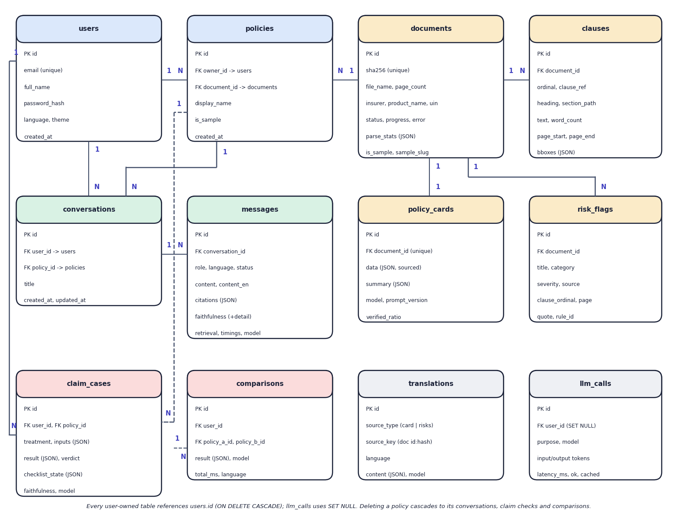
Fig. 5.9: Entity-relationship diagram (12 tables)
Twelve tables are created by SQLAlchemy in SQLite. A user owns policies; a policy points to a document, which is shared by content hash so that the same PDF is processed once even if two users upload it. A document has many clauses and risk flags and at most one Policy Card. Conversations belong to a user and a policy and contain messages. Claim cases and comparisons belong to a user and reference policies. Translations are cached by a key built from the document and a content hash, and the llm_calls table logs every model request.
Table 5.1: Database tables
Table | Purpose | Key columns
users | Accounts | email (unique), full_name, password_hash (bcrypt), language, theme
documents | One parsed PDF, shared by content hash | sha256 (unique), file_name, page_count, insurer, product_name, uin, status, progress, parse_stats
policies | A document in one user's library | owner_id, document_id, display_name, is_sample
clauses | Retrievable chunks of a document | document_id, ordinal, clause_ref, heading, section_path, text, page_start/end, bboxes (JSON), word_count
policy_cards | Extracted card (one per document) | document_id (unique), data (JSON with sources), summary, model, prompt_version, verified_ratio
risk_flags | Risk highlights | document_id, title, category, severity, explanation, clause_ordinal, page, quote, source (rule/ai), rule_id
conversations | A chat about one policy | user_id, policy_id, title
messages | Questions and answers | conversation_id, role, content, content_en, language, status, citations, faithfulness (+detail), retrieval, timings, model
claim_cases | Claim Copilot checks | user_id, policy_id, treatment, inputs, result, verdict, checklist_state, faithfulness
comparisons | Plan comparisons | user_id, policy_a_id, policy_b_id, result, model
translations | Cached Hindi/Telugu translations | source_type, source_key, language, content
llm_calls | Usage log of model requests | user_id (SET NULL), purpose, model, input/output tokens, latency_ms, ok, cached

Deleting a user cascades to their policies, conversations, claim cases and comparisons. A document row uses RESTRICT from policies, so a shared document is never removed while a policy still points to it.

5.6 Module Design
Table 5.2: Modules of PolicyLens
Module | Code | Responsibility
REST API | backend/app/api/ | Authentication, policies, chat, claims, comparisons, dashboard, evaluation; consistent {detail, code} errors
Ingestion worker | services/ingestion.py | Runs parse, index and extract in a background thread; resumes unfinished work after a restart
PDF parser | services/pdf_parser.py | Lines with page, position and font; removes running headers and footers; two-column reading order; joins letter-spaced headings; tables as rows; rejects scans
Segmenter | services/segmenter.py | Clause starts (4.2.1, Def. 5, Excl03, headings); IRDAI exclusion-code items as separate clauses; heading path; chunks of 12-380 words with highlight boxes
Hybrid retriever | ml/retrieval/ | BM25 with insurance synonyms; MiniLM + ChromaDB; Reciprocal Rank Fusion; cross-encoder re-rank
Extractor | services/extractor.py | One schema-constrained Gemini call; quote location to verify clause and page
Risk engine | services/risk_engine.py | Rules on extracted numbers plus AI findings, de-duplicated, with severity
Answerer | services/answerer.py | Retrieval, abstention rule, rule/table context, cited answer, tag filtering
Faithfulness scorer | ml/faithfulness.py | NLI support of each claim against sentence windows of its cited clauses, number check
Claim Copilot | services/claim_copilot.py, eligibility.py | Multi-query retrieval; calculated pre-checks and estimate; structured verdict, checklist and steps
Comparator | services/comparator.py | Field-by-field table with better markers and AI trade-offs citing both policies
Language service | services/language.py | Script detection; query translation; card and risk translation (cached)
Gemini client | services/gemini_client.py | JSON-schema calls, fallback chain, cool-down, RPM pacing, disk cache, usage log
Evaluation harness | ml/ | Retrieval, answer, claim and extraction evaluations; metrics, plots, run folders

5.7 User Interface Design
The web application has twelve pages: the landing page, sign-in and registration, the dashboard, My policies, the policy view (with tabs for the Policy Card, risks, the original document and clause search), Ask your policy, the four-step Claim Copilot wizard, Compare plans, Model performance, Settings and a not-found page. A sidebar on wide screens and a bottom bar on phones give access to the main sections.
Design decisions follow from the purpose of the product. Every fact carries a clause and page chip that opens the original page with the clause highlighted, so that trust never rests on the interface alone. Every answer shows its faithfulness badge, the model that produced it and its response time. Verdicts and severities use colour together with a text label, so the meaning does not depend on colour. The interface is available in light and dark themes, and honours the reduced-motion setting. Screens are shown in Chapter 8 and Appendix C.

CHAPTER 6
METHODOLOGY AND SOFTWARE IMPLEMENTATION

6.1 Overall Methodology
PolicyLens turns an uploaded policy wording into four things: a searchable set of clauses, a Policy Card, cited answers and a claim plan. The method has two phases. Preparation runs once per document in a background worker: validate, parse, segment, index, extract the Policy Card and compute risks. Use runs on demand: retrieve clauses, generate a grounded answer or plan, and check it. The central idea, taken from the extract-then-generate structure of the base paper [1], is that the language model never reads the policy from memory: it is given only the clauses that retrieval selected, tagged so that every statement can be traced back, and everything it returns is checked afterwards.
Table 6.1: Pipeline of PolicyLens
Step | Method | Output
1 Validate | PDF signature, size limit, encryption check, SHA-256 of the content | Accepted document or a coded error
2 Parse | PyMuPDF lines with position and font; header/footer removal; column order; table rows | Ordered lines per page
3 Segment | Rule-based clause starts and exclusion codes; heading path; 12-380 word chunks | Clauses with page and highlight boxes
4 Index | BM25 Okapi; MiniLM embeddings in ChromaDB | Keyword and vector indexes
5 Policy Card | One Gemini call with a JSON schema; quote location | Card with source and verified flag per value
6 Risks | Rules on card numbers plus AI findings; de-duplication | Risk highlights with severity
7 Retrieve | BM25 + dense, Reciprocal Rank Fusion, cross-encoder re-rank | Top-7 clauses
8 Generate | Gemini with tagged clauses and a JSON schema | Answer, claims, citations
9 Check | NLI entailment and number check; tag filtering | Faithfulness score 0-100
10 Claim / compare | Calculated eligibility rules + Gemini; field-by-field table + trade-offs | Verdict, checklist, estimate; comparison

6.2 Dataset
PolicyLens trains nothing, so it needs no training data. It works on whatever policy wording a user uploads. The repository ships two kinds of data: four sample policy wordings that make the product usable immediately, and an evaluation set written from them. Everything is small (about 4.7 MB), so the complete data is committed; no Kaggle or other dataset was used.
Table 6.2: The four sample policy wordings
Sample | Insurer | UIN | Pages | Words | Clauses | Layout | Parse (s)
Family Health Optima | Star Health and Allied Insurance | SHAHLIP26046V092526 | 44 | 17,135 | 219 | two-column A4 | 3.2
my: Optima Secure | HDFC ERGO General Insurance | HDFHLIP25041V062425 | 53 | 20,958 | 207 | single column, Def. N | 4.2
ReAssure 2.0 | Niva Bupa Health Insurance | NBHHLIP23169V012223 | 24 | 12,852 | 166 | single column, multi-level | 3.2
Care Supreme | Care Health Insurance | CHIHLIP23128V012223 | 45 | 22,056 | 209 | small-page two-column | 4.1
Total |  |  | 166 | 73,001 | 801

Source and licence. The wordings are public documents that Indian insurers publish for prospective customers, downloaded from each insurer's official website and stored unmodified. Copyright remains with the insurers; the files are included only as sample input for demonstration and testing, and PolicyLens is not affiliated with or endorsed by any of them. Why these four: they cover the layouts a real product meets: two-column A4 with letter-spaced headings, small-page two-column with separately printed clause numbers, single column with Def. N numbering and ruled tables, and single column with multi-level numbering.

6.2.1 Evaluation set
The evaluation set was written by hand from the four wordings; every expected answer was checked against the PDF and the evidence snippets are copied verbatim from the policy text.
Table 6.3: Evaluation set (data/eval/)
File | Items | Content
qa.jsonl | 57 | 51 answerable questions (Star 14, HDFC ERGO 13, Niva Bupa 12, Care 12 in total with 6 out-of-scope) in seven categories, each with evidence, pages and key facts
qa_multilingual.jsonl | 5 | Hindi or Telugu questions (and one English question answered in Hindi)
claims.jsonl | 14 | Claim scenarios with expected verdict: covered 5, partly covered 1, not covered 7, needs info 1
cards.json | 52 | Hand-checked Policy Card values: UIN, insurer, waiting periods, pre/post-hospitalisation, free-look, room rent, bonus, deadlines

Split. There is no training, so the whole set is a held-out test set. Nothing in it is used to fit any weight. It is used only to measure, and, as stated in the limitations, to choose a few pipeline settings and to find parser faults.
Question categories (51 answerable): benefits 15, waiting periods 14, claim process 8, exclusions 5, policy terms 4, room rent 3, sub-limits 2; plus 6 out-of-scope questions, for example "Does this policy insure my house against fire?".

6.3 Preprocessing: Parsing and Segmentation
Preprocessing is the most domain-specific part of the system, because policy wordings are laid out for printing, not for machines. Validation rejects files that are not PDFs (the content must start with %PDF), are larger than the configured limit (25 MB by default), are password-protected, have no pages or have no text layer, and reuses a document that was already processed (by SHA-256 of the content).
Parsing (pdf_parser.py) reads every line with its page, bounding box and font. It removes running headers and footers by finding lines that repeat across pages, detects two-column pages and restores the reading order, joins words that were letter-spaced in headings, merges fragments on the same baseline, and reads tables row by row. A page with no text layer raises an error that is shown as "no readable text layer".
Segmentation (segmenter.py) turns the ordered lines into clauses. A new clause starts at a printed number (4.2.1), a definition (Def. 5), an IRDAI exclusion code (Excl03), a section heading or a bold or Roman heading. A list item that carries an exclusion code becomes its own clause whether the code opens the item ("o. Maternity: Code - Excl18") or closes it. Each clause keeps its heading path (for example Exclusions > Standard exclusions), its page range and the rectangles of its lines, so that the viewer can highlight it. Long clauses are split into chunks of at most 380 words and fragments shorter than 12 words are merged. The four samples produced 801 clauses.
Why not fixed-size chunks? A citation must point at one rule. Fixed windows cut rules in half and join unrelated ones, and the survey [6] names segmentation as the bottleneck for multi-step questions. Clause-aware chunks also give the viewer exact highlight positions. The cost is that the segmenter is rule-based and had to be extended when a failure showed a new pattern, as the third evaluation run shows (Chapter 8).

6.4 Algorithm Choice and Justification
Table 6.4: Algorithm choices
Decision | Chosen | Alternatives considered | Why
Keyword retrieval | BM25 Okapi (k1 = 1.4, b = 0.7) with insurance synonyms | TF-IDF | Policies are full of exact terms ("cataract", "Excl02", "30 days"); BM25 alone put the right clause in the top 5 for every question
Dense retrieval | all-MiniLM-L6-v2 + ChromaDB (cosine) | Gemini embeddings | Runs locally in about 10 ms, no quota; helps with paraphrases ("glasses" vs "refractive error")
Combining retrievers | Reciprocal Rank Fusion, k = 60 | Weighted score sum | BM25 scores and cosine scores are not comparable; RRF needs no calibration [9]
Ranking | Cross-encoder ms-marco-MiniLM-L6-v2 | No re-ranking | Reads the question and clause together; lifted rank-1 accuracy from 69% to 80% and MRR from 0.795 to 0.897
Generator | Gemini, JSON schema, low thinking, temperature 0.2 | Fine-tuned small model | A whole wording fits in one request, structured output is checkable, Hindi/Telugu are good, free tier [17]
Faithfulness | nli-deberta-v3-xsmall + number check | LLM-as-judge | Independent of the writer, offline, no quota, deterministic [13], [14]
Claim rules | Calculated from the Policy Card | Ask the model | Months, ages and money must be exact; a failed waiting period must never read "covered"
Training | None | Fine-tune on policies | The task is reading, not predicting; no labelled public set; wordings change every year

The retrieval choices were made by measurement. The table and figure below repeat the ablation reported in Chapter 8: no single method was best on every measure, and the combination of fusion and re-ranking gave the best ranking.
Table 6.5: Retrieval ablation on 51 questions (run eval-20260922-0027)
Method | hit@1 | hit@3 | hit@5 | MRR@10 | recall@5
BM25 (keywords) | 0.647 | 0.922 | 1.000 | 0.779 | 1.000
Dense (MiniLM + Chroma) | 0.490 | 0.765 | 0.804 | 0.632 | 0.794
Hybrid (RRF) | 0.686 | 0.882 | 0.961 | 0.795 | 0.951
Hybrid + re-rank (used) | 0.804 | 0.980 | 1.000 | 0.897 | 0.990

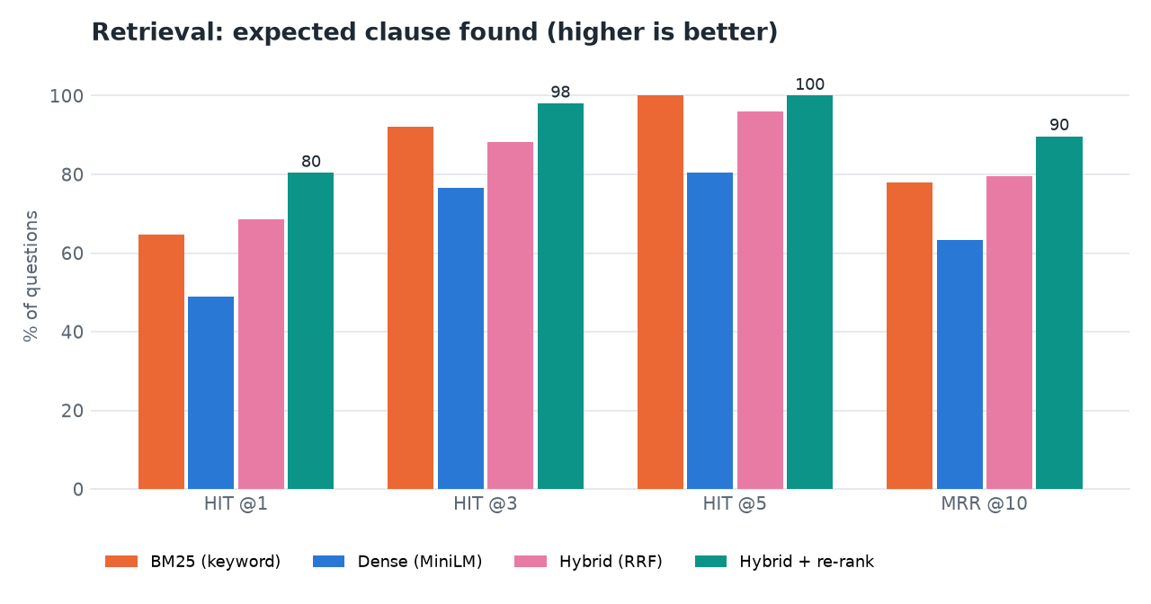
Fig. 6.1: Retrieval ablation: BM25, dense, hybrid and hybrid with re-rank

6.5 Mathematical Formulation
The formulas below are the ones implemented in the code; symbols are defined where they are used.

6.5.1 Keyword score (BM25 Okapi)
For a query Q with terms q and a clause D, score(D, Q) = sum over q of IDF(q) * f(q, D) * (k1 + 1) / (f(q, D) + k1 * (1 - b + b * |D| / avgdl)), where f(q, D) is the frequency of q in D, |D| the length of D in tokens, avgdl the average clause length, k1 = 1.4 and b = 0.7 [8]. Queries are expanded with an insurance synonym list.

6.5.2 Dense score
Each clause and each query is embedded by all-MiniLM-L6-v2 into a 384-dimensional vector; the dense score is the cosine similarity of the query vector and the clause vector, searched in ChromaDB [10], [11].

6.5.3 Reciprocal Rank Fusion
Given the rankings r (BM25 and dense, for each query variant), the fused score of a clause d is RRF(d) = sum over r of w_r / (k + rank_r(d)) with k = 60 and w_r = 1 [9]. The pool for re-ranking is the fused top 20 plus the top 8 of each retriever, so that a clause found by only one method (for example an exact keyword match) still reaches the re-ranker.

6.5.4 Re-ranking and the final score
The cross-encoder returns a relevance score s_ce(q, d) for each pool member. The final score is s(d) = s_ce(q, d) + 0.001 * 60 * RRF(d): the cross-encoder decides and the fused rank breaks ties. The best seven clauses are kept (TOP_K = 7).

6.5.5 Abstention rule
Let s_max be the best final score and b_max the best BM25 score among the retrieved clauses. PolicyLens answers "not covered in this policy" without calling the model if there are no clauses or if s_max < 0.004 and b_max < 9.0. Neither value separates answerable from unanswerable questions on its own (answerable questions had re-rank scores as low as 0.0020 and BM25 scores as low as 7.1; out-of-scope questions reached 0.0029 and 7.3), but the pair did on the evaluation set.

6.5.6 Faithfulness score
The model restates its answer as short claims c_1 ... c_n, each tagged with clauses. For each claim the cited clause text is cut into sentence and two-sentence windows w, the eight windows most similar to the claim are kept, and an NLI model gives the probability of entailment e(w, c) from the softmax of its logits. The support of a claim is support(c) = max( max_w e(w, c), 0.75 * overlap(c, text) if overlap(c, text) >= 0.8 ), multiplied by 0.5 if a number in the claim (dates and calendar years excluded) does not occur in the cited text. The answer's score is F = 100 * (1/n) * sum of support(c_i). The labels are well supported (F >= 80), partly supported (50 <= F < 80) and weakly supported (F < 50).

6.5.7 Claim estimate
For an estimated bill C, a deductible dd, a sub-limit cap L that names the treatment (if any) and an applicable co-payment of p percent, the payable amount is P = min(max(0, C - dd), L), the co-payment is P * p / 100, the insurer pays P - P * p / 100, and the policyholder pays C minus that amount. The estimate is before non-payable items and before any room-rent proportionate deduction, and says so.

6.5.8 Evaluation measures
hit@k is the share of questions with a relevant clause in the top k, where a clause is relevant if it contains one of the question's verbatim evidence snippets; MRR@10 is the mean of 1/rank of the first relevant clause (0 if none in the top 10); evidence recall@5 is the share of a question's evidence snippets found in the top 5. Answer accuracy is the share of answerable questions whose answer is not "not in policy" and contains every key fact; citation accuracy is the share whose cited clause contains the evidence or lies on an expected page; abstention accuracy is the share of out-of-scope questions declined. Claim accuracy is the share of scenarios with the expected verdict.

6.6 Models and Training Configuration
PolicyLens does not train a model. It combines pre-trained models, each chosen for one job, with rules that check their output. The tuned quantities are pipeline settings, each chosen by measurement on the evaluation set.
Table 6.6: Models used
Role | Model | Runs | Size
Generation, card, claim, comparison, translation | Gemini: gemini-3.8-flash, then gemini-3.6-flash, then gemini-3.5-flash-lite | Google API | -
Dense retrieval | sentence-transformers/all-MiniLM-L6-v2 (384-d) | CPU | 91.6 MB
Re-ranking | cross-encoder/ms-marco-MiniLM-L6-v2 | CPU | 91.8 MB
Faithfulness | cross-encoder/nli-deberta-v3-xsmall | CPU | 294.5 MB
Keyword retrieval | BM25 Okapi (rank-bm25), k1 = 1.4, b = 0.7 | CPU | -
Vector store | ChromaDB, persistent, cosine | CPU | -

Table 6.7: Pipeline settings
Setting | Value | Chosen because
Clause size | 12-380 words | A citation points at one rule; long clauses are split at sub-items
Candidates per retriever | 30 | Lets fusion see clauses ranked well by only one retriever, keeping search under 20 ms
Fusion | RRF, k = 60 | Standard; no score scaling needed
Re-rank pool | fused top 20 + top 8 of each retriever | The extra 8 recovered questions where one retriever alone found the clause
Clauses given to Gemini | top 7 + up to 4 governing rules or governed tables | Waiting-period lists and sub-limit tables are separate chunks from the rule that gives them meaning
Abstention | re-rank < 0.004 and best BM25 < 9.0 | Separates the 6 out-of-scope from the 51 answerable questions
Temperature | 0.2 (answers), 0.1 (Policy Card) | Stable, repeatable wording
Gemini fallback | 3 models, 10-minute cool-down, RPM 10 | Free-tier quota and overload

Why there is no training. The task is reading, not predicting; every answer must come from the user's own wording. There is no public set of policy questions with clause-level answers for Indian health policies, so the hand-built set is small and is used only to measure. And wordings change every year, whereas retrieval over the uploaded document keeps working without retraining. Consequently there are no training curves, no epochs and no learning rate; the corresponding evidence is the evaluation in Chapter 8.

6.7 Application Architecture
The backend is organised in layers: routers in api/ validate input and enforce ownership; services in services/ and ml/ hold the logic; models in models/ map to tables; schemas in schemas/ define request and response types with Pydantic v2; core/ holds configuration, the database session, error types, logging and security. A background thread (the ingestion worker) takes jobs from a queue so that upload returns immediately; the web app polls /policies/{id}/status every two seconds until the status is ready.
The frontend is a single-page React application in TypeScript. React Router provides the routes with lazy-loaded pages; TanStack Query caches server data and drives the polling; Axios attaches the JWT; Tailwind CSS and shadcn/ui components provide the styling; Recharts draws the dashboard and the Model performance charts. The viewer shows page images that the backend renders with the highlight rectangles supplied by the parser, so the browser needs no PDF library.

6.8 Key Code Walkthroughs

6.8.1 Reciprocal Rank Fusion
The fusion function is eleven lines. It adds 1/(k + rank) for each list in which an item appears and sorts by the total.
Listing: reciprocal_rank_fusion() in ml/retrieval/fusion.py
def reciprocal_rank_fusion(rankings: Sequence[Sequence[Hashable]], k: int = 60,
weights: Sequence[float] | None = None) -> list[tuple[Hashable, float]]:
weights = weights or [1.0] * len(rankings)
scores: dict[Hashable, float] = {}
for ranking, weight in zip(rankings, weights):
for rank, item in enumerate(ranking, start=1):
scores[item] = scores.get(item, 0.0) + weight / (k + rank)
return sorted(scores.items(), key=lambda kv: kv[1], reverse=True)

6.8.2 The abstention rule and the call to the model
In answer_question(), after retrieval, the answerer checks the two scores. Only if the rule does not fire is the model called.
Listing: Abstention check in services/answerer.py
if not retrieved or (result.best_score < ABSTAIN_BELOW and best_keyword < KEYWORD_FLOOR):
timings["total_ms"] = round((time.perf_counter() - t0) * 1000)
text = NOT_IN_POLICY.get(language, NOT_IN_POLICY["en"])
return AnswerResult("not_in_policy", text, NOT_IN_POLICY["en"], [], score_claims([], {}), [],
retrieval_info, timings, None, language, {"abstained_before_llm": True})

6.8.3 Dropping citations that were not retrieved
The model can only cite clauses it was given. Any tag that does not belong to a retrieved clause is removed from the text, and unknown ordinals are discarded from the claims, so a citation can never point to something the system did not show.
Listing: Citation filtering in services/answerer.py
# Keep only citations to clauses we actually retrieved.
def clean(text: str) -> str:
text = normalise_tags(text)
return _TAG.sub(lambda m: m.group(0) if int(m.group(1)) in by_ordinal else "", text).replace(" ", " ")

answer, answer_en = clean(out.answer), clean(out.answer_en)
claims: list[ClaimInput] = []
for c in out.claims:
ordinals = [int(m) for tag in c.clauses for m in re.findall(r"\d+", tag) if int(m) in by_ordinal]
claims.append(ClaimInput(c.text_en, ordinals))
cited = sorted({int(m) for m in _TAG.findall(answer_en + " " + answer)} | {o for c in claims for o in c.clause_ordinals})
citations = [citation_for(by_ordinal[o], [c.text for c in claims if o in c.clause_ordinals] or [answer_en])
for o in cited if o in by_ordinal]

6.8.4 Faithfulness: support of a claim
The support of each claim is the best entailment over the evidence windows, with a lexical backstop for near-verbatim restatements and a penalty when a number is not found in the cited text.
Listing: Claim support in ml/faithfulness.py
claim_numbers = _numbers(claim.text)
evidence_numbers = _numbers(evidence_text)
numbers_ok = claim_numbers.issubset(evidence_numbers) or not claim_numbers
# Lexical backstop: a near-verbatim restatement of the clause is supported even when the
# small NLI model is unsure about long legal sentences.
overlap = token_overlap(claim.text, evidence_text)
support = max(entail, 0.75 * overlap if overlap >= 0.8 else 0.0)
if not numbers_ok:
support *= 0.5

6.8.5 Calculated claim estimate
The estimate is plain arithmetic on the Policy Card values, not model output.
Listing: Cost estimate in services/eligibility.py
cost = inputs.get("estimated_cost")
if isinstance(cost, (int, float)) and cost > 0:
deductible = card.get("deductible") or {}
ded = deductible.get("number") if deductible.get("found") and deductible.get("unit") == "INR" else 0
payable = max(0.0, float(cost) - float(ded or 0))
cap_note = None
if sub_hit and sub_hit.get("unit") == "INR" and isinstance(sub_hit.get("number"), (int, float)):
if payable > sub_hit["number"]:
payable = float(sub_hit["number"])
cap_note = f"capped by the sub-limit ({sub_hit.get('value')})"
copay_amount = payable * (copay_pct or 0) / 100
payable -= copay_amount

6.9 Implementation Decisions and Reasoning
Table 6.8: Implementation decisions
Decision | Why
Local embeddings, re-ranker and NLI model | No API quota, deterministic, offline; the faithfulness check is independent of the model that wrote the answer
Hybrid retrieval with a pool that always includes each retriever's top 8 | Keyword search is precise for exclusion codes and medical terms; embeddings handle paraphrase; the re-ranker puts the best clause first
Schema-constrained JSON from Gemini | Predictable structure, no fragile text parsing; every value carries its clause tag and quote
Quote verification of Policy Card values | A value whose quote cannot be found in the text is shown as unverified rather than silently trusted
Clause-aware segmentation instead of fixed windows | A citation must point at one rule and be highlighted on the original page
Rules calculate waiting periods, co-payments and the estimate | Months, ages and money must be exact; the model cannot overrule a failed waiting period
Abstain on two scores, not one | Neither the re-rank score nor the BM25 score separates answerable from out-of-scope questions alone
Server-rendered page images for the viewer | Exact highlight positions from the parser and no PDF library in the browser
Fallback chain and cool-down for Gemini | Free-tier models can be overloaded or out of quota; the app keeps answering and shows which model answered
Response cache keyed by content hash | Re-running the evaluation or re-importing a known PDF does not spend quota twice; a button bypasses the cache
Documents shared by SHA-256 | The same PDF is processed once even if two users upload it
SQLite and ChromaDB, no server to run | One-machine installation by a student or a policyholder
Background ingestion worker with resume | Upload returns at once; unfinished work is resumed after a restart
No training | The task is reading, not predicting; no labelled public data; wordings change every year

6.10 API Design
The API is REST over JSON under /api, with 42 route handlers. Interactive documentation (Swagger UI) is served at /docs. All endpoints except health, registration, login and the evaluation endpoints require Authorization: Bearer <token>. Errors are always {"detail": "readable message", "code": "machine_code"}.
Table 6.9: API endpoints
Group | Endpoints
Health | GET /health
Auth and user | POST /auth/register, POST /auth/login, GET /auth/me, PATCH /users/me, POST /users/me/password, GET /users/languages
Policies | GET/POST /policies, POST /policies/samples, GET/PATCH/DELETE /policies/{id}, GET /policies/{id}/status, /file, /pages, /pages/{n}, /clauses, /clauses/{ordinal}, /card, /risks, POST /policies/{id}/extract, POST /policies/{id}/search
Chat | POST/GET /conversations, GET/DELETE /conversations/{id}, POST /conversations/{id}/messages
Claims | POST/GET /claims, GET/DELETE /claims/{id}, PATCH /claims/{id}/checklist
Compare | POST/GET /comparisons, GET/DELETE /comparisons/{id}
Dashboard and evaluation | GET /dashboard/summary; GET /evaluation/latest, /evaluation/runs, /evaluation/runs/{run}, /evaluation/runs/{run}/plots/{file}

Example: ask a question. POST /api/conversations/{id}/messages with the body below returns the stored question and the answer with its citations, faithfulness score, retrieval trace and timings; the status is answered, partial or not_in_policy.
Listing: Request body
{"question": "Is cataract surgery covered and after how long?", "language": "en"}

Example: Claim Copilot. POST /api/claims needs only policy_id and treatment; the other fields sharpen the result.
Listing: Request body
{"policy_id": 4, "treatment": "Knee replacement", "hospitalization_type": "planned", "claim_mode": "cashless",
"policy_start_date": "2023-10-01", "insured_age": 64, "pre_existing": "no", "estimated_cost": 350000, "language": "en"}

The response contains the verdict (covered, partly_covered, not_covered, needs_info), the reasons with their clauses, the pre-checks (pass, fail, warning, unknown), the document checklist, the claim steps, the estimate and the timings.

6.11 Security and Error Handling
- Passwords are hashed with bcrypt; a password needs at least eight characters with a letter and a number; login is case-insensitive on the e-mail address.
- Tokens. A signed JWT (HS256, PyJWT) with a 24-hour expiry (JWT_EXPIRE_MINUTES, default 1440). The signing secret is generated by setup.bat in .env; if it is missing the code falls back to a development default, which must be replaced for any shared deployment.
- Ownership. Every policy, conversation, claim check and comparison is tied to its owner and returned only to that user; this is covered by test_policy_flow.py.
- Uploads are validated before they are stored: PDF signature, size limit (25 MB by default), encryption, page count and duplicate hash.
- Secrets (the Gemini key, the JWT secret) live in .env, which is excluded from version control; the API never returns them.
- CORS is limited to the configured origins (the web app on port 5101).
- Error handling. Application errors carry a code and a readable message; validation errors return 422 with details; unexpected errors are logged and returned as a generic message. AI errors are mapped to ai_quota (429), ai_unavailable (503) or ai_not_configured (503), and the web app turns them into plain messages.
- Model-output safety. Output is constrained by a JSON schema, citations are filtered to retrieved clauses, and rule-based checks cannot be overruled by the model. Text inside an uploaded PDF is passed to the model, so a deliberately crafted document could try to instruct it; this was not tested (see Chapter 7).

6.12 Installation and Execution
The full guide is docs/03_HOW_TO_RUN.md and Appendix B. In short, on Windows 10 or 11 with Python 3.11 and Node.js LTS:
Table 6.10: Installation and execution
Step | Command | What it does
1 | setup.bat | Checks Python and Node, creates the virtual environment, installs packages, creates .env, downloads the three local models (about 480 MB), installs the web packages, creates the database, the demo account and the four sample policies, and builds their index
2 | edit .env | Paste the free Gemini API key after GEMINI_API_KEY=
3 | run.bat | Starts the API (port 8101) and the web app (port 5101) and opens http://localhost:5101
4 | demo@policylens.app / Demo@12345 | Sign in to the demo account with four ready sample policies
5 | stop.bat | Stops both servers
6 | venv\Scripts\python ml\run_all.py | Re-runs the full evaluation (about 10 minutes, about 80 Gemini requests)

CHAPTER 7
SYSTEM TESTING

7.1 Testing Strategy
PolicyLens is checked at four levels: automated backend tests, a production build of the web application, a measured evaluation of the AI pipeline, and a scripted end-to-end walk-through of the demo scenario in a real browser. The levels answer different questions. The backend tests ask whether the code behaves as designed, deterministically and without the network. The build asks whether the web application type-checks and bundles. The evaluation asks whether the AI pipeline is accurate. The walk-through asks whether a person can use the product from start to finish.
Because the language model is an external service whose output varies, the automated tests never call it. Where an AI step is needed, a stand-in returns a schema-valid response, so that the rest of the pipeline (retrieval, citation filtering, faithfulness scoring, persistence) runs for real. The tests use an isolated temporary data folder, a synthetic two-page policy generated deterministically by tests/fixtures.py, and the real local models.

7.2 Unit Testing
Table 7.1: Unit tests
Test file | Tests | What it checks
test_units.py | 6 | Reciprocal Rank Fusion; tokeniser and synonym expansion; fuzzy quote matching; risk rules and de-duplication of AI findings; waiting-period checks; co-payment and cost estimate with a sub-limit
test_faithfulness.py | 3 | Supported claims score high; wrong numbers and uncited claims score low; no claims means no score
test_parser.py | 3 | Header removal, clause references (2.1, 3.1, Excl01, Excl02), pages, highlight boxes, heading path, UIN detection; exclusion-coded list items become clauses whether the code opens, closes or wraps onto the next line; scanned PDFs rejected

These twelve tests cover the pure logic of the system: ranking, parsing, scoring and the rules that must be exact. They run in a few seconds and caught real faults while the parser was extended for exclusion codes.

7.3 Integration Testing
Table 7.2: Integration tests
Test file | Tests | What it checks
test_auth.py | 6 | Health endpoint; register, duplicate e-mail, case-insensitive login, bad credentials, missing and invalid token; password rules; language and password changes; the demo account is seeded
test_policy_flow.py | 7 | Upload validation; full processing of an uploaded PDF; clause list; hybrid search in all four modes returns the cataract clause first; page image and original PDF; owner-only access; chat answer with citation filtering (a citation to a clause that was not retrieved is removed) and faithfulness; abstention; Claim Copilot with checklist ticks; dashboard; delete

Table 7.3: Backend test inventory (pytest, 15 October 2026)
File | Tests
test_auth.py | 6
test_faithfulness.py | 3
test_parser.py | 3
test_policy_flow.py | 7
test_units.py | 6
Total | 25 passed (about 15 s)

The web application is checked by npm run build, which runs the TypeScript compiler in strict mode and the Vite production build. On 15 October 2026 it completed with no type errors.

7.4 Functional Testing
The functional tests follow the demo scenario of the project, run against the live application with live Gemini calls on 15 October 2026 using the demo account and the four sample policies. The observed results are those recorded during the run and shown in the screenshots of Chapter 8.
Table 7.4: Functional test cases
No. | Test | Expected | Observed
F1 | Sign in with the demo account | Dashboard opens | Pass
F2 | Open My policies | Four ready sample policies | Pass: four policies, all ready
F3 | Open the Policy Card of the Star Health policy | Values with clause and page chips; verified share shown | Pass: 91% of values verified in the text
F4 | Ask "Is cataract surgery covered and after how long?" | Covered after the 24-month specified-disease wait; citations; faithfulness | Pass: answered, citations Clause 2 p. 10 and Clause Excl02 p. 28, faithfulness 88, 6.2 s
F5 | Ask "Does this policy insure my house against fire?" | Declines without a model call | Pass: "Not covered in this policy document", 1.7 s
F6 | Ask a room-rent question in Hindi (HDFC ERGO) | Hindi answer with citations; Show in English | Pass: answered in Hindi with 4 citations, faithfulness 91.5
F7 | Claim Copilot: knee replacement, cover from 2023-10-01, age 64, Rs. 3,50,000 | Partly covered: waiting periods complete, 20% co-payment | Pass: partly covered; 36 months of cover; estimate shown
F8 | Claim Copilot: same treatment, cover from 2026-04-01, age 45 | Not covered: waiting period incomplete | Pass: not covered
F9 | Compare Star Health with HDFC ERGO Optima Secure | Side-by-side table, trade-offs, choose-A/B-if | Pass: 21-row table
F10 | Open a cited clause | Original page with the clause highlighted | Pass
F11 | Switch the card to Telugu | Translated card | Pass with a defect: one line contains Bengali/Gurmukhi script
F12 | Dark theme and 390 px phone layout | Readable, no horizontal scroll | Pass (captured)

7.5 Security Testing
Security testing in this project is limited to the automated tests and the code review of the validation paths. The tests confirm that a missing or invalid token is refused, that passwords below the rule are rejected, that a duplicate e-mail is refused, that login with a wrong password fails with a generic message, and that one user cannot read another user's policy, conversation, claim check or comparison. Upload validation (PDF signature, size, encryption, empty or damaged files) is covered by the upload tests. Not tested: penetration testing, rate limiting, HTTPS deployment, and resistance to a PDF that contains instructions aimed at the language model (prompt injection). The mitigations that exist (schema-constrained output, citation filtering, calculated rules that the model cannot overrule) were not attacked.

7.6 Validation and Edge Cases
Table 7.5: Validation and edge cases
Case | Behaviour
Scanned PDF without a text layer | Rejected with "no readable text layer" (test_parser.py)
Not a PDF, oversize, encrypted, empty or damaged file | Rejected with a coded message (not_pdf, too_large, encrypted, bad_pdf)
Same PDF uploaded twice | Processed once (SHA-256); the second upload reuses the document or returns duplicate_policy
Question outside the policy | "Not covered in this policy" without a model call; 6 of 6 out-of-scope questions
Model cites a clause that was not retrieved | The tag is removed (test_policy_flow.py)
Gemini model out of quota or overloaded | Falls back to the next model; the answer shows which model produced it
No Gemini key | Upload, search and the viewer work; the Policy Card explains how to add a key
Claim for a treatment in the waiting period | Calculated check fails; the verdict can never be "covered"
Plan with several variants (HDFC ERGO) | Known limitation: the card reports the Optima Secure figure; variant selection not implemented
Hindi or Telugu question | Translated for search; the answer is in the requested script (5 of 5)

7.7 Performance Testing
Performance was measured on the development machine (12-thread Intel Core i5-12500, 15.7 GB RAM, no GPU) with live Gemini calls. The figures come from the evaluation run eval-20260922-0027 and from the live run of 15 October 2026.
Table 7.6: Performance measurements
Measurement | Result
Retrieval, 51 queries, median (p95) | BM25 1.1 ms (32.2); dense 10.7 ms (15.7); hybrid 11.0 ms (16.6); hybrid + re-rank 878.9 ms (995.5)
Answer, all 62 questions, median / p95 / max | 4.34 s / 18.18 s / 24.77 s
Answer stages, median (p95) | retrieval 0.86 s (1.83); Gemini 2.53 s (17.16); faithfulness 0.83 s (1.72)
Claim check, 4 timed live calls | mean 13.8 s, median 12.3 s, p95 22.8 s
Parsing a policy wording | 3.2 s (24 pages) to 4.2 s (53 pages)
Live run, 15 October 2026 | cataract answer 6.2 s; co-payment answer 5.6 s; abstained question 1.7 s; Hindi answer 10.0 s; claim check 14.2 s
Web build | Vite production build 7.6 s; type check passes

The long tail of the answer time comes from the fallback chain: when the primary models report quota or overload, the request moves to the next model and that wait is included in the figure. Not measured: concurrent users, memory use under load, other hardware.

7.8 User Acceptance Testing
No user-acceptance test with real policyholders was carried out. The usability claims in this report rest on the scripted demo scenario, on captures of every screen at 1440 px and 390 px, and on the project's own checks (no horizontal scrolling at phone width, no console errors, reduced-motion support). A pilot in which policyholders upload their own wordings and rate the answers is the most important piece of future work.

7.9 Limits of the Testing Done
- The 25 automated tests use a synthetic two-page policy and a stand-in for the language model; they do not test answer quality, which is measured separately.
- The evaluation set is small (51 answerable questions, 14 claim scenarios, 52 card values, four policies) and was used to tune the abstention thresholds and parser, so its results are optimistic.
- All results come from the smallest model in the fallback chain, gemini-3.5-flash-lite, because the larger models' free quota was exhausted; results with the larger models were not measured.
- No load, concurrency, security or penetration testing; one machine; one browser family (Chrome).
- No user study with real policyholders.

CHAPTER 8
RESULTS AND OUTPUT SCREENS

8.1 Output Screens
Every screen below is a real capture of PolicyLens running with real data on 15 October 2026: the four sample policy wordings, answers produced by live Gemini calls, and claim checks and a comparison created through the application. The captures are 1440 by 900 pixels unless stated.
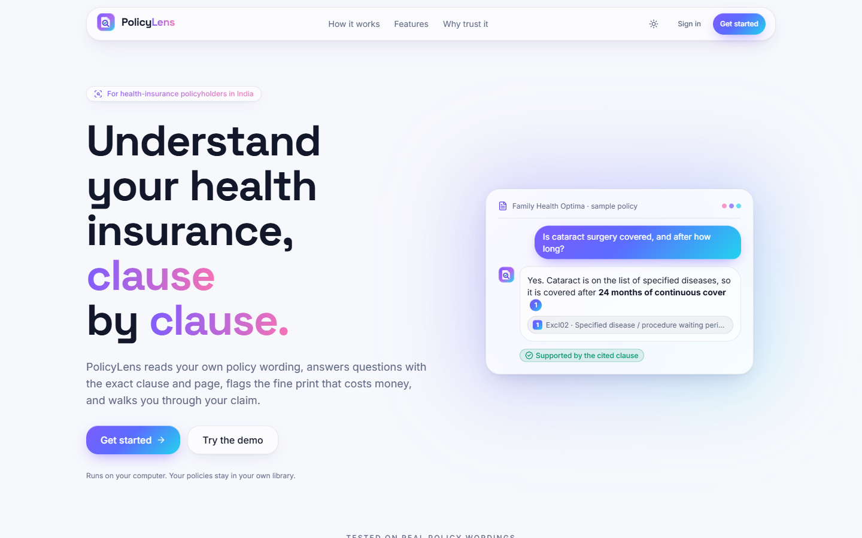
Fig. 8.1: Landing page
The public home page: the headline "Understand your health insurance, clause by clause", a sample question about cataract surgery answered with a cited clause and the badge "Supported by the cited clause", and the buttons Get started and Try the demo.
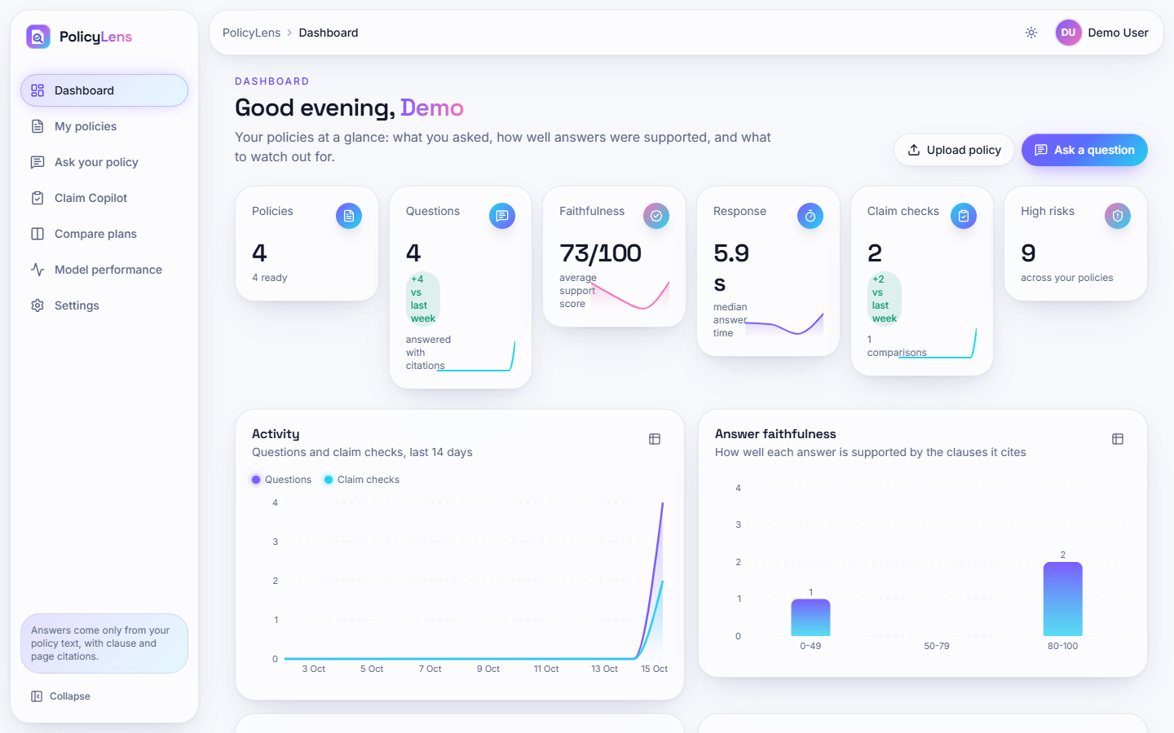
Fig. 8.2: Dashboard
Counters for policies (4 ready), questions asked (4), average faithfulness (73/100 over the three answers of this live session that were scored), median response time (5.9 s), claim checks (2) and high risks (9), the 14-day activity chart, and the faithfulness distribution of the answers asked so far.
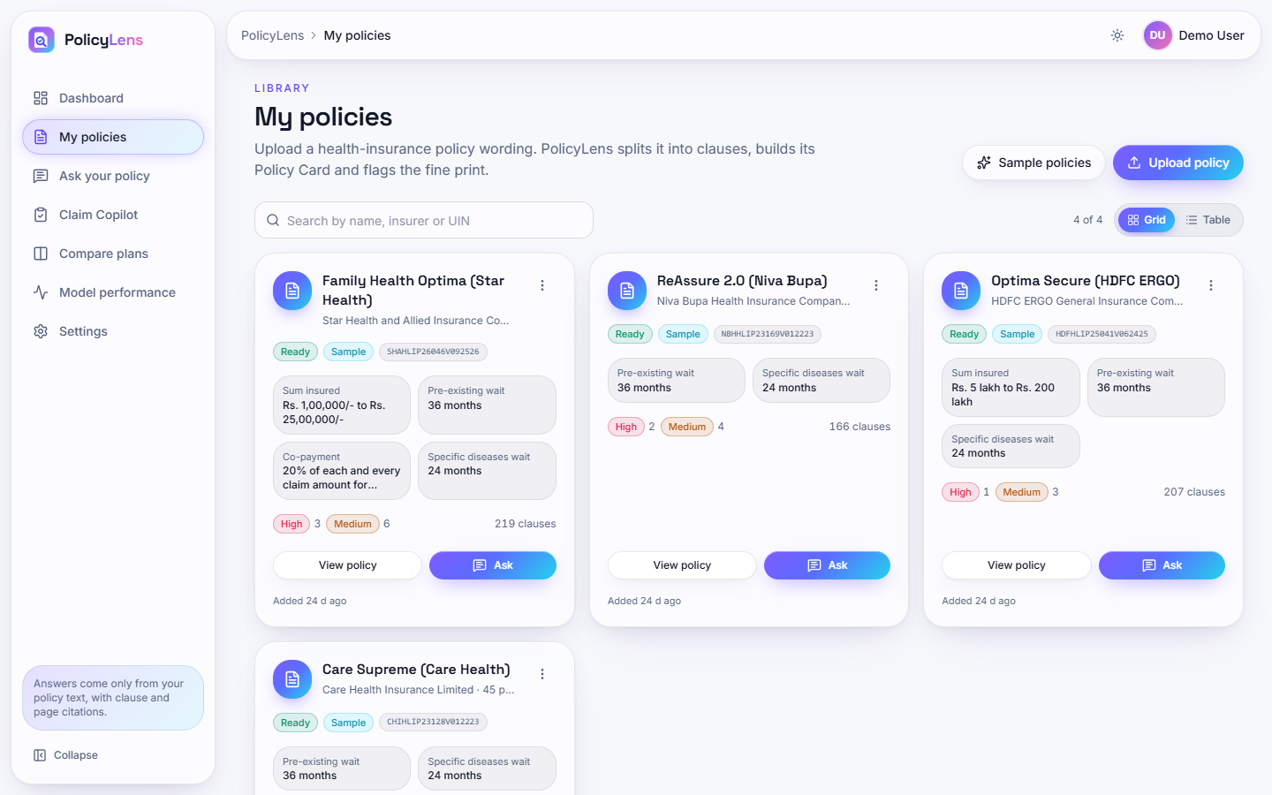
Fig. 8.3: My policies
The library with the four sample policies, each tile showing its status, UIN, key values from the Policy Card (sum insured, pre-existing and specific-disease waiting periods, co-payment), the number of high and medium risks and the number of clauses.
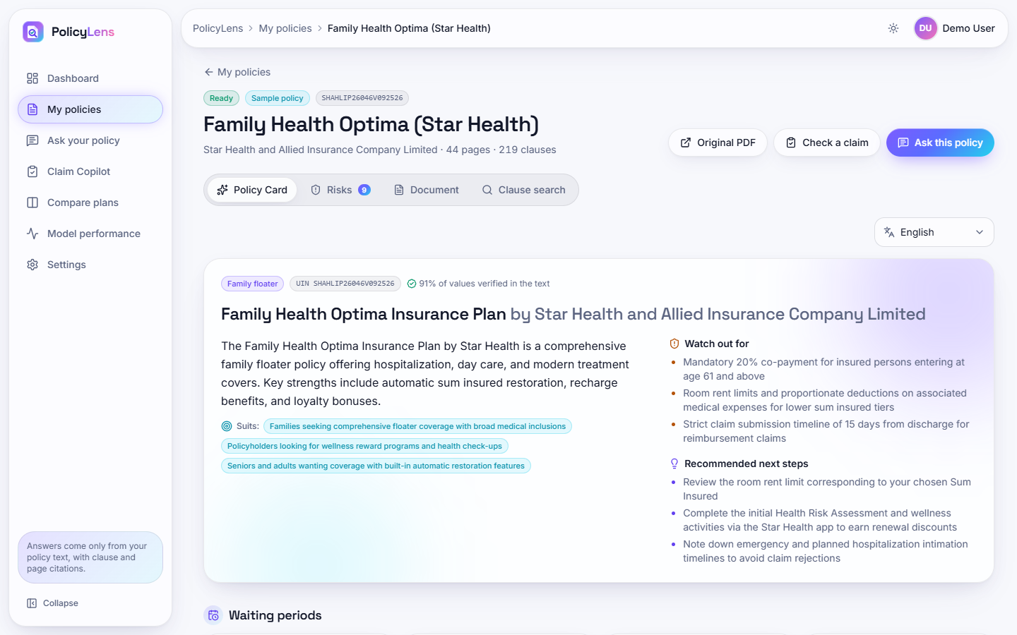
Fig. 8.4: Policy Card
The Star Health Family Health Optima card: type, UIN, the share of values verified in the text (91%), a plain-language overview, the people it suits, what to watch out for and recommended next steps; the waiting periods and other values follow below, each with a clause and page chip.
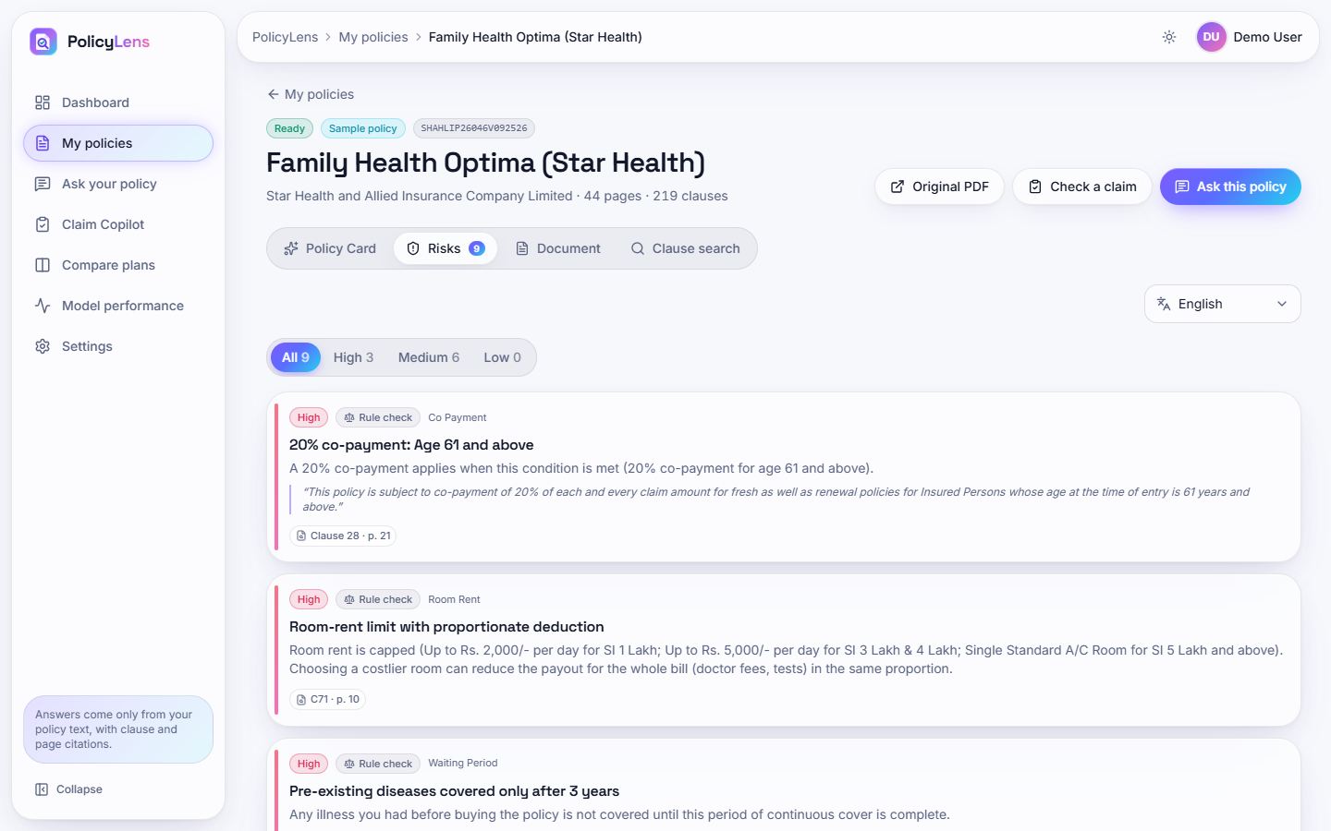
Fig. 8.5: Risk highlights
Nine risks for the Star Health wording (3 high, 6 medium), each with its category, the source (rule check or AI), an explanation, the quoted wording and the clause and page chip: the 20% co-payment from age 61, the room-rent limit with proportionate deduction and the three-year pre-existing-disease wait.
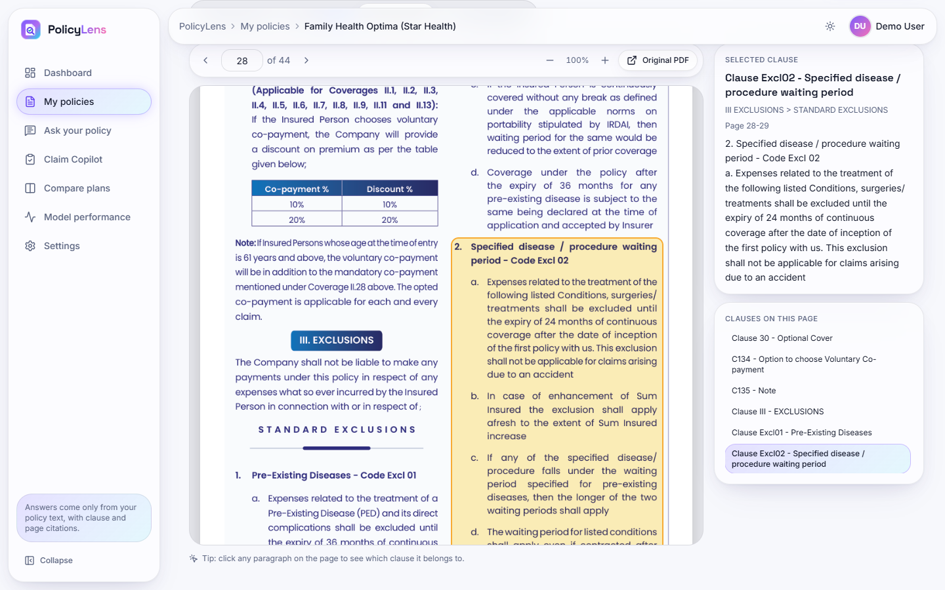
Fig. 8.6: Original document with the cited clause highlighted
Page 28 of the original wording with the clause Excl02 (specified disease and procedure waiting period) outlined in yellow; the side panel shows the selected clause, its section path and text, and the other clauses on the page.
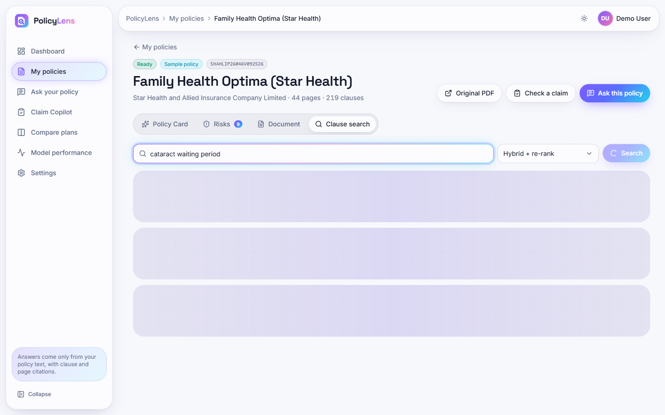
Fig. 8.7: Clause search
Hybrid search with re-ranking for "cataract waiting period": eight clauses, the timings of each stage (BM25 2 ms, dense 20 ms, fusion 0 ms, re-rank 1.0 s), and for each result its keyword rank, semantic rank and relevance with the matching words highlighted.
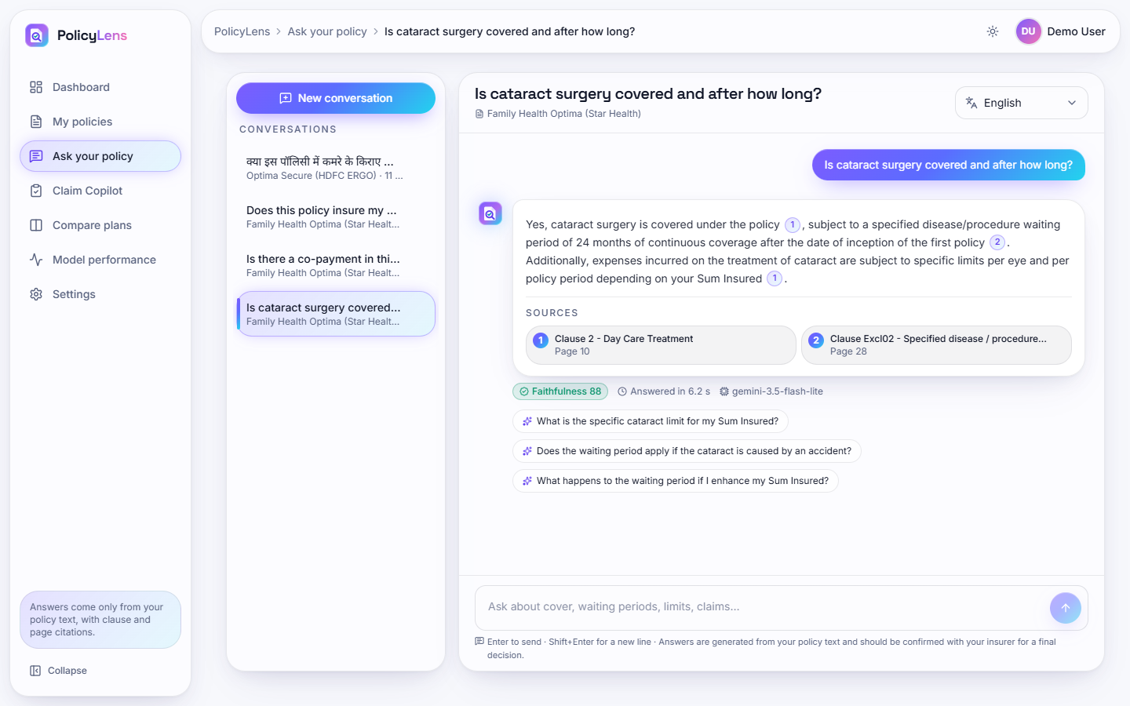
Fig. 8.8: Cited answer
The answer to "Is cataract surgery covered and after how long?": covered after a 24-month specified-disease waiting period, with per-eye limits; two source chips (Clause 2, page 10; Clause Excl02, page 28), the badge Faithfulness 88, the response time 6.2 s, the model used and three follow-up questions.
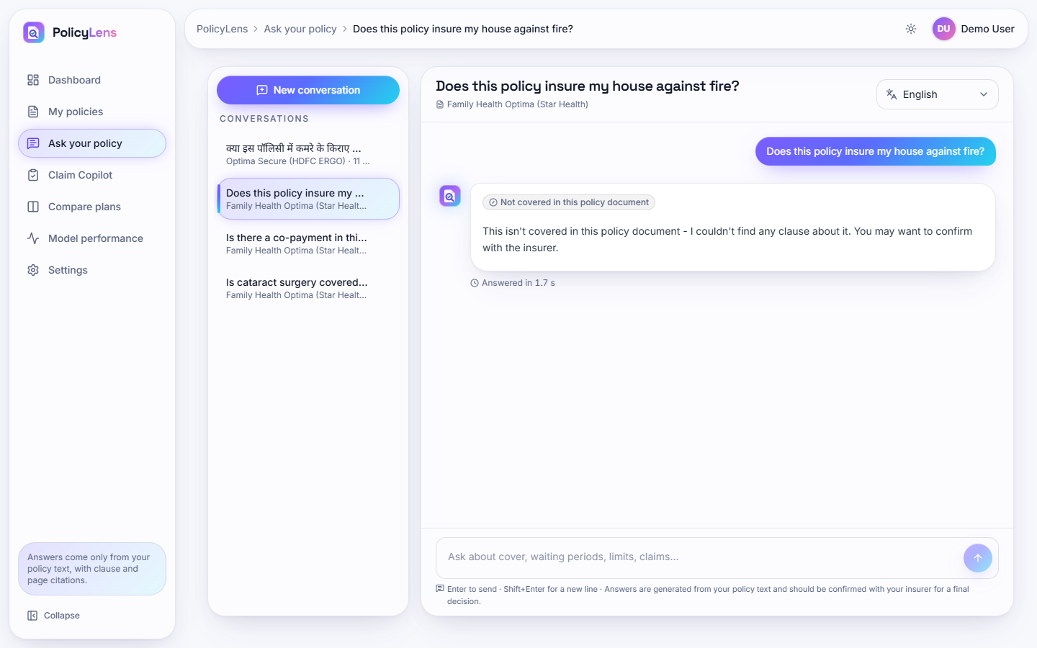
Fig. 8.9: Out-of-scope question declined
"Does this policy insure my house against fire?" is answered "Not covered in this policy document - I couldn't find any clause about it" in 1.7 s, with no sources and no model call.
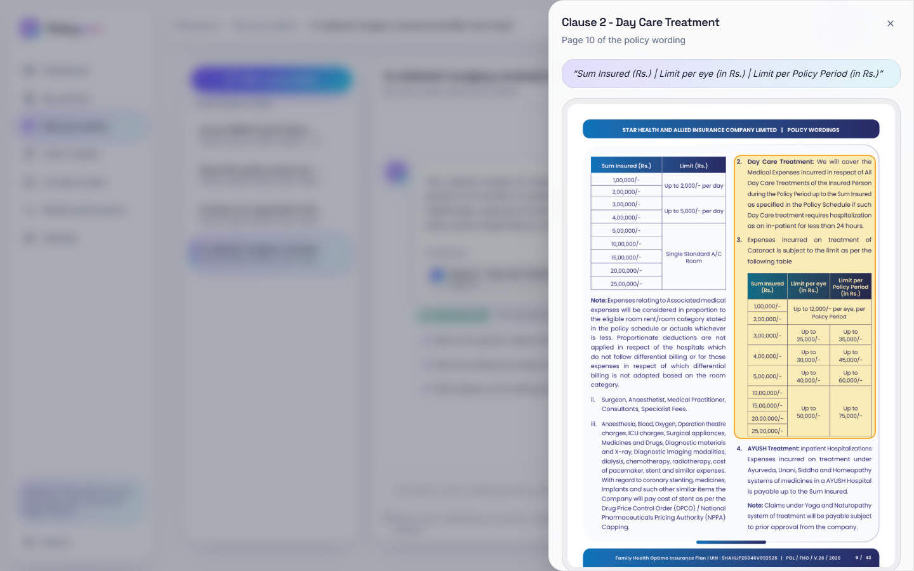
Fig. 8.10: Citation sheet
Clicking a source chip opens the cited page of the original policy with the clause outlined, and the quoted text at the top.
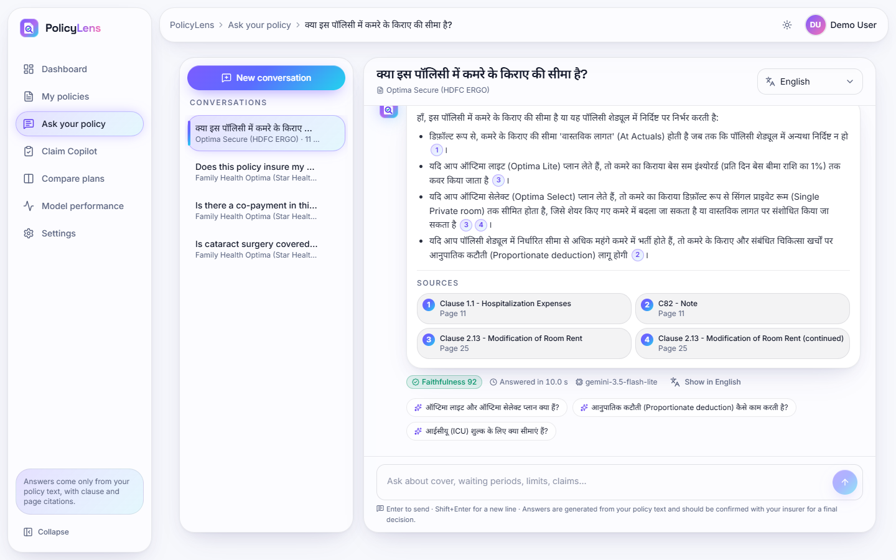
Fig. 8.11: Hindi answer
A question about the room-rent limit asked in Hindi is answered in Hindi with four source chips, faithfulness 92 and the link Show in English.
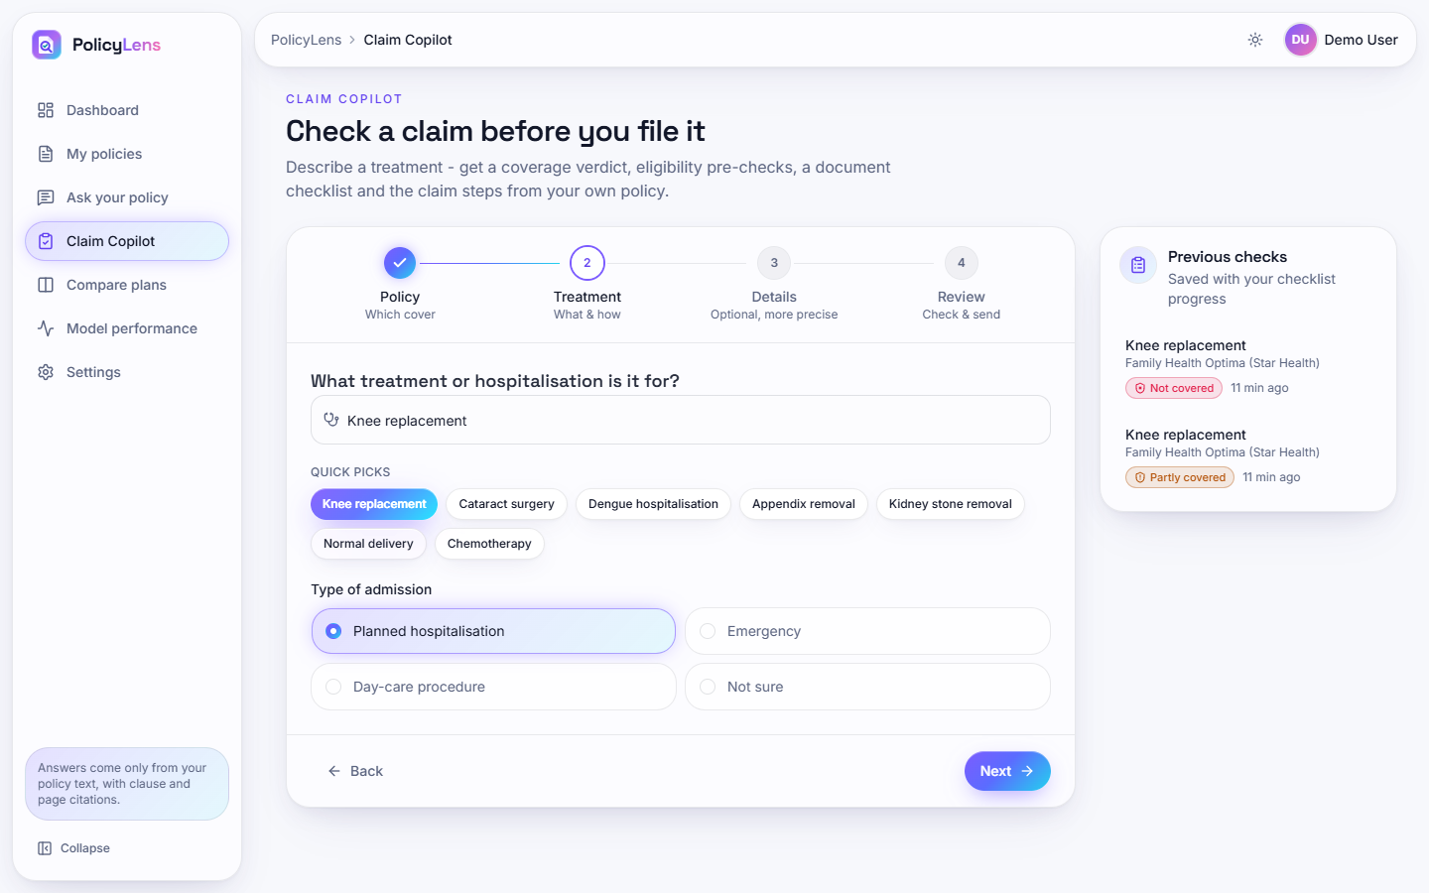
Fig. 8.12: Claim Copilot: treatment step
Step 2 of the four-step wizard (Policy, Treatment, Details, Review) with quick picks (Knee replacement, Cataract surgery, Dengue hospitalisation and others), the type of admission, and the list of previous checks.
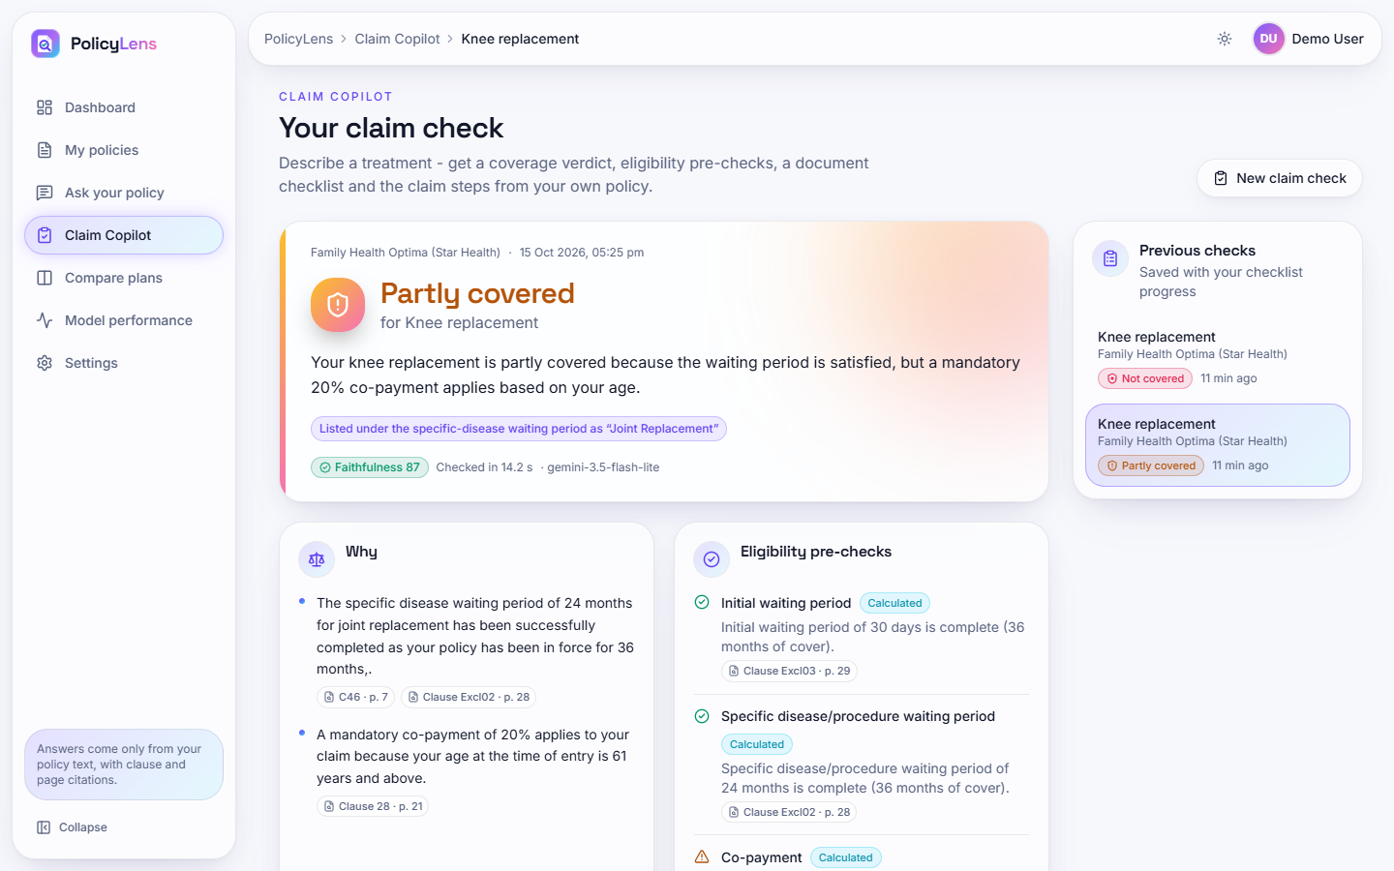
Fig. 8.13: Claim check: partly covered
Knee replacement under the Star Health policy, cover from 1 October 2023, age 64: partly covered because the waiting periods have passed but a mandatory 20% co-payment applies from age 61; the eligibility pre-checks are marked Calculated and each carries its clause and page.
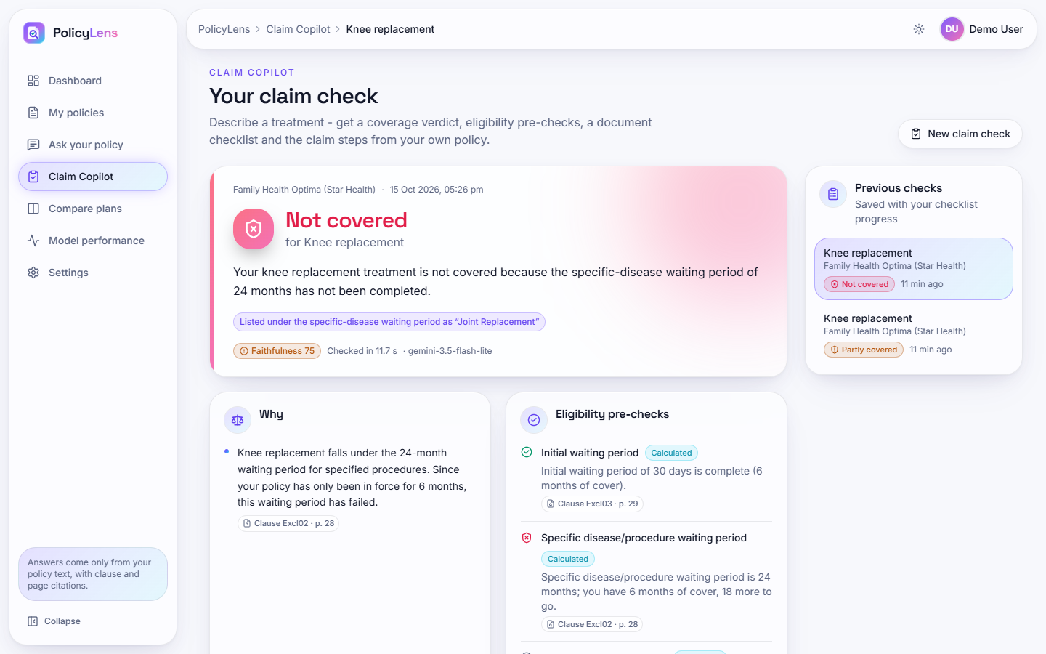
Fig. 8.14: Claim check: not covered
The same treatment with cover from 1 April 2026: not covered because the 24-month specific-disease waiting period has not been completed (6 months of cover, 18 more to go).
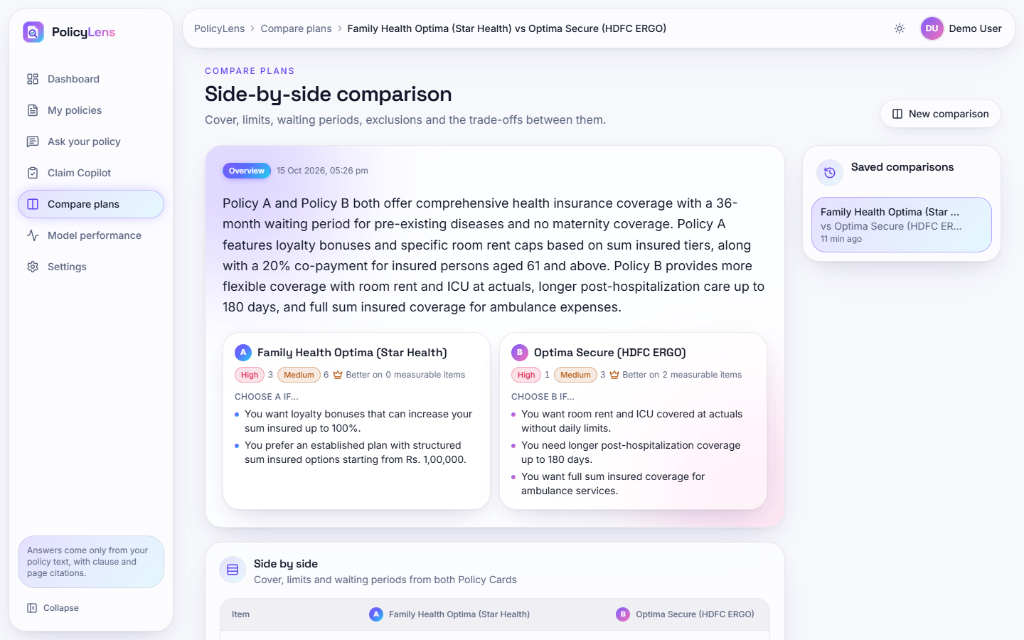
Fig. 8.15: Plan comparison
Star Health Family Health Optima against HDFC ERGO Optima Secure: an overview, the risk counts of each policy, "choose A if / choose B if" lists and the start of the side-by-side table.
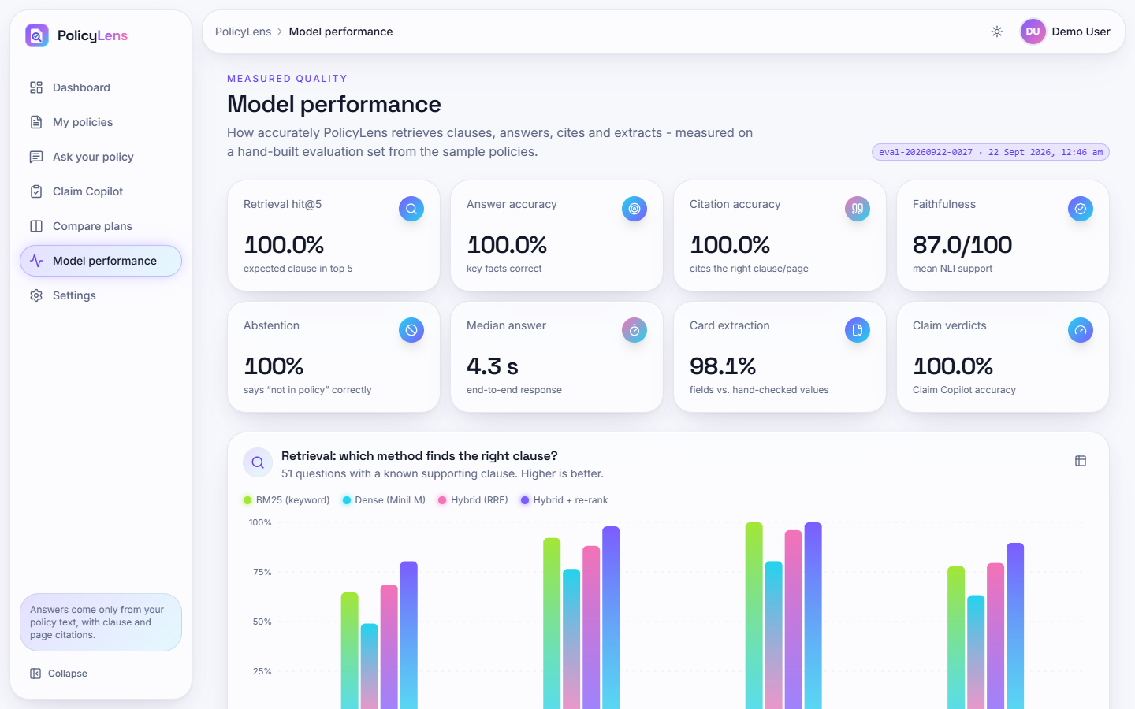
Fig. 8.16: Model performance
The public page of measured results from run eval-20260922-0027: retrieval hit@5 100%, answer accuracy 100%, citation accuracy 100%, faithfulness 87.0/100, abstention 100%, median answer 4.3 s, card extraction 98.1%, claim verdicts 100%, and the retrieval ablation chart.

8.2 Model Performance
PolicyLens trains no model, so there are no accuracy curves, confusion matrices of a classifier or F1 scores of a trained network. The evaluation measures the pipeline that PolicyLens actually runs, on the hand-built set described in Chapter 6, with the product's own code. All figures below come from run eval-20260922-0027 (22 September 2026). During this run the free-tier quota of the two larger Gemini models was used up, so every answer, claim check and Policy Card came from gemini-3.5-flash-lite, the smallest model in the chain.
Table 8.1: Headline results (run eval-20260922-0027)
Measure | Result
Retrieval: relevant clause in the top 5 (hybrid + re-rank) | 100% (51 / 51)
Retrieval: relevant clause ranked first | 80.4% (hit@1 0.804, MRR@10 0.897)
Answer accuracy (every key fact present) | 100% (51 / 51)
Citation accuracy | 100% (51 / 51)
Faithfulness score, mean / median | 87.0 / 91.7 (56 answers scored)
Out-of-scope questions declined | 100% (6 / 6), 0 false abstentions on 51 answerable questions
Hindi / Telugu answers in the requested script with all key facts | 5 / 5
Claim Copilot verdict accuracy | 100% (14 / 14)
Policy Card extraction accuracy | 98.1% (51 / 52); 96.9% of values have a verified source quote
Answer time, median / 95th percentile | 4.3 s / 18.2 s

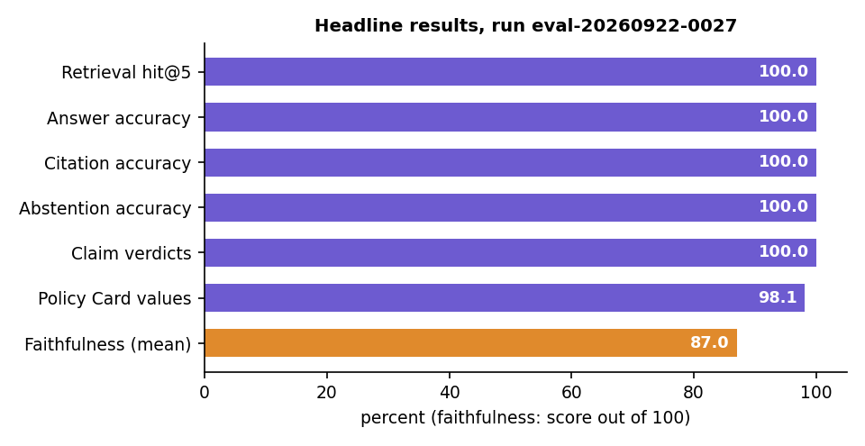
Fig. 8.17: Headline results of the evaluation run

8.2.1 Retrieval
Table 8.2: Retrieval on 51 answerable questions
Method | hit@1 | hit@3 | hit@5 | MRR@10 | recall@5 | median ms
BM25 (keywords) | 0.647 | 0.922 | 1.000 | 0.779 | 1.000 | 1.1
Dense (MiniLM + Chroma) | 0.490 | 0.765 | 0.804 | 0.632 | 0.794 | 10.7
Hybrid (RRF) | 0.686 | 0.882 | 0.961 | 0.795 | 0.951 | 11.0
Hybrid + re-rank (used) | 0.804 | 0.980 | 1.000 | 0.897 | 0.990 | 878.9

Fig. 8.18: Retrieval ablation (hit@1, hit@3, hit@5, MRR@10) for the four methods
- Keywords matter in policies. BM25 alone already finds the clause in the top 5 every time, because questions and clauses share exact terms ("cataract", "ambulance", "free look").
- Embeddings alone are weakest. Policy clauses are formulaic and look alike to a general-purpose embedding model; dense search misses one question in five at rank 5 (hit@5 0.804). It still helps fusion with paraphrased questions.
- The re-ranker makes the difference at the top. Reading question and clause together lifts hit@1 from 0.686 (fusion) to 0.804 and MRR@10 from 0.795 to 0.897, at a cost of about 0.9 s on the CPU, the largest part of retrieval time.

8.2.2 Answers, citations and faithfulness
Table 8.3: Answer accuracy by question category
Category | Questions | Correct
Waiting periods | 14 | 14
Benefits | 15 | 15
Claim process | 8 | 8
Exclusions | 5 | 5
Policy terms | 4 | 4
Room rent | 3 | 3
Sub-limits | 2 | 2
Total | 51 | 51

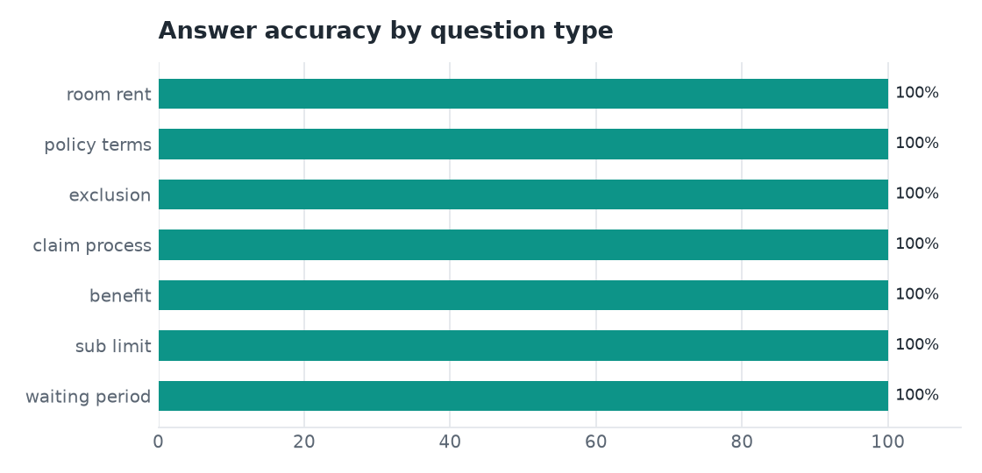
Fig. 8.19: Answer accuracy by question category
Of the 56 answers that were scored for faithfulness (the 51 answerable questions and the 5 multilingual ones), 45 are well supported (80-100), 8 partly supported (50-79) and 3 weakly supported (below 50). All three weakly supported answers were still correct and correctly cited; they show where the small NLI model struggles: an exclusion-list item that does not itself say "excluded" (the heading above it does), a rule stated as the inverse of an exclusion, and a defined term replaced by its abbreviation.
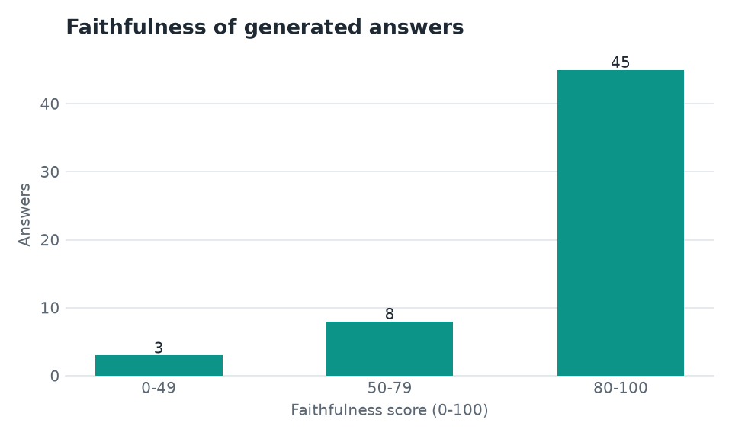
Fig. 8.20: Distribution of faithfulness scores (56 answers)
Adding the clause heading to the evidence lifted the first kind of case (0.003 to 0.92) but also let the model confirm a wrong statement about an exception ("ectopic pregnancy treatment is excluded" scored 0.87 against a clause that excepts it). That change was therefore not adopted: a faithfulness score should err towards caution. It is shown next to every answer as a prompt to open the cited clause, not as a verdict.

8.2.3 Knowing when to say "not covered in this policy"
Table 8.4: Scores used by the abstention rule
 | Best re-rank score | Best BM25 score
Out-of-scope questions (6) | at most 0.0029 | at most 7.3
Answerable questions (51) | as low as 0.0020 | as low as 7.1
Answerable with re-rank < 0.004 (3) | 0.0020-0.0021 | 15.5 or more

Neither score separates the two groups alone, but the pair does: answering "not covered" without a model call only when the re-rank score is below 0.004 and the BM25 score is below 9.0 declined 6 of 6 out-of-scope questions and none of the 51 answerable ones.

8.2.4 Response time
Table 8.5: Answer time by stage (live Gemini calls)
Stage | Median | 95th percentile
Retrieval (BM25 + dense + fusion + re-rank) | 0.86 s | 1.8 s
Gemini answer | 2.5 s | 17.2 s
Faithfulness (NLI) | 0.83 s | 1.7 s
Total | 4.3 s | 18.2 s

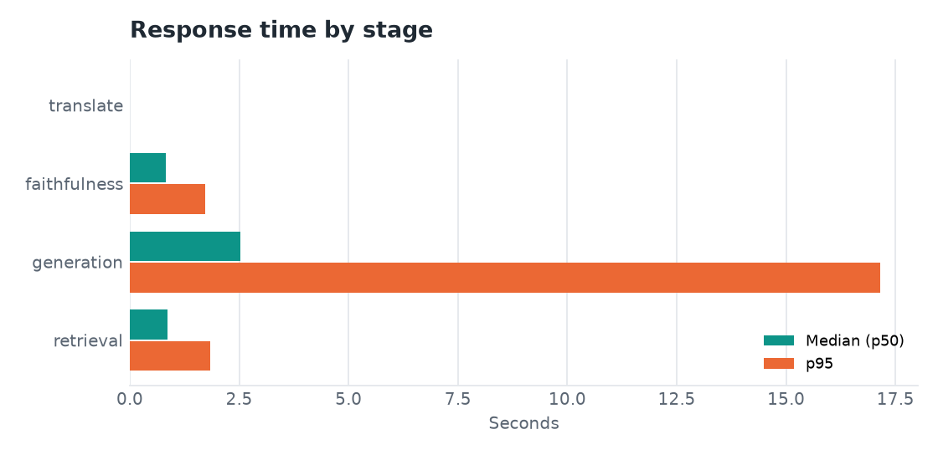
Fig. 8.21: Median and 95th-percentile time by stage
The long tail comes from the fallback chain: when the primary models answer "quota exceeded" or "overloaded", the request moves to the next model and that wait is included. Claim Copilot checks take longer (one larger Gemini call plus retrieval for several queries): a mean of 13.8 s on four timed live calls.

8.2.5 Claim Copilot
Table 8.6: Claim verdicts: expected (rows) against predicted (columns), 14 scenarios
expected \ predicted | covered | partly covered | not covered | needs info
covered | 5 | 0 | 0 | 0
partly covered | 0 | 1 | 0 | 0
not covered | 0 | 0 | 7 | 0
needs info | 0 | 0 | 0 | 1

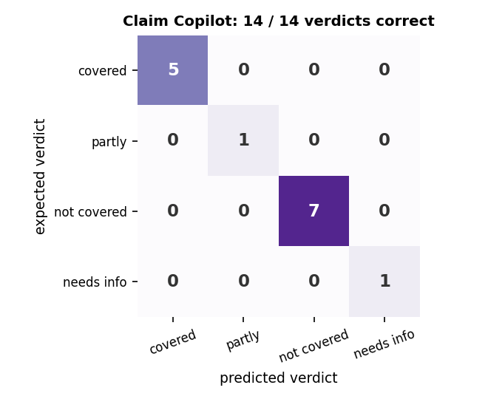
Fig. 8.22: Claim Copilot confusion matrix
Precision, recall and F1 are 1.0 for every verdict. The reasons behind the verdicts have a mean faithfulness of 82.7, and each check lists 7.3 documents and 4.3 claim steps on average. Waiting periods, age-based and network co-payments, sub-limits and the cost estimate are calculated by rules from the Policy Card, not generated, and a failed waiting period always yields "not covered".

8.2.6 Policy Card extraction
Table 8.7: Policy Card values by policy (52 hand-checked values)
Policy | Values checked | Correct
Family Health Optima | 14 | 14
my: Optima Secure | 14 | 13
ReAssure 2.0 | 11 | 11
Care Supreme | 13 | 13

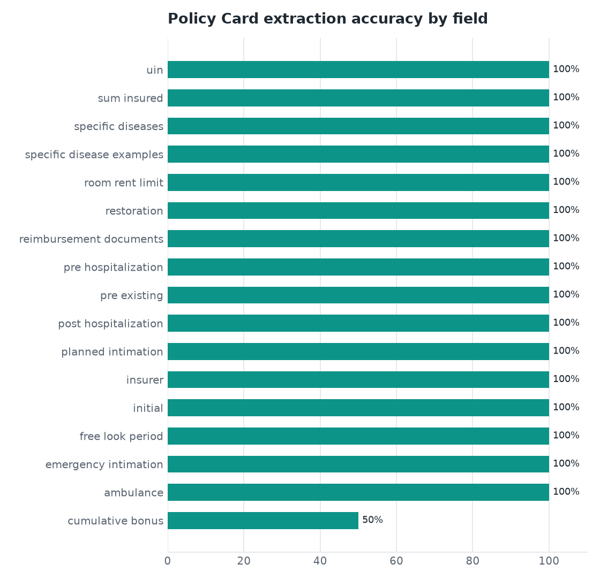
Fig. 8.23: Extraction accuracy by field
The single difference is the cumulative bonus of the HDFC ERGO wording, and it is an ambiguity in the document rather than a misreading: the wording covers seven plan variants (10% a year for Optima Suraksha and Optima Lite, 25% for Optima Select, none for Optima Secure, which instead grows cover by 50% a year through its Plus Benefit). The reference value takes the general clause (10%); the card reports the Optima Secure figure (50%, up to 100%). Letting the user pick the plan variant on the card is the planned fix.

8.3 Improvement Across the Three Runs
Three evaluation runs are kept in experiments/. Each fixed what the previous one revealed.
Table 8.8: Evaluation runs
Run | Change | hit@5 | Answer acc. | Citation acc. | False abstentions | Claim verdicts
eval-20260921-2353 | Baseline | 98.0% | 88.2% | 92.2% | 5 | 14/14
eval-20260922-0008 | Abstain only if both scores are low; rule and governed tables sent together | 98.0% | 98.0% | 96.1% | 1 | 14/14
eval-20260922-0027 | Exclusion-code list items become separate clauses; prompt says an exclusion is an answer; non-network co-pay not applied to cashless | 100% | 100% | 100% | 0 | 14/14

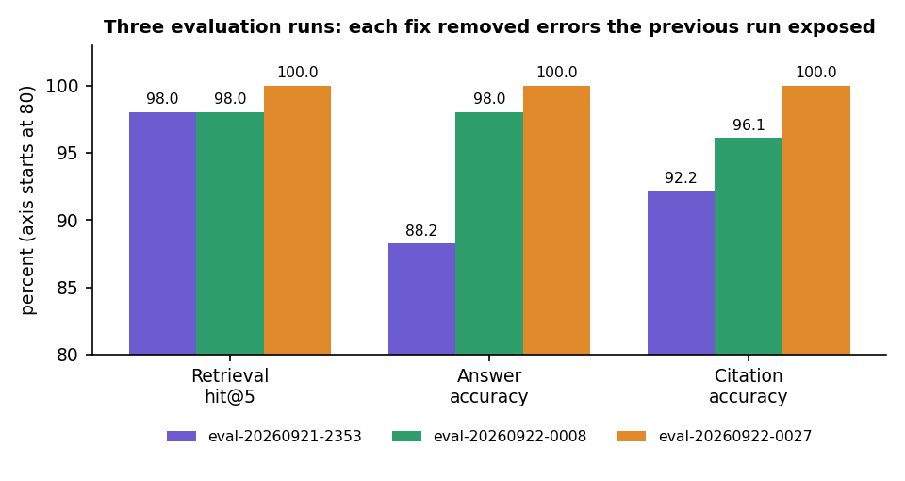
Fig. 8.24: Retrieval, answer and citation accuracy across the three runs
The first run's errors were of two kinds: the system answered "not covered" for answerable questions (5 false abstentions) and cited a neighbouring fragment instead of the governing rule. Requiring both a low re-rank score and a low keyword score before abstaining, and sending a rule together with the tables it governs, removed most of them. The remaining errors came from list items that carry an IRDAI exclusion code, which the segmenter had merged into one clause; making each its own clause removed them. Because these fixes were made by studying failures on the evaluation set itself, the final figures are optimistic.

8.4 Comparison with the Base Paper
The base paper [1] summarises Turkish court rulings and reports ROUGE scores; PolicyLens answers questions about English health-insurance wordings and reports retrieval, citation, faithfulness and verdict measures. The datasets, the tasks, the languages and the metrics all differ, so the numbers cannot be compared and no head-to-head claim is made. What can be compared is the approach.
Table 8.9: PolicyLens and the base paper
Aspect | Base paper [1] | PolicyLens
Task | Multi-document summarisation | Cited question answering, claim guidance, comparison
Documents | 2,000 Turkish court rulings (consumer-rights cases) | 4 English health-insurance wordings (166 pages, 801 clauses)
Selection step | TF-IDF and TextRank sentence extraction | BM25 + dense retrieval, fusion and cross-encoder re-ranking, measured
Generation | LED, Long-T5, BART-large, GPT-3.5 Turbo | Gemini with a JSON schema and tagged clauses
Training | Models fine-tuned for summarisation | None; pre-trained models only
Metric | ROUGE-1 55%, ROUGE-2 35%, ROUGE-L 42% (best model); content F1 0.47 (TF-IDF) | hit@5 100%, answer accuracy 100%, citation accuracy 100%, faithfulness 87.0, verdicts 14/14
Support for statements | Not measured; no citations | Citations to clause and page; NLI faithfulness score
Language | Turkish | English documents; English, Hindi, Telugu interaction

The closest quantitative point of comparison is the policy-document RAG study [6], which reports faithfulness of 0.347 (plain LLM), 0.621 (basic RAG) and 0.797 (RAG with a cross-encoder) with a different model, a different corpus (public-health guidance) and a different faithfulness measure. PolicyLens's mean faithfulness of 87.0 out of 100 is on its own NLI-based scale and is not comparable with those values either; the shared observation is that two-stage retrieval with re-ranking is what makes grounded answers reliable.

8.5 Sample Inputs and Outputs
Table 8.10: Sample inputs and outputs (live run, 15 October 2026)
Input | Output
Question: "Is cataract surgery covered and after how long?" (Star Health) | Covered under the policy, subject to a specified disease/procedure waiting period of 24 months of continuous coverage; expenses for cataract are subject to limits per eye and per policy period depending on the sum insured. Sources: Clause 2 (p. 10), Clause Excl02 (p. 28). Faithfulness 88.
Question: "Does this policy insure my house against fire?" | "Not covered in this policy document - I couldn't find any clause about it. You may want to confirm with the insurer." No sources; 1.7 s.
Claim: knee replacement, planned, cashless, cover from 2023-10-01, age 64, Rs. 3,50,000 | Partly covered: waiting periods complete (36 months of cover); mandatory 20% co-payment from age 61; document checklist and claim steps; estimated split of the bill.
Claim: knee replacement, cover from 2026-04-01, age 45 | Not covered: the 24-month specific-disease waiting period has not been completed (6 months of cover).
Compare: Star Health Family Health Optima and HDFC ERGO Optima Secure | Overview; 21-row side-by-side table; Policy A better on 0 measurable items, Policy B on 2; choose-A and choose-B lists.

8.6 Success and Failure Analysis

8.6.1 Where it works
- Every answerable question in the evaluation set was answered correctly and cited correctly; every out-of-scope question was declined.
- Every claim scenario received the expected verdict, including the single "needs information" case.
- The Policy Card is right for 51 of 52 checked values and marks values whose quote it cannot find as unverified.
- Hindi and Telugu questions return answers in the requested script with the key facts (5 of 5).

8.6.2 Where it fails or is weak
Table 8.11: Failure and weakness analysis
Observation | Cause | Effect / handling
Cumulative bonus of the HDFC ERGO card differs from the reference | The wording covers seven plan variants with different bonuses | Card reports the Optima Secure figure (50%) while the reference takes the general clause (10%); plan-variant selection is planned
Three correct answers scored below 50 for faithfulness | NLI limits: exclusion item vs heading; inverted rule; abbreviation vs defined term | Score is shown as a prompt to open the cited clause; the heading-evidence fix was rejected because it confirmed a wrong statement
Same co-payment question scored 99.0 and then 37.9 | The score depends on how the model phrases its claims and which windows the NLI model sees | The score is a heuristic; sources are always shown
Telugu card line mixes Bengali and Gurmukhi script; bracketed English terms | Translation by the smaller model | Known limitation; English card and citations remain correct
Answer time up to 24.8 s | Fallback chain waits when the larger models are out of quota or overloaded | Median 4.3 s; the model used is shown
Dashboard tiles at 1440 px wrap values and have uneven heights | Layout of the tiles at that width | Cosmetic; noted for the next UI pass

8.7 Limits of the Results
- Small set. 51 answerable questions over four policies. 100% here means no errors were found on this set, not that PolicyLens never errs. Every answer shows its sources and a faithfulness score for that reason.
- Tuned on the same set. The abstention thresholds and the parsing fixes were made after studying failures on this set, so the final figures are optimistic. The next check is a fresh question set on policy wordings PolicyLens has not seen.
- Model and quota. The Gemini model used depends on the free-tier quota at the time. The run records which model produced each result; all results here are for the smallest model in the chain.
- One machine, no user study. All timings are from one desktop; no load testing; no policyholder has rated the answers.
- No numeric comparison with the base paper is possible, as explained above.

8.8 Objectives Against Outcomes
Table 8.12: Objectives against outcomes
Objective | Outcome | Evidence
1. Extract key policy attributes automatically | Achieved | Policy Card with sourced values; 51 of 52 values correct; 96.9% verified in the text
2. Build a RAG pipeline that retrieves the relevant clauses | Achieved | Hybrid + re-rank: relevant clause in the top 5 for 51 of 51 questions; first for 80.4%
3. Generate plain-language answers grounded in and citing the clauses | Achieved | Answer accuracy 51/51, citation accuracy 100%; out-of-scope questions declined 6/6
4. Provide guided claim support with pre-checks, checklists and steps | Achieved | 14 of 14 verdicts correct; calculated pre-checks; checklist and steps; cost estimate
5. Summarise risks, exclusions and trade-offs to support plan comparison | Achieved | Risk highlights with severity (23 across the four samples); 21-row comparison with trade-offs. The comparison quality was not scored against a reference
6. Evaluate answer accuracy, faithfulness and response time | Achieved, with limits | Measured on a small set partly tuned on itself; faithfulness mean 87.0; median 4.3 s; no user study

CHAPTER 9
CONCLUSION

9.1 Summary of the Work
This project built PolicyLens, an AI assistant that explains a health-insurance policy from the policyholder's own wording. A PDF is parsed into numbered clauses with page positions; a Policy Card lists the key terms with the clause and page that support each value; a hybrid retriever (BM25, MiniLM embeddings, Reciprocal Rank Fusion and a cross-encoder) finds the clauses relevant to a question; Gemini writes a plain-language answer from those clauses only; and an independent NLI model scores how well each answer is supported. The assistant says "not covered in this policy" when the wording is silent, guides claims with calculated eligibility pre-checks, a document checklist and a cost estimate, compares two policies, and works in English, Hindi and Telugu.
The system was evaluated on a hand-built set drawn from four real policy wordings: 57 questions, 14 claim scenarios and 52 Policy Card values. The relevant clause was in the top five for 51 of 51 answerable questions, all 51 answers were correct and correctly cited, 6 of 6 out-of-scope questions were declined with no false abstentions, 14 of 14 claim verdicts were correct, 51 of 52 card values were correct, the mean faithfulness score was 87.0 and the median answer time was 4.3 seconds. Twenty-five automated tests pass.

9.2 Objectives Achieved
Each of the six objectives was met: key attributes are extracted automatically into a verified Policy Card (51 of 52 values correct); a RAG pipeline retrieves the relevant clauses (hit@5 of 100%); answers are in plain language, grounded and cited (accuracy and citation accuracy 100%); claim support provides pre-checks, a checklist, steps and an estimate (14 of 14 verdicts); risks and trade-offs support plan comparison; and answer accuracy, faithfulness and response time were measured. The sixth objective is met with the limits stated below: the evaluation set is small and was partly used for tuning, and no user study was carried out.

9.3 Key Findings
1. Keywords matter most in policy text. BM25 alone found the relevant clause in the top five for every question; embeddings alone found it for 80%.
2. Re-ranking decides the top of the list. Adding the cross-encoder raised hit@1 from 0.686 to 0.804 and MRR@10 from 0.795 to 0.897.
3. Structure beats chunks. The largest accuracy gain across the three runs (answer accuracy 88.2% to 100%) came from segmentation and context fixes, not from a better model.
4. Two scores are needed to know when to abstain. Neither the re-rank score nor the BM25 score separated answerable from out-of-scope questions alone; together they did.
5. A small model was enough on this set. Every result was obtained with the smallest model in the fallback chain, gemini-3.5-flash-lite, because retrieval and rules do much of the work.
6. Faithfulness scores are a prompt, not a verdict. Three correct answers scored below 50 and one question scored 99.0 and 37.9 in two runs; the score must be shown together with the sources.
Fig. 9.1: Improvement across the three evaluation runs

9.4 Practical Applications
- Policyholders who want to understand what they bought, check a planned claim before filing it, or compare two policies.
- Insurance advisers and customer-service teams who need a fast, cited answer to a wording question.
- Hospitals' insurance desks preparing claim documents (the checklist and steps are generated from the policy).
- Regulators and consumer groups reviewing how clearly policy wordings state waiting periods, sub-limits and exclusions (the risk highlights surface them).
- Teaching retrieval-augmented generation with a real, checkable evaluation.

9.5 Known Limitations
- The evaluation set is small (51 answerable questions, four policies, 14 claim scenarios) and the abstention thresholds and parser fixes were tuned on it; results on unseen policies are not yet known.
- All results are from the smallest Gemini model in the chain; larger models were not measured.
- The faithfulness score is a heuristic; the translation of the Policy Card into Telugu contained one mixed-script line.
- Plan variants (for example the seven variants in one HDFC ERGO wording) are not yet selectable, so one card value is ambiguous.
- Text-layer English PDFs only; no OCR.
- No user study, no load or security testing.
- No numeric comparison with the base paper is possible, because it summarises Turkish court rulings and reports ROUGE.

CHAPTER 10
FUTURE SCOPE

10.1 Improvements
- Evaluate on a fresh, larger question set from policy wordings not used in development, with independent annotators.
- Re-run the evaluation with the larger Gemini models and report the difference.
- Let the user select the plan variant on the Policy Card and use it in answers and claim checks.
- Improve the faithfulness scorer, for example with a larger NLI model or by giving the scorer the clause heading only for inclusion lists.
- Check translation quality automatically (script detection per line) and retry a line that mixes scripts.
- Fix the dashboard tile layout at 1440 px and repeat the accessibility checks.

10.2 Additional Features
- OCR for scanned policy documents.
- Upload and parsing of non-English wordings and more languages for answers.
- Claim document upload with a check against the generated checklist; reminders for claim deadlines.
- Policy renewal comparison: a changed wording against last year's.
- Hospital network look-up for cashless claims; voice input for questions.

10.3 Scalability and Deployment
- Replace SQLite and the local vector store with a server database and a hosted vector store for many users.
- Run the three local models in a separate worker service, and queue ingestion with a job system.
- Serve over HTTPS with a generated signing secret, rate limiting and a security review before any shared deployment.
- Add monitoring of model quota, latency and the faithfulness distribution; keep the evaluation as a regression test in continuous integration.
- Measure load and concurrency, which were not tested here.

10.4 Further Research
- Compare clause-aware segmentation with learned segmentation and with graph-structured retrieval [5] on insurance wordings.
- Calibrate the faithfulness score against human judgement and learn the abstention rule from data instead of two thresholds.
- Study how often retrieval-grounded answers still contain a false statement, as in [2], on health-insurance wordings with a larger panel of expert answers.
- Evaluate whether policyholders make better decisions with the assistant: a user study with real wordings.

REFERENCES
[1] M. A. A. Albayati and O. Findik, "A hybrid transformer-based framework for multi-document summarization of Turkish legal documents," IEEE Access, vol. 13, pp. 37165-37181, 2025, doi: 10.1109/ACCESS.2025.3545750.
[2] D. Beauchemin, R. Khoury and Z. Gagnon, "Quebec automobile insurance question-answering with retrieval-augmented generation," in Proc. Natural Legal Language Processing Workshop (NLLP), Miami, FL, USA, 2024, pp. 48-60, doi: 10.18653/v1/2024.nllp-1.5.
[3] "A medical insurance question answering system based on multi-strategy retrieval-augmented generation," in Proc. 2026 5th Int. Symp. Computer Applications and Information Technology (ISCAIT), 2026 (listed in the batch literature survey; not independently retrieved).
[4] "Artificial intelligence chatbot in Iran Health Insurance Organization: A new era in service providing," Iranian Journal of Health Insurance, 2023 (listed in the batch literature survey; not independently retrieved).
[5] S. Knollmeyer, O. Caymazer and D. Grossmann, "Document GraphRAG: Knowledge graph enhanced retrieval augmented generation for document question answering within the manufacturing domain," Electronics, vol. 14, no. 11, Art. 2102, 2025, doi: 10.3390/electronics14112102.
[6] A. Maharjan and U. Yadav, "Chunking, retrieval, and re-ranking: An empirical evaluation of RAG architectures for policy document question answering," arXiv:2601.15457, Jan. 2026.
[7] P. Lewis et al., "Retrieval-augmented generation for knowledge-intensive NLP tasks," in Advances in Neural Information Processing Systems (NeurIPS), vol. 33, 2020, pp. 9459-9474.
[8] S. Robertson and H. Zaragoza, "The probabilistic relevance framework: BM25 and beyond," Foundations and Trends in Information Retrieval, vol. 3, no. 4, pp. 333-389, 2009.
[9] G. V. Cormack, C. L. A. Clarke and S. Buettcher, "Reciprocal rank fusion outperforms Condorcet and individual rank learning methods," in Proc. 32nd Int. ACM SIGIR Conf. Research and Development in Information Retrieval, 2009, pp. 758-759.
[10] N. Reimers and I. Gurevych, "Sentence-BERT: Sentence embeddings using Siamese BERT-networks," in Proc. EMNLP-IJCNLP, 2019, pp. 3982-3992.
[11] W. Wang, F. Wei, L. Dong, H. Bao, N. Yang and M. Zhou, "MiniLM: Deep self-attention distillation for task-agnostic compression of pre-trained transformers," in Advances in Neural Information Processing Systems (NeurIPS), vol. 33, 2020, pp. 5776-5788.
[12] R. Nogueira and K. Cho, "Passage re-ranking with BERT," arXiv:1901.04085, 2019.
[13] P. He, J. Gao and W. Chen, "DeBERTaV3: Improving DeBERTa using ELECTRA-style pre-training with gradient-disentangled embedding sharing," arXiv:2111.09543, 2021.
[14] A. Williams, N. Nangia and S. Bowman, "A broad-coverage challenge corpus for sentence understanding through inference," in Proc. NAACL-HLT, 2018, pp. 1112-1122.
[15] T. Bajaj et al., "MS MARCO: A human generated machine reading comprehension dataset," arXiv:1611.09268, 2016.
[16] Z. Ji et al., "Survey of hallucination in natural language generation," ACM Computing Surveys, vol. 55, no. 12, Art. 248, 2023.
[17] Gemini Team, Google, "Gemini: A family of highly capable multimodal models," arXiv:2312.11805, 2023.
[18] V. Karpukhin et al., "Dense passage retrieval for open-domain question answering," in Proc. EMNLP, 2020, pp. 6769-6781.
[19] C.-Y. Lin, "ROUGE: A package for automatic evaluation of summaries," in Text Summarization Branches Out, ACL Workshop, Barcelona, Spain, 2004, pp. 74-81.

APPENDIX A
IMPORTANT CODE
The listings below are extracted from the source files when this report is built, so they match the code that produced the results.

A.1 Hybrid Retrieval
Listing: retrieve() in ml/retrieval/hybrid.py
def retrieve(document_id: int, query: str, k: int = 6, mode: Mode = "hybrid_rerank",
provider: str | None = None, extra_queries: list[str] | None = None) -> RetrievalResult:
"""Return the top-``k`` clauses of one document for ``query``.

``extra_queries`` (e.g. an English translation or sub-questions) are searched too and fused.
"""
timings: dict[str, float] = {}
queries = [query, *(extra_queries or [])]

t = time.perf_counter()
bm25_lists = [bm25_index.search(document_id, q, CANDIDATES) for q in queries] if mode != "dense" else []
timings["bm25"] = round((time.perf_counter() - t) * 1000, 1)

t = time.perf_counter()
dense_lists = [dense_index.search(document_id, q, CANDIDATES, provider) for q in queries] if mode != "bm25" else []
timings["dense"] = round((time.perf_counter() - t) * 1000, 1)

by_ordinal: dict[int, Retrieved] = {}

def entry(clause: ClauseRecord) -> Retrieved:
if clause.ordinal not in by_ordinal:
by_ordinal[clause.ordinal] = Retrieved(clause=clause, score=0.0)
return by_ordinal[clause.ordinal]

for results in bm25_lists:
for rank, (clause, score) in enumerate(results, start=1):
e = entry(clause)
if e.bm25 is None or score > e.bm25:
e.bm25, e.bm25_rank = round(score, 4), rank
for results in dense_lists:
for rank, (clause, score) in enumerate(results, start=1):
e = entry(clause)
if e.dense is None or score > e.dense:
e.dense, e.dense_rank = round(score, 4), rank

if mode == "bm25":
ranked = sorted((e for e in by_ordinal.values() if e.bm25 is not None), key=lambda e: e.bm25, reverse=True)
for e in ranked:
e.score = e.bm25 or 0.0
return RetrievalResult(query, mode, ranked[:k], timings)
if mode == "dense":
ranked = sorted((e for e in by_ordinal.values() if e.dense is not None), key=lambda e: e.dense, reverse=True)
for e in ranked:
e.score = e.dense or 0.0
return RetrievalResult(query, mode, ranked[:k], timings)

t = time.perf_counter()
rankings = [[c.ordinal for c, _ in lst] for lst in (*bm25_lists, *dense_lists)]
fused = reciprocal_rank_fusion(rankings, k=60)
for ordinal, score in fused:
by_ordinal[ordinal].rrf = round(score, 5)
timings["fusion"] = round((time.perf_counter() - t) * 1000, 1)

pool = [by_ordinal[o] for o, _ in fused]
if mode == "hybrid":
for e in pool:
e.score = e.rrf or 0.0
return RetrievalResult(query, mode, pool[:k], timings)

t = time.perf_counter()
# Re-rank the fused top candidates plus each retriever's own top hits, so a clause that only one
# method finds (e.g. an exact keyword match) still gets a chance.
chosen: dict[int, Retrieved] = {e.clause.ordinal: e for e in pool[:RERANK_POOL]}
for results in (*bm25_lists, *dense_lists):
for clause, _ in results[:SOLO_TOP]:
chosen.setdefault(clause.ordinal, by_ordinal[clause.ordinal])
pool = list(chosen.values())
scores = rerank_scores(query, [e.clause.index_text for e in pool])
if extra_queries:
# Score against the English/sub-queries as well and keep the best view of each clause.
for q in extra_queries:
alt = rerank_scores(q, [e.clause.index_text for e in pool])
scores = [max(a, b) for a, b in zip(scores, alt)]
for e, s in zip(pool, scores):
e.rerank = round(s, 4)
# Blend: cross-encoder relevance first, fused rank as a tie-breaker.
e.score = round(s + 0.001 * (e.rrf or 0.0) * 60, 4)
pool.sort(key=lambda e: e.score, reverse=True)
timings["rerank"] = round((time.perf_counter() - t) * 1000, 1)
return RetrievalResult(query, mode, pool[:k], timings)

A.2 Faithfulness Scoring
Listing: score_claims() in ml/faithfulness.py
def score_claims(claims: Sequence[ClaimInput], clause_texts: dict[int, str]) -> dict:
"""Return {"score": 0-100 | None, "label": ..., "claims": [...]}."""
if not claims:
return {"score": None, "label": label_for(None), "claims": []}
model = get_nli()
labels = nli_label_index()
ent_idx = labels.get("entailment", 1)
con_idx = labels.get("contradiction", 0)

pairs: list[tuple[str, str]] = []
spans: list[tuple[int, int]] = []
for claim in claims:
evidence = [clause_texts[o] for o in claim.clause_ordinals if o in clause_texts]
windows = _windows(evidence, claim.text) if evidence else []
start = len(pairs)
pairs.extend((w, claim.text) for w in windows)
spans.append((start, len(pairs)))

probs = np.zeros((0, 3))
if pairs:
logits = np.asarray(model.predict(pairs, batch_size=16, show_progress_bar=False, convert_to_numpy=True))
logits = logits - logits.max(axis=1, keepdims=True)
exp = np.exp(logits)
probs = exp / exp.sum(axis=1, keepdims=True)

details = []
for claim, (start, end) in zip(claims, spans):
evidence_text = " ".join(clause_texts.get(o, "") for o in claim.clause_ordinals)
if start == end:
details.append({"text": claim.text, "clauses": claim.clause_ordinals, "support": 0.0,
"contradiction": 0.0, "evidence": None, "numbers_ok": False,
"note": "No valid clause cited"})
continue
block = probs[start:end]
best = int(block[:, ent_idx].argmax())
entail = float(block[best, ent_idx])
contra = float(block[:, con_idx].max())
claim_numbers = _numbers(claim.text)
evidence_numbers = _numbers(evidence_text)
numbers_ok = claim_numbers.issubset(evidence_numbers) or not claim_numbers
# Lexical backstop: a near-verbatim restatement of the clause is supported even when the
# small NLI model is unsure about long legal sentences.
overlap = token_overlap(claim.text, evidence_text)
support = max(entail, 0.75 * overlap if overlap >= 0.8 else 0.0)
if not numbers_ok:
support *= 0.5
details.append({
"text": claim.text, "clauses": claim.clause_ordinals, "support": round(support, 3),
"contradiction": round(contra, 3), "evidence": pairs[start + best][0][:400], "numbers_ok": numbers_ok,
"note": None if numbers_ok else "A number in this statement was not found in the cited clause",
})
score = round(100 * float(np.mean([d["support"] for d in details])), 1)
return {"score": score, "label": label_for(score), "claims": details}

def quick_support(claim: str, evidence: str) -> float:
"""Entailment probability of one claim against one evidence text (used in evaluation)."""
result = score_claims([ClaimInput(claim, [0])], {0: evidence})
return result["claims"][0]["support"] if result["claims"] else 0.0

def normalised_equal(a: str, b: str) -> bool:

A.3 Co-payment Rule
Listing: copay_applies() in services/eligibility.py
def copay_applies(wording: str, age: int | None, claim_mode: str | None = None) -> tuple[bool | None, str]:
"""Does a co-payment described by ``wording`` apply to this claim? (True/False/None=unknown, reason)."""
text = wording or ""
if _NON_NETWORK.search(text):
if claim_mode == "cashless":
return False, "cashless claims are settled only in network hospitals, where it does not apply"
return None, "applies only if treatment is taken in a hospital outside the insurer's network"
if _OPTIONAL.search(text):
return None, "only if this option is chosen in your policy schedule"
match = _AGE_THRESHOLD.search(text) if re.search(r"\bage", text, re.I) else None
if match:
threshold = int(match.group(1) or match.group(2))
if 18 <= threshold <= 99:
if age is None:
return None, f"applies if the insured person's age (at entry) is {threshold} or above"
if age >= threshold:
return True, f"age {age} is {threshold} or above"
return False, f"it applies from age {threshold} and the patient is {age}"
if _ZONE.search(text):
return None, "depends on the hospital or city where treatment is taken"
return True, "applies to every claim"

A.4 Password Hashing and Tokens
Listing: hash_password(), verify_password() and create_access_token() in core/security.py
def hash_password(password: str) -> str:
return _pwd.hash(password)

def verify_password(password: str, password_hash: str) -> bool:
try:
return _pwd.verify(password, password_hash)
except ValueError:
return False

def create_access_token(user_id: int, expires_minutes: int | None = None) -> tuple[str, datetime]:
settings = get_settings()
expires = datetime.now(timezone.utc) + timedelta(minutes=expires_minutes or settings.jwt_expire_minutes)
payload = {"sub": str(user_id), "exp": expires, "iat": datetime.now(timezone.utc), "typ": "access"}
return jwt.encode(payload, settings.jwt_secret, algorithm=ALGORITHM), expires

def decode_access_token(token: str) -> int | None:

APPENDIX B
INSTALLATION AND USER GUIDE

B.1 Installation Guide
1. Install Python 3.11 (tick Add python.exe to PATH) and Node.js LTS on Windows 10 or 11.
2. Open the project folder (it contains setup.bat, run.bat, backend and frontend) and run setup.bat. It creates the virtual environment, installs the packages, creates .env, downloads the three local models (about 480 MB), installs the web packages, creates the database, the demo account and the four sample policies, and builds their index. This takes about 15 minutes, mostly downloads.
3. Get a free Gemini API key at https://aistudio.google.com/apikey, open .env and paste it after GEMINI_API_KEY=.
4. Optional: run venv\Scripts\python scripts\check_gemini.py to send three tiny test requests.
5. Run run.bat. It starts the API on port 8101 and the web app on port 5101 and opens http://localhost:5101.
6. Sign in with demo@policylens.app and Demo@12345, or register a new account.
7. Stop with stop.bat. scripts\reset.bat resets the data.

B.2 User Guide
Table B.1: User guide
Task | How
Upload a policy | My policies, then Upload policy; choose a PDF with selectable text; watch the status move from queued to ready; or press Sample policies to add the four samples
Read the Policy Card | Open the policy; the Policy Card tab lists the values; every chip "Clause - page" opens the original page with the clause highlighted
See the risks | Risks tab; filter by severity
Search the wording | Clause search tab; choose BM25, dense, hybrid or hybrid with re-rank
Ask a question | Ask this policy (or Ask your policy); type a question or press a suggestion; open a source chip to see the page; the badge shows the faithfulness score
Change the language | Settings, or the language menu in the chat, or on the card; the source quotes stay in English
Check a claim | Claim Copilot: choose the policy, the treatment, the details (start date, age, pre-existing disease, estimated bill), then Review; tick the checklist as documents are collected
Compare two policies | Compare plans: choose Policy A and Policy B and the language, then Compare
See measured quality | Model performance (no sign-in needed)

PolicyLens explains policy wordings; the insurer makes the final decision on any claim.

APPENDIX C
ADDITIONAL SCREENS
Additional captures of the running application (15 October 2026).
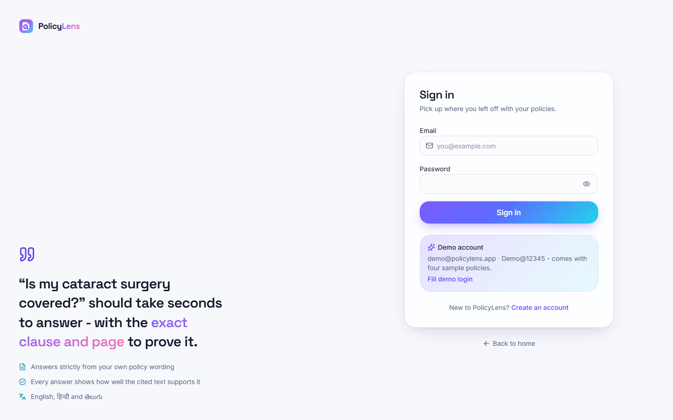  Fig. C.1: Sign in | 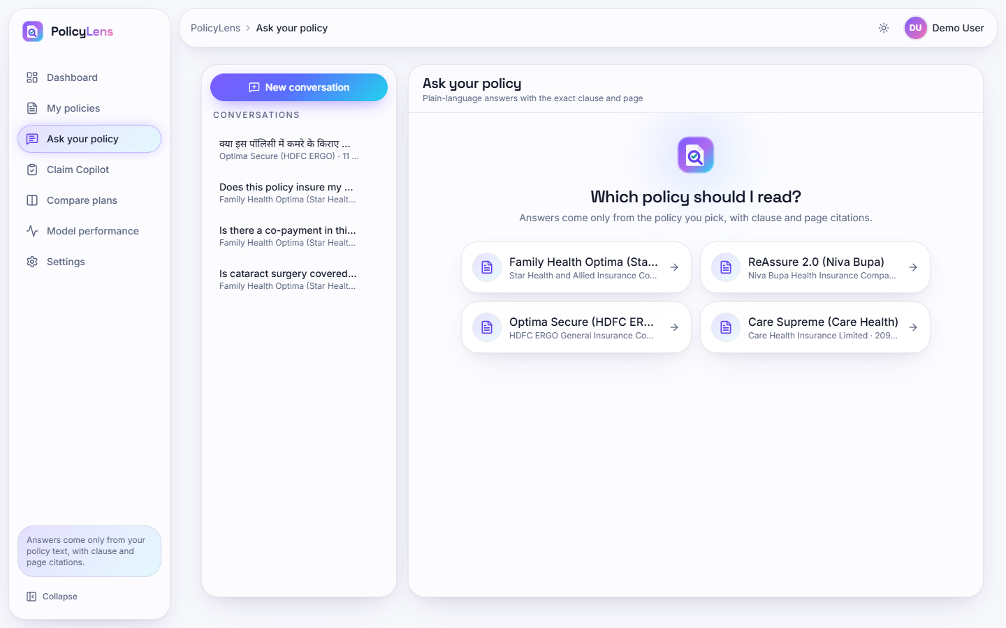  Fig. C.2: Ask your policy: choose a policy

Sign in. The sign-in form with the e-mail and password fields.
Ask your policy: choose a policy. The start of a conversation: the user picks which of the four policies the answers must come from.
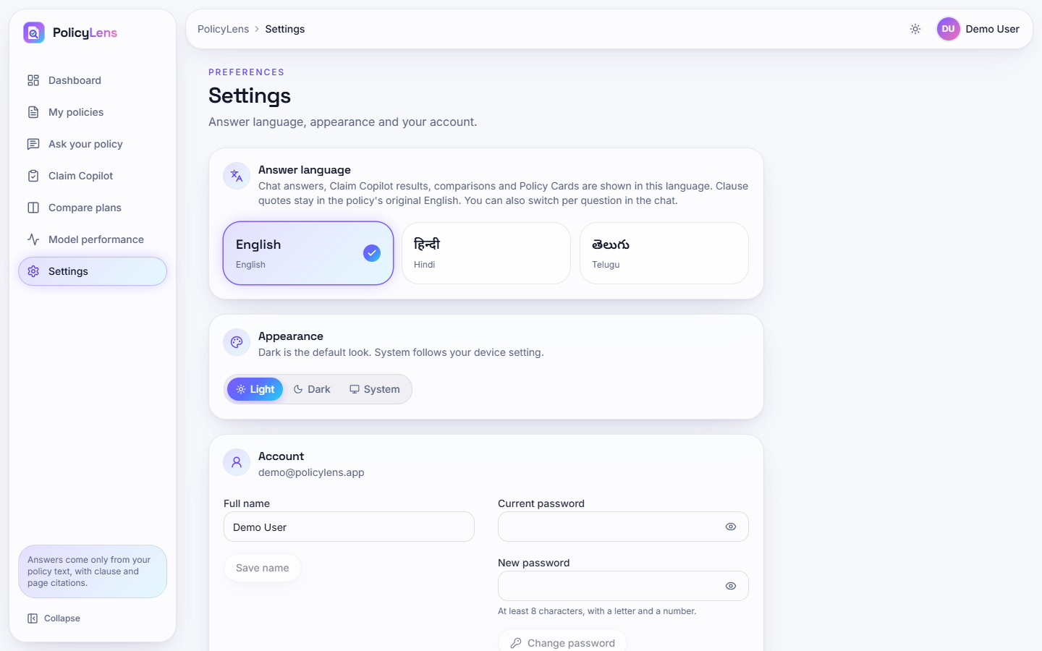  Fig. C.3: Settings | 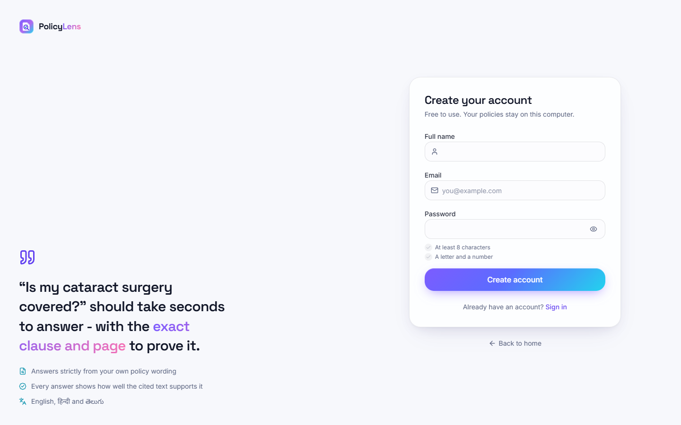  Fig. C.4: Create account

Settings. The answer language (English, Hindi, Telugu), the appearance (light, dark, system) and the account: name and password change.
Create account. The registration form (name, e-mail, password with the stated rule).
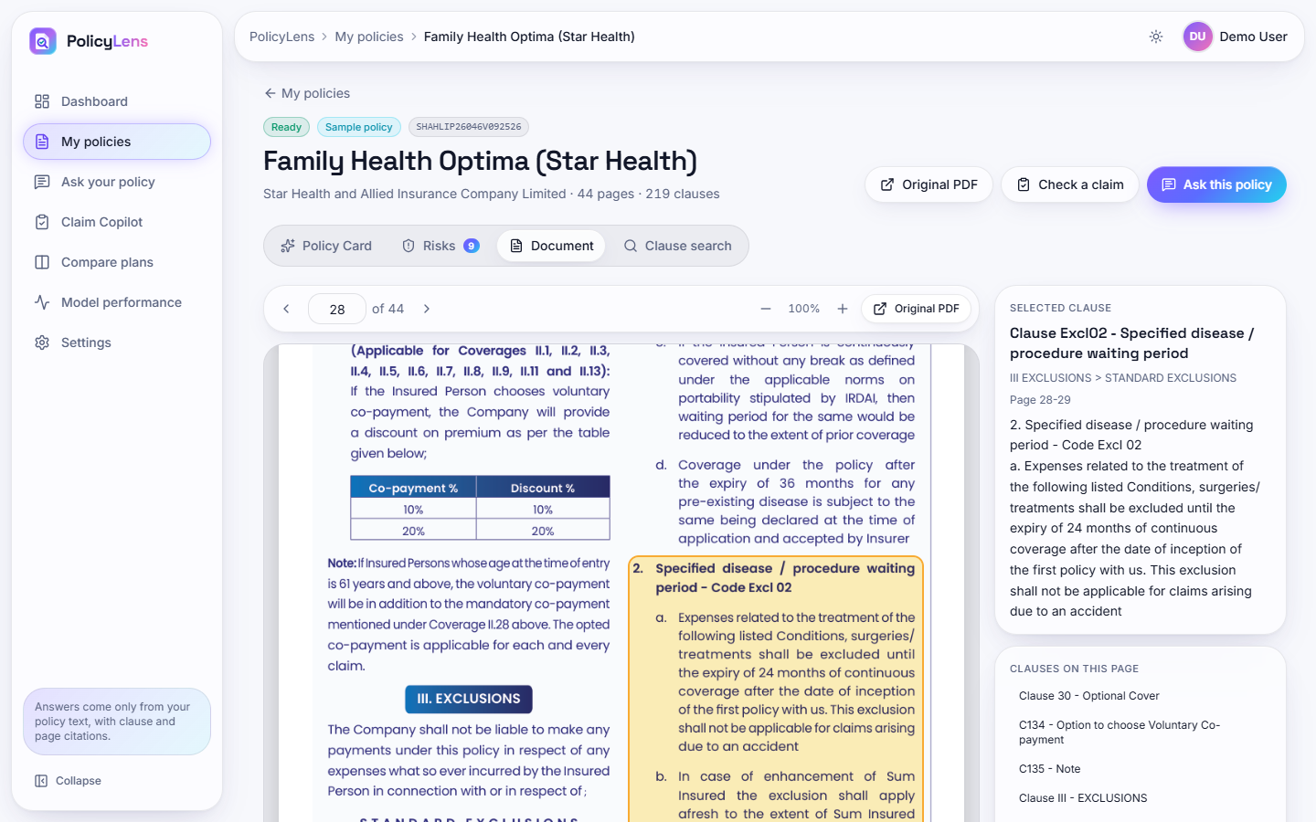  Fig. C.5: Original document viewer | 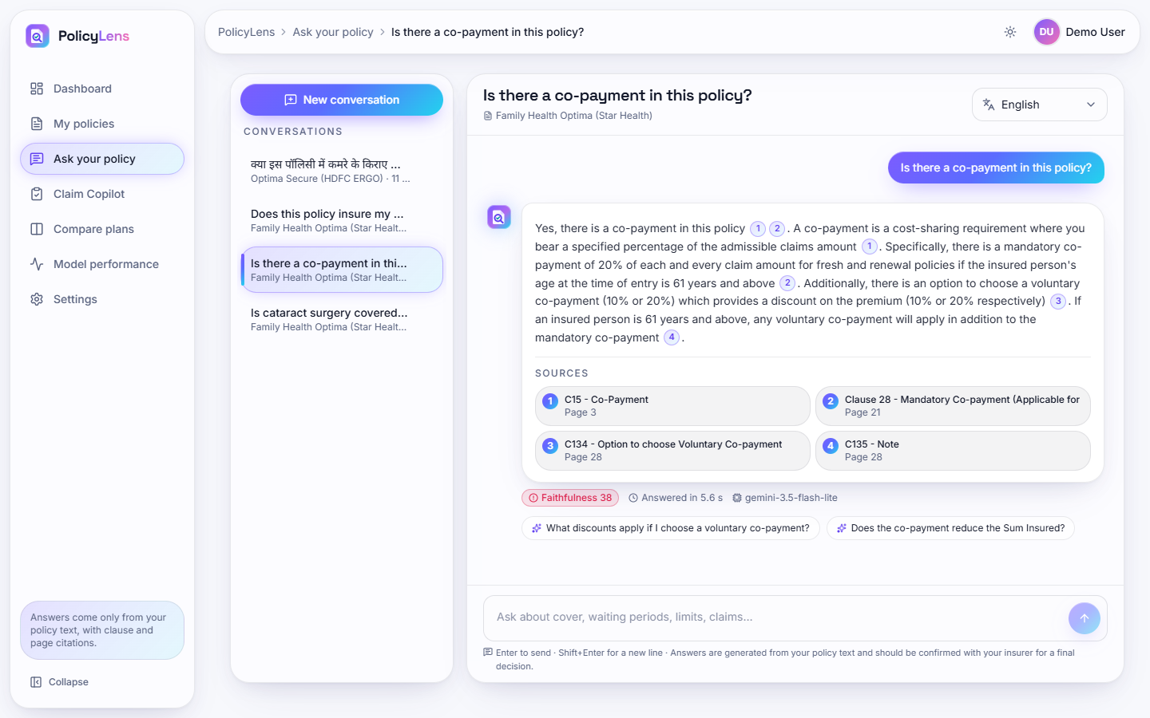  Fig. C.6: Co-payment answer (weak support score)

Original document viewer. The viewer on the page of a cited clause before scrolling: page navigation, zoom, the selected clause and the clauses on the page.
Co-payment answer (weak support score). The answer to "Is there a co-payment in this policy?" received a faithfulness score of 38 in this run (99 in an earlier run of the same question), an example of the variability of the score discussed in Section 8.7.
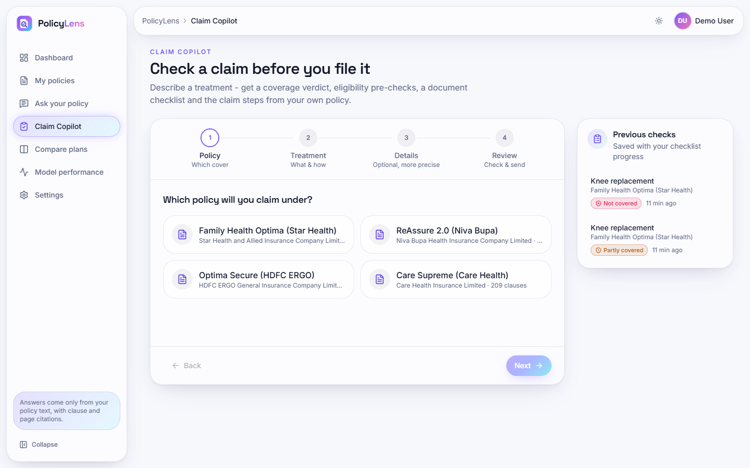  Fig. C.7: Claim Copilot: policy step | 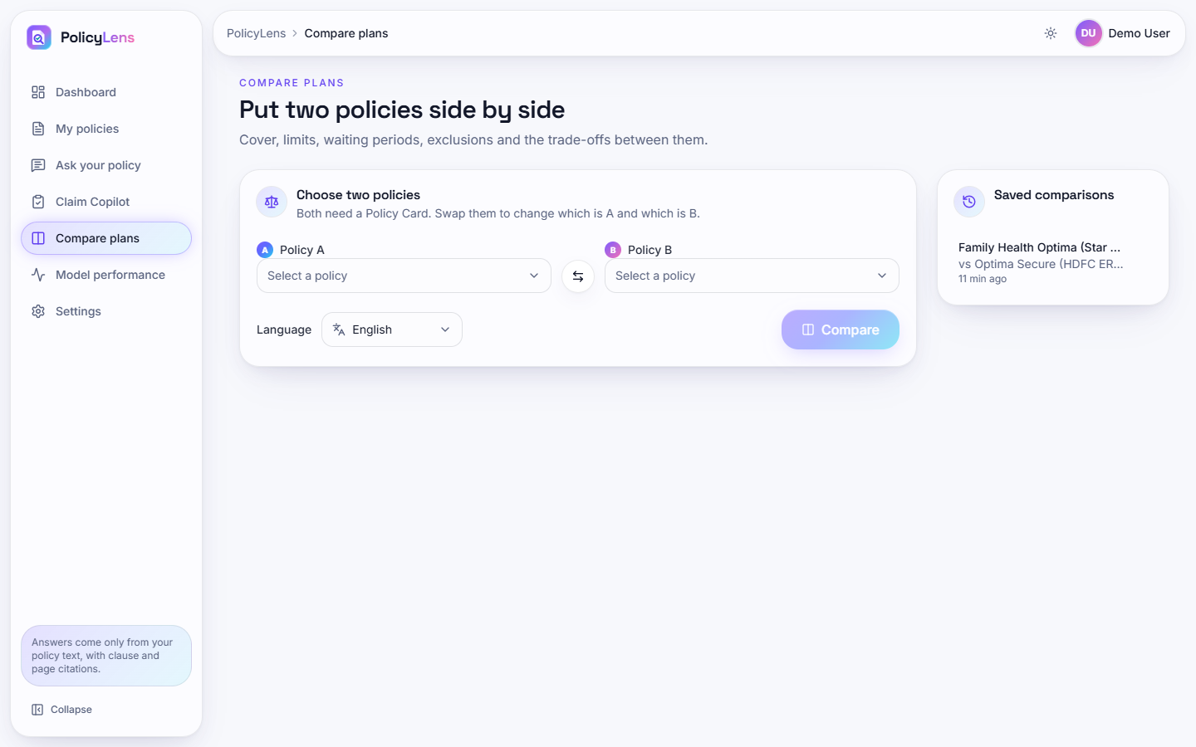  Fig. C.8: Compare plans: form

Claim Copilot: policy step. Step 1: choose the policy to claim under.
Compare plans: form. Choose two policies, swap them and choose the answer language.
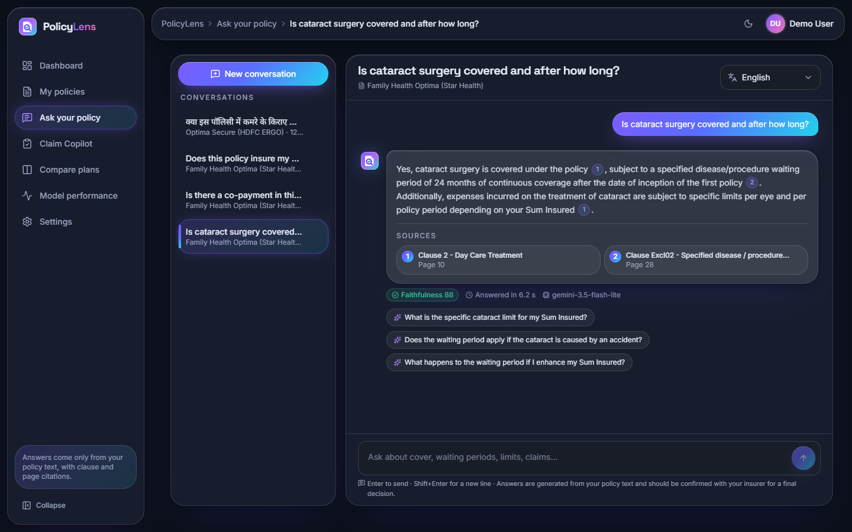  Fig. C.9: Dark theme | 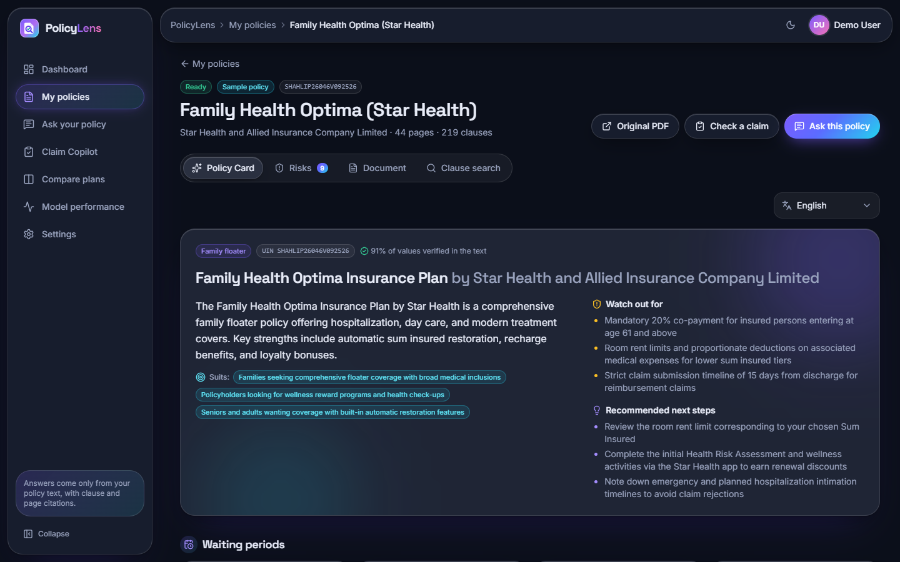  Fig. C.10: Policy Card, dark theme

Dark theme. The cited answer in the dark theme.
Policy Card, dark theme. The Policy Card in the dark theme.
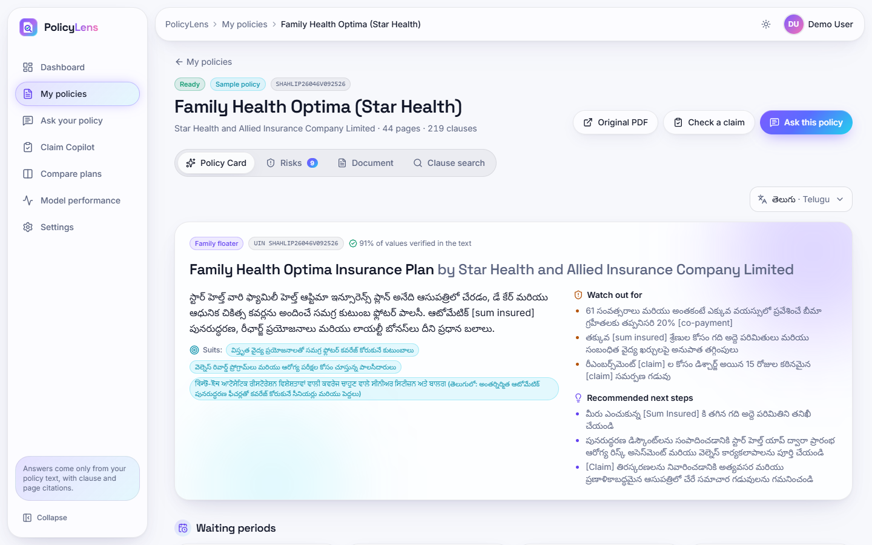
Fig. C.11: Policy Card translated to Telugu

Policy Card translated to Telugu. The card in Telugu. The third "Suits" line contains Bengali and Gurmukhi script mixed into the Telugu text and several terms stay in English in brackets; this is a known limitation of the translation step.
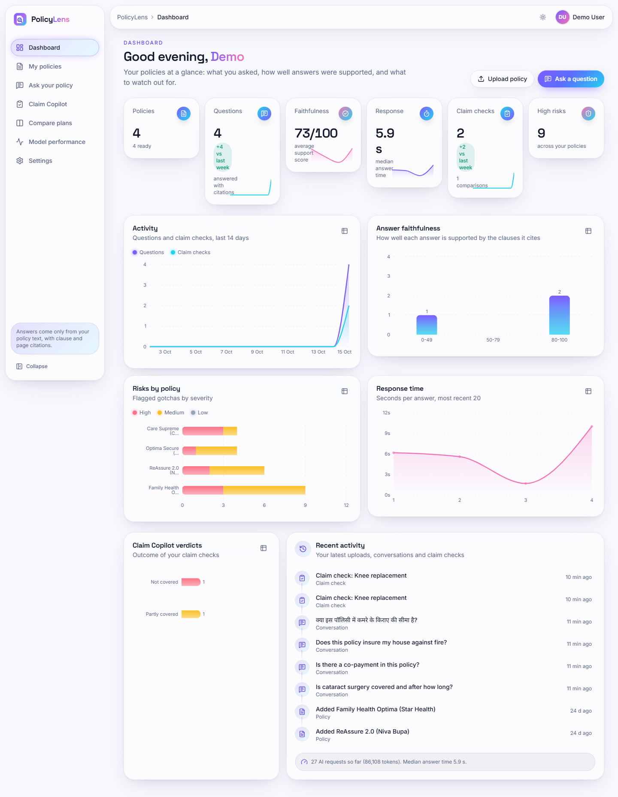  Fig. C.12: Dashboard (full page) | 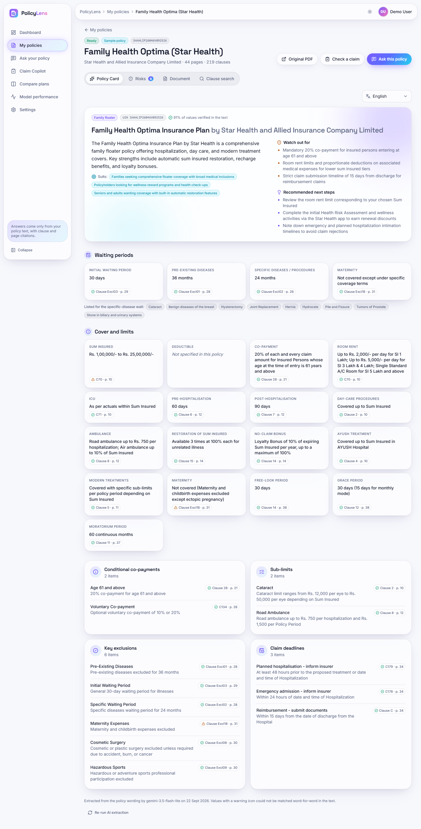  Fig. C.13: Policy Card (full page)

Dashboard (full page). The whole dashboard including the answer faithfulness chart and the latest activity.
Policy Card (full page). The complete card: waiting periods, benefits, sub-limits, exclusions and claim deadlines, each with a clause and page chip.
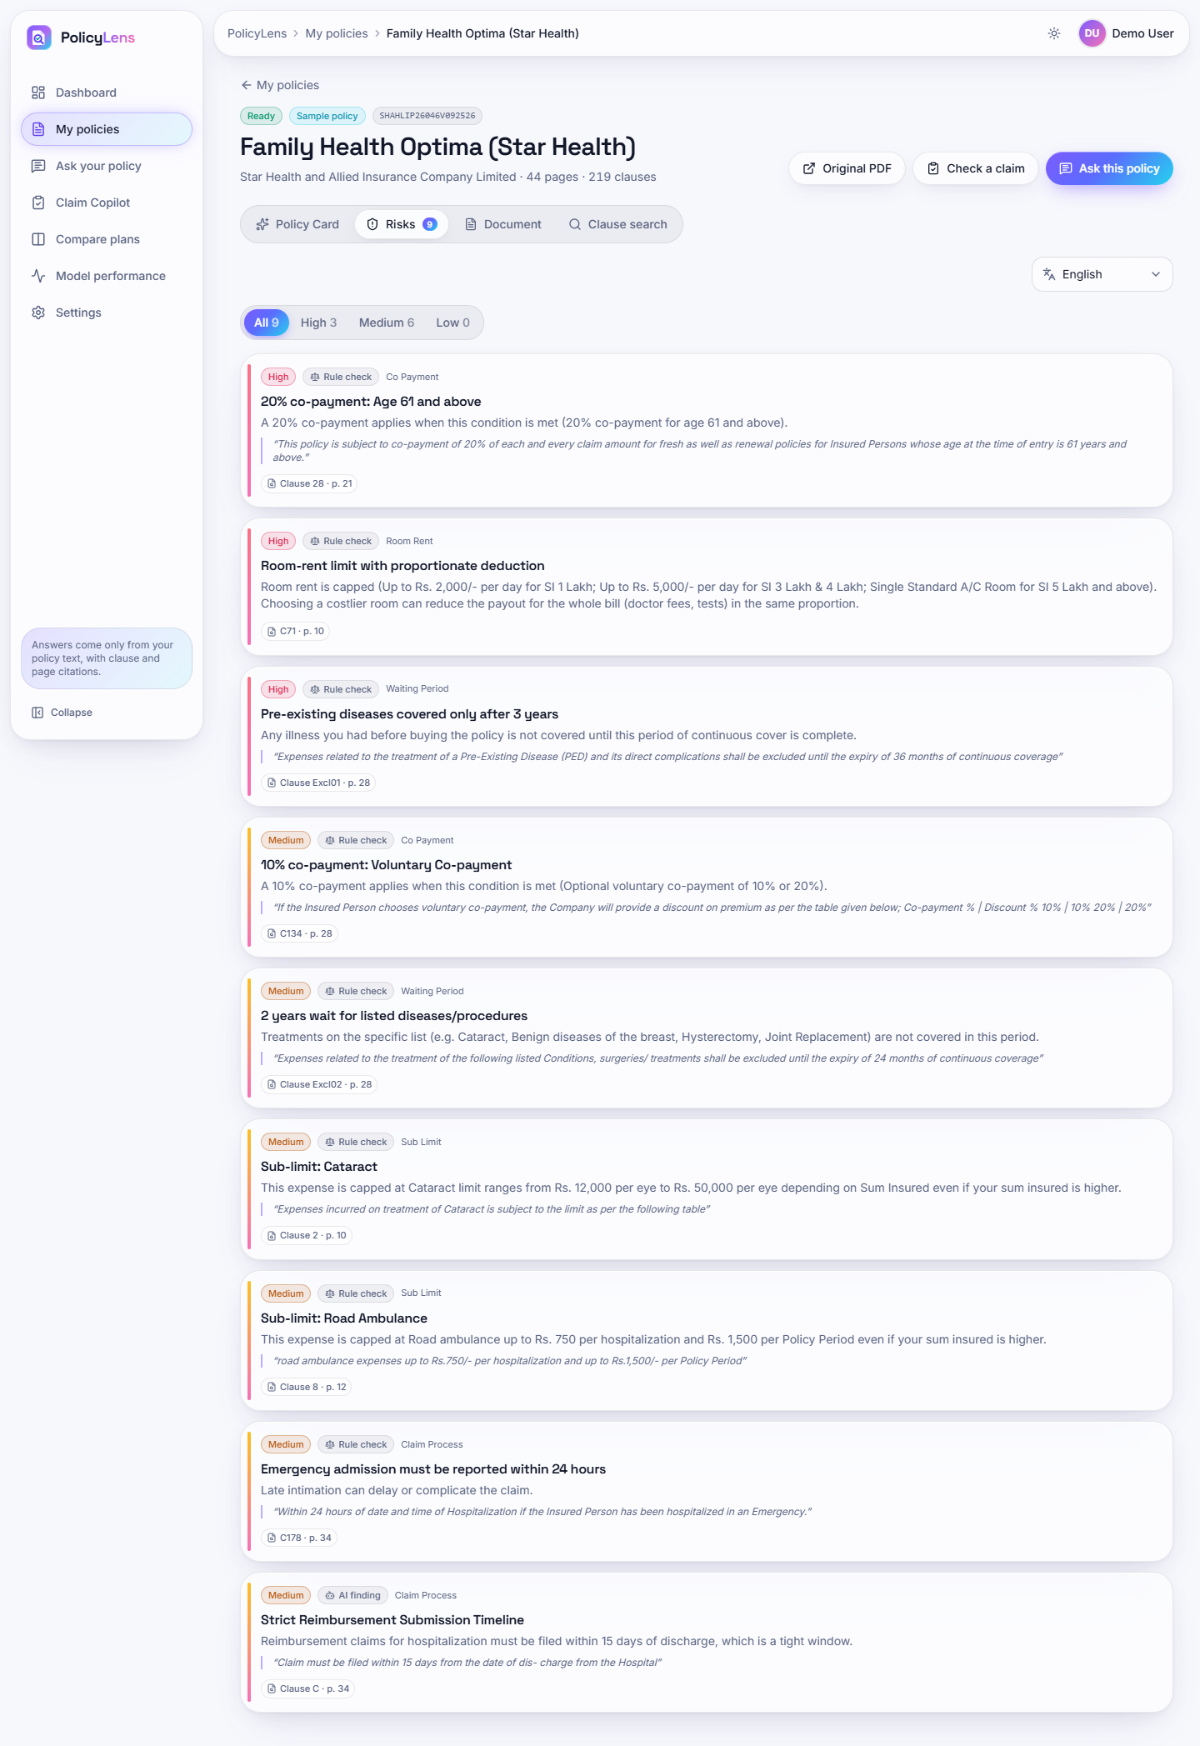  Fig. C.14: Risk highlights (full page) | 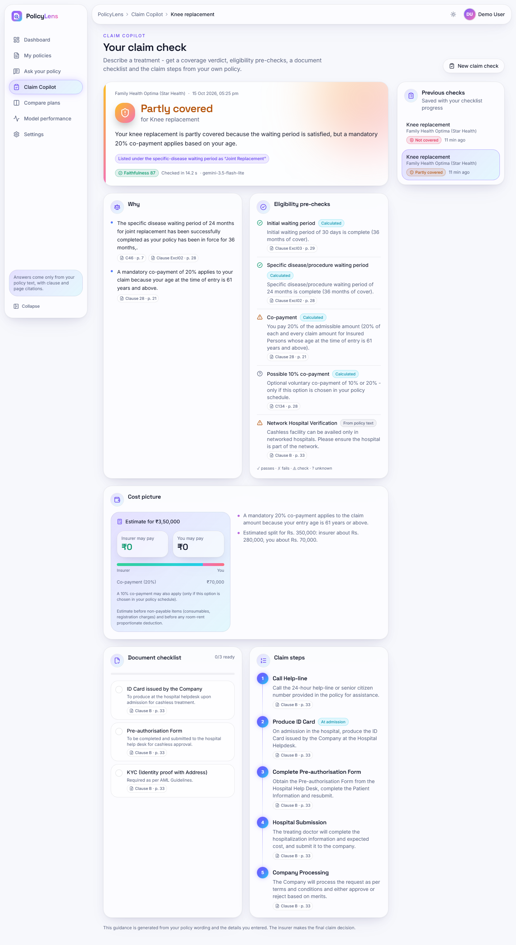  Fig. C.15: Claim check, partly covered (full page)

Risk highlights (full page). All nine risks of the Star Health wording.
Claim check, partly covered (full page). The complete plan: reasons, pre-checks, estimated split of the bill, document checklist and claim steps.
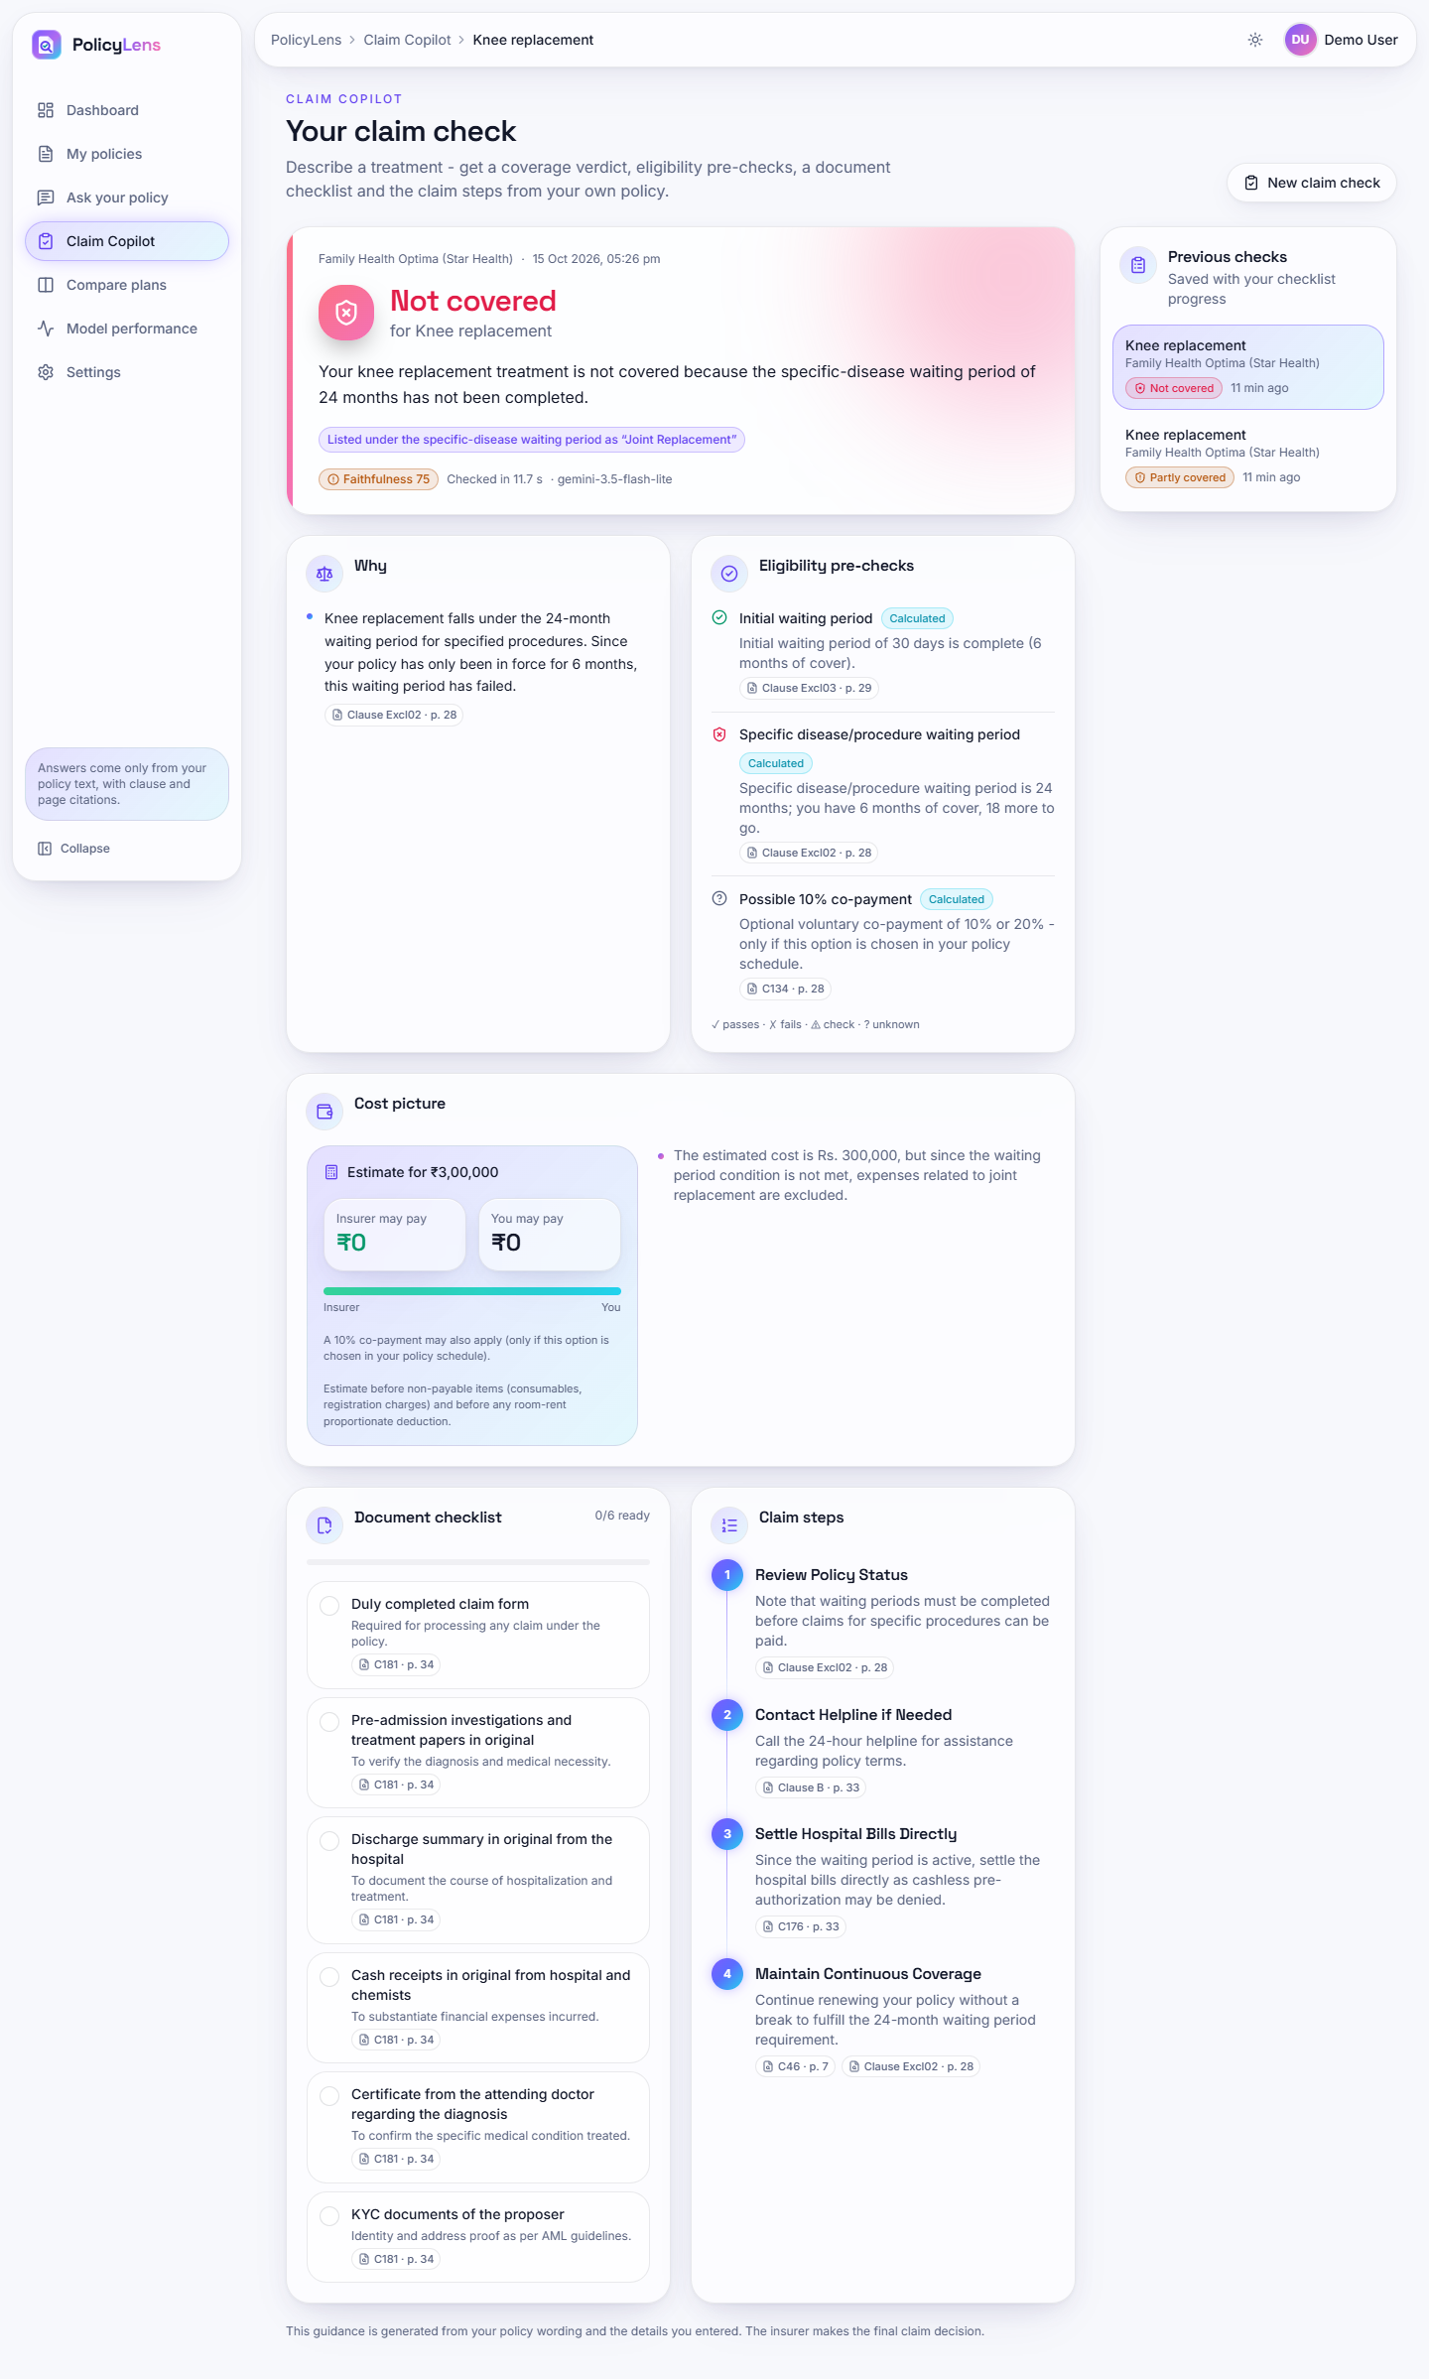  Fig. C.16: Claim check, not covered (full page) | 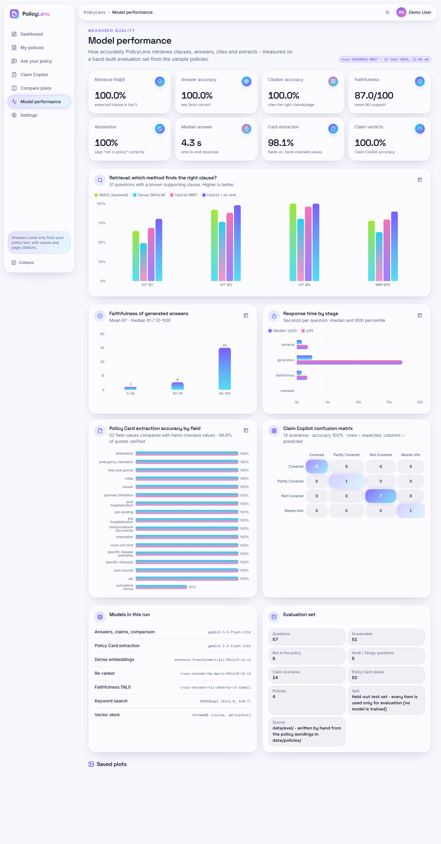  Fig. C.17: Model performance (full page)

Claim check, not covered (full page). The complete plan for the failed waiting period.
Model performance (full page). All charts of the measured-quality page.
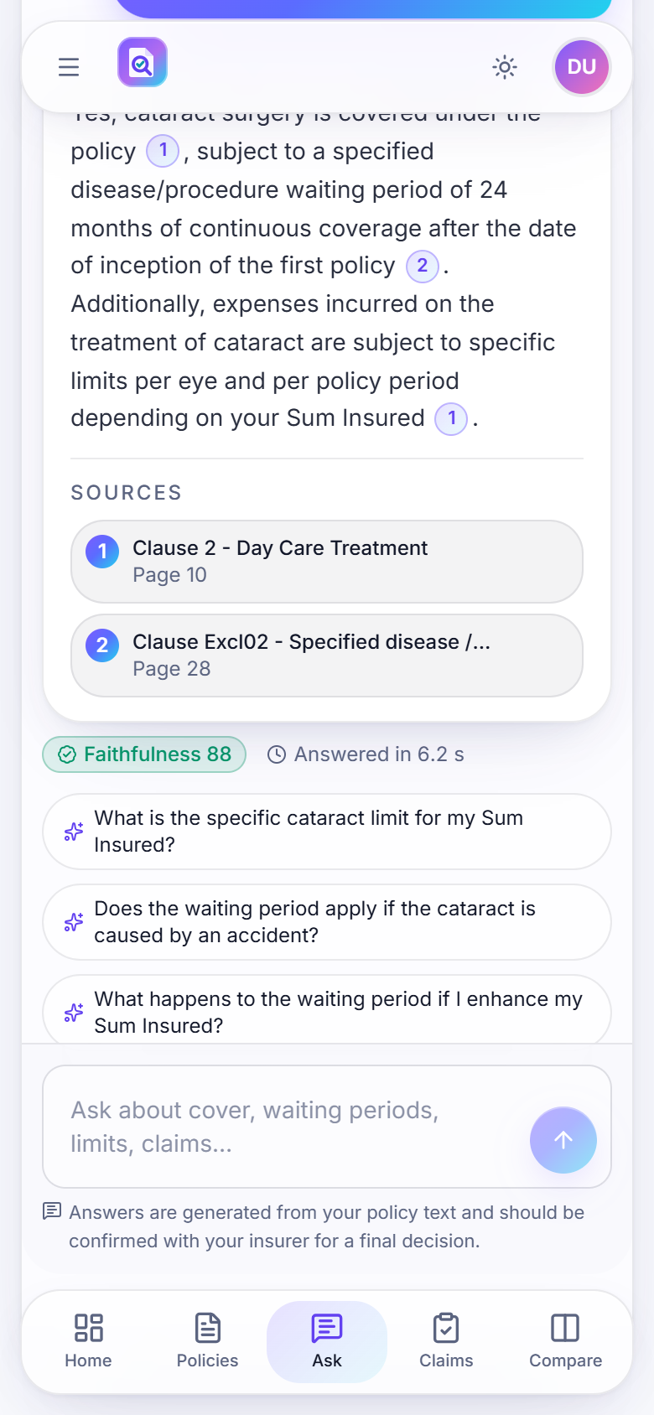  Fig. C.18: Phone layout: cited answer (390 px) | 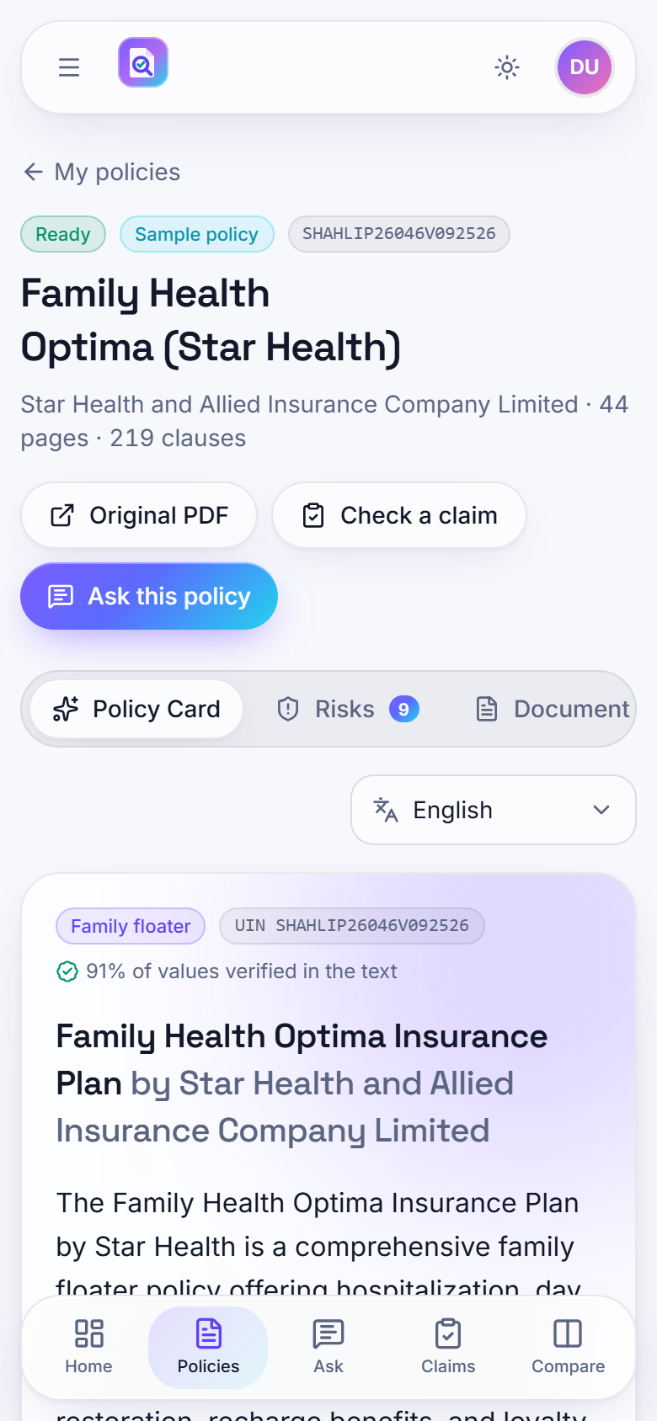  Fig. C.19: Phone layout: Policy Card (390 px)

